### UNIVERSITY OF BELGRADE FACULTY OF BIOLOGY

Fathia E. Faid

**DEVELOPMENT AND VALIDATION OF A QUESTIONNAIRE FOR VITAMIN D DIETARY INTAKE ASSESSMENT AND ANALYSIS OF VITAMIN D STATUS IN LIBYAN WOMEN LIVING IN LIBYA AND SERBIA**

### Doctoral Dissertation

UNIVERZITET U BEOGRADU BIOLOŠKI FAKULTET

Fathia E. Faid

**RAZVOJ I VALIDACIJA UPITNIKA ZA PROCENU UNOSA I ODREĐIVANjE**

**STATUSA VITAMINA DE KOD LIBIJSKIH ŽENA KOJE ŽIVE U LIBIJI I SRBIJI**

### doktorska disertacija

MENTORS

Dr Marija Glibetić, Principal Research Fellow, University of Belgrade - Institute for Medical Research

Dr Nevena Vidović, Scientific Associate, University of Belgrade - Institute for Medical Research

COMMISSION FOR THE EVALUATION AND DEFENSE OF THE DOCTORAL DISSERTATION

Dr Siniša Đurašević, Full Professor, University of Belgrade - Faculty of Biology

Dr Marija Knez, Scientific Associate, University of Belgrade - Institute for Medical Research

Dr Dragana Jović, Scientific Associate, Institute of Public Health of Serbia „Dr Milan Jovanović Batut”

DEFENSE DATE:

***Acknowledgments***

*First of all, most praises and thanks are due to Allah Almighty, the most beneficent and compassionate, who bestowed me with the ability to complete this thesis. Further, I would like to express my sincere thanks to many individuals and organizations who have provided me with invaluable support throughout my academic journey.*

*The deepest imaginable gratitude goes to my main supervisor and mentor Professor Maria Glibetic, for her academic guidance, support, patience, wisdom. Due to her continuous guidance and unceasing support, I was able to complete my dissertation, while achieving intellectual and professional maturity. I feel greatly privileged to have worked under her supervision.*

*I express my sincere appreciation and gratitude to Dr. Marija Knez for her willingness to guide me in the writing stage, she was with me step by step, reading and correcting my thesis many times. Her helpful comments, instructions, and valuable notes immensely helped me improve my thesis.*

*My thanks and appreciation go to Marina Nikolic, for helping me to statistically analyze and present the data, and to Dr. Agnes Kadvan for helping me with nutrition software.*

*My thankfulness goes to Dr. Milica Zekovic, Dr. Jelena Milesevic, Dr. Nevena Kardum, Dr. Biljana Pokimica, for their supervision and support regarding my thesis. They provided the guidance and help I needed during my Ph.D. study.*

*I would like to extend my thanks to Dr. Manja Zec, Dr. Ana Pantovic, Dr. Marija Takic, Dr. Maria Ranic, Dr. Jasmina Debeljak-Martačić, for their help with blood analysis for various indicators during the research period, without them my work would not have been possible.*

*I would also like to convey my deep gratitude to committee members Dr Siniša Đurašević and Dr Dragana Jović for reviewing my work.*

*I am thankful to all of the interviewees who participated in this research, for their invaluable contribution and input.*

*I am indebted to my mother a great deal of gratitude for always believing in me, for her continuous love, and for supporting my decisions.*

*I want to thank my husband and my kids, they have been, and remain, the driving force of my life. Throughout the Ph.D. process, their encouragement has been unwavering. I would not be the person I am today without all of your love and support.*

*Warmest thanks to all my friends, both living locally and abroad, who have supported, challenged, or joined me on this journey. Yet all of this wouldn’t have been possible without the support of my family, there are not enough words to say how grateful I am for their support and for having faith in me. Thus, I dedicate this thesis to them.*

*I wish to thank the staff from The Centre of Research Excellence in Nutrition and Metabolism, National Institute for Medical Research, Belgrade, Serbia for providing research resources throughout my studies.*

*I would like to thank Al-Hikma Hospital in which the collection of the participants data was conducted, and also a lot of gratitude to the Misurata Central Laboratory for their efforts in providing the important material for my thesis.*

*Finally, thanks to the Ministry of Higher Education and Scientific Research - Libya for direct and indirect funds that have supported my study.*

Development and validation of a questionnaire for vitamin D dietary intake assessment and analysis of vitamin D status in Libyan women living in Libya and Serbia

**Abstract**

Vitamin D is an important micronutrient with a central role in the skeletal, immune, neuroendocrine, and cardiovascular systems. The prevalence of vitamin D deficiency is increasing and it is estimated that about a billion people are currently affected. Vitamin D deficiency is common in Near East, North Africa, and the Middle East regions, despite plentiful sunshine throughout the year. The human body synthesizes vitamin D in the skin when exposed to UV-β radiation. However, inadequate sun exposure means that the status of vitamin D depends primarily on eating habits. Currently, very limited data is available on the dietary intake of vitamin D in the Libyan population. The unstable political situation in Libya has led to the migration of residents to European countries, including Serbia, which could lead to change in their dietary habits. Vitamin D is important for the prevention and treatment of cardiovascular diseases; however, the mechanisms of its influence require additional research.

This doctoral dissertation aims to create, validate and apply a questionnaire to assess the dietary intake of vitamin D in Libyan women residing in Libya, as well as those living in Serbia as migrants. In addition, to examine the correlation between vitamin D intake and status with risk factors for the development of cardiovascular diseases (magnesium and zinc status, polyunsaturated fatty acid profile, redox status parameters, cholesterol and sphingolipid concentrations in erythrocyte cell membranes).

The quantitative food frequency questionnaire for estimating vitamin D intake (LW-FFQ) was created and validated, confirming significant statistical consistency among methods for estimating dietary intake, the degree of correlation between LW-FFQ and 24-hour dietary surveys (24HDR) of 0.600 (p < 0.001). A study of vitamin D status in 455 residents of Libya, Misurata region, showed suboptimal concentrations of vitamin D in 80% of subjects. The most vulnerable group for the development of vitamin D deficiency are women aged 25 to 64. The dietary intake of vitamin D is far below the recommended values, 3.9 ± 4.2 μg/day based on 24HDRs, and 4.2 ± 5.2 μg/day based on LW-FFQ. Fish and seafood products are the most important source of vitamin D and contribute to 63.6% of the total intake. An inverse correlation between the status of vitamin D and n-6 fatty acids of erythrocytes, one of the risk factors associated with the development of cardiovascular diseases, is found in Libyan migrants 0.604 (p = 0.029), but also in the group of women from Serbia 0.579 (p = 0.024). Based on the fatty acid profile of erythrocytes, migrant women from Libya have a lower risk of developing cardiovascular diseases. Vitamin D status is directly correlated with the concentration of sphingolipids in erythrocyte membranes (p < 0.05). Significant differences are found between groups with optimal and suboptimal vitamin D status for superoxide dismutase. There were statistically significant differences in magnesium status between migrant women from Libya and Serbian women.

This study, for the first time, provided data on the nutritional status of vitamin D in Libyan women using validated and harmonized questionnaires, indicating a suboptimal dietary intake of this important micronutrient. In addition, the results confirm the undesirable effect of vitamin D deficiency on risk factors for the development of cardiovascular diseases. Overall, the results of this thesis contribute to a better understanding of the problem of vitamin D deficiency, the importance of appropriate intake of this important nutrient, and its role in the development of cardiovascular diseases. Finally, the obtained data could help in creating adequate recommendations for increasing the intake of vitamin D in the Libyan population and in developing tailored nutritional interventions for the migrant population.

**Keywords:** Vitamin D, dietary intake, food frequency questionnaire, vitamin D status, Libyan women, Serbian women, cardiovascular diseases

**Scientific Field:** Biology

**Scientific Subfield:** Integrated Food Science

Razvoj i validacija upitnika za procenu unosa i određivanje statusa vitamina De kod libijskih žena koje žive u Libiji i Srbiji

**Sažetak**

Vitamin De je važan mikronutrijent sa centralnom ulogom u skeletnom, imunom, neuroendokrinom i kardiovaskularnom sistemu. Prevalenca deificijencije vitamina De je u porastu i procenjuje se da je oko milijardu ljudi trenutno ugroženo. Veliki broj ugroženih je na Bliskom i Srednjem istoku i Severnoj Africi, uprkos velikoj učestalosti sunčanih dana tokom godine. Vitamin De se sintetiše u koži čoveka kada je ona izložena UV-β zračenju. Međutim, neadekvatno izlaganje suncu doprinosi tome da status vitamina De zavisi primarno od navika u ishrani. Trenutno je nedovoljno podataka dostupno o dijetarnom unosu vitamina De kod stanovnika Libije. Nestabilna politička situacija u Libiji dovela je do migracija stanovnika u evropske zemlje, uključujući i Srbiju a poznato je da migranti vrlo često imaju izmenjen način ishrane. Vitamin De je važan za prevenciju i tretman kardiovaskularnih bolesti, međutim mehanizmi njegovog delovanja su nedovoljno ispitani i iziskuju dodatna istraživanja.

Cilj ove doktorske disertacije je kreiranje, validacija i primena upitnika za procenu dijetarnog unosa vitamina De kod libijskih žena koje žive u svojoj domovini, kao i onih koje žive u Srbiji kao migranti. Uz to, ispitivanje korelacije između unosa i statusa vitamina De sa faktorima rizika za razvoj kardiovaskularnih bolesti (status magnezijuma i cinka, profil polinezasićenih masnih kiselina, parametri redoks statusa, koncentracije holesterola i sfingolipida u ćelijskim membranama eritrocita). Kvantitativni upitnik učestalosti konzumacije namirnica za procenu unosa vitamina De (LW- FFQ) je kreiran i validiran, ukazujući na značajnu statističku usaglašenost metoda za procenu dijetarnog unosa, stepen korelacije između LW-FFQ i 24-časovnih anketa ishrane (24HDR) od 0,600 (p < 0,001). Ispitivanje statusa vitamina De kod 455 stanovnika Libije, Misurata region, pokazalo je suboptimalne koncentracije vitamina De kod 80% ispitanika. Najosetljivija grupa za razvoj deficijencije vitamina De su žene starosne dobi od 25 do 64 godine. Dijetarni unos vitamina De je daleko ispod preporučenih vrednosti, 3,9 ± 4,2 μg/dnevno na osnovu 24HDRs, odnosno 4,2 ± 5,2 μg/dnevno na osnovu LW-FFQ. Morska riba i proizvodi iz ove grupe namirnica su najznačajniji izvor vitamina De i doprinose 63,6% ukupnom unosu. Inverzna korelacija između statusa vitamina De i n- 6 masnih kiselina eritrocita, jednog od faktora rizika povezanog sa nastanakom kardiovaskularnih oboljenja, utvrđena je kod migranata iz Libije 0,604 (p = 0,029), kao i u grupi žena iz Srbije 0,579 (p

= 0,024). Na osnovu masnokiselinskog profila eritrocita, žene migrantkinje iz Libije imaju manji rizik za nastanak kardiovaskularnih bolesti. Status vitamina De je u direktnoj korelaciji sa količinom sfingolipida u membranama eritrocita (p < 0,05). Utvrđene su značajne razlike između grupa sa optimalnim i suboptimalnim statusom vitamina De za superoksid dismutazu, kao i razlike u statusu magnezijuma između grupa migrantkinja iz Libije i srpskih žena.

Ovom studijom su po prvi put prikupljeni podaci o nutritivnom statusu vitamina De libijskih žena, korišćenjem validiranih i harmonizovanih upitnika, ukazujući na suboptimalan dijetarni unos ovog važnog mikroelementa. Dodatno, rezultati potvrđuju nepovoljan uticaj nedostatka vitamina De na faktore rizika za razvoj kardiovaskularnih bolesti. Sveukupno, rezultati ove teze doprinose boljem razumevanju problema deficijencije vitamina De, adekvantog unosa ovog važnog mikronutrijenta kao i njegove uloge u razvoju kardiovaskularnih bolesti. Istovremeno, dobijeni rezultati mogu značajno pomoći u kreiranju preporuka za povećanje unosa vitamina De stanovništva Libije i razvoju specifičnih nutritivnih intervencija usmerenih ka migrantskoj populaciji.

**Ključne reči**: Vitamin De, dijetarni unos vitamina De, upitnik o učestalosti konzumacije namirnica, status vitamina De, žene u Libiji, srpske žene, kardiovaskularne bolesti

**Naučna oblast:** Biologija

**Uža naučna oblast:** Integrisane nauke o ishrani

**List of abbreviations**

|  |  |
| --- | --- |
| **24HDRs** | 24 h dietary recalls |
| **7-DHC** | 7-dehydrocholesterol |
| **AI** | adequate intake |
| **AIP** | atherogenic index of plasma |
| **ALA** | linolenic acid |
| **BMI** | body mass index |
| **CVDs** | cardiovascular diseases |
| **DAP** | Diet Assess and Plan |
| **DHA** | docosahexaenoic acid |
| **EAR** | estimated average requirement; |
| **EFSA** | European Food Safety Authority |
| **EPA** | eicosapentaenoic acid |
| **FCDB** | food composition database |
| **FFQ** | food frequency questionnaire |
| **GFR** | glomerular function rate |
| **GPx** | glutathione peroxidase |
| **H2O2** | hydrogen peroxide |
| **HDL** | high-density lipoprotein |
| **IOM** | The Institute of Medicine |
| **IU** | international unit |
| **LA** | linoleic acid |
| **LDL** | low-density lipoprotein |
| **LOOH** | lipid hyperoxides |
| **LW-FFQ** | Libyan women-FFQ |
| **MED** | minimal erythemal dose |
| **MENA** | Middle East and North Africa |
| **MetS** | metabolic syndrome |
| **MND** | micronutrient deficiencies |
| **MUFA** | monounsaturated fatty acids |
| **NCDs** | noncommunicable diseases |
| **NCEP** | National Cholesterol Education Program |
| **NCEP** | The National Cholesterol Education Program |
| **NENA** | Near East and North Africa |
| **NHANES** | National Health and Nutrition Examination Survey |
| **PTH** | parathyroid hormone |
| **PUFA** | polyunsaturated fatty acids |
| **RDA** | Recommended dietary allowance |
| **ROS** | reactive oxygen species |
| **SFA** | saturated fatty acids |
| **SOD** | superoxide dismutase |
| **TEI** | total energy intake |
| **TLC** | thin-layer chromatography |
| **UL** | upper limit |
| **USDA** | United States Department of Agriculture |
| **VDD** | vitamin D deficiency |
| **VDR** | vitamin D receptor |
| **vitamin D2** | ergocalciferol |
| **vitamin D3** | cholecalciferol |
| **WC** | waist circumference |
| **WHO** | World Health Organization |

**Table of contents**

1. INTRODUCTION 1
   1. Chemical structure and metabolism of vitamin D 1
   2. The functions of vitamin D 4
   3. Sources of vitamin D 5
      1. Cutaneous synthesis of vitamin D 5
      2. Dietary sources of vitamin D 5
         1. Natural dietary sources 5
         2. Vitamin D fortified foods 7
   4. Assessment of vitamin D intake 7
      1. Dietary recommendations for vitamin D intake 7
      2. Methods used to assess vitamin D intake 9
         1. Food frequency questionnaire 9
         2. 24 h dietary recall 10
      3. Classification of vitamin D status 12
         1. Measurement of serum 25(OH)D concentration 13
         2. Vitamin D deficiency 14
      4. Causes of vitamin D deficiency 16
         1. Malabsorption and vitamin D deficiency 17
         2. Association between age and vitamin D deficiency 18
         3. Association between anthropometric parameters and vitamin D deficiency 19
         4. Prevention and treatment of vitamin D deficiency 19
         5. Effects of vitamin D deficiency on health 20
      5. Vitamin D and cardiovascular diseases 21
         1. Association of risk factors for development of cardiovascular diseases with vitamin D intake and status 22
         2. Association of other risk factors for cardiovascular disease with vitamin D status 23
            1. Erythrocyte fatty acid composition, cardiovascular disease and vitamin D 23
            2. Vitamin D, magnesium, zinc and risk of developing cardiovascular diseases 26
            3. Sphingolipid and cholesterol content of erythrocyte membranes, cardiovascular diseases and vitamin D status 27
            4. Redox stress parameters, cardiovascular diseases and vitamin D status 27
2. AIMS 29
   1. The main scientific goals 29
      1. Goal 1. Creation, adaptation, and validation of a questionnaire for the assessment of vitamin D intake among Libyan women 29
      2. Goal 2. To determine the association between the dietary intake and status of vitamin D and the risk factors for the development of cardiovascular diseases in Libyan women 30
   2. Significance of the proposed research project 30
3. MATERIAL AND METHODS 31
   1. Research sites 31
      1. Misurata, Libya setting 31
      2. Belgrade, Serbia setting 31
   2. Research design 31
   3. Study participants 32
   4. Data gathering procedures 33
   5. Ethical considerations 33
   6. Anthropometric measurements 33
   7. Blood sample analysis 34
   8. The analysis of serum magnesium and zinc concentrations 36
   9. The analysis of redox status parameters 37
   10. Determination of blood erythrocytes cholesterol and sphingolipids 37
   11. Determination of serum vitamin D status 37
   12. Determination of erythrocytes phospholipid-derived fatty acid composition 37
   13. An assessment of the dietary intake of participants 38
   14. Creation and validation of a nutritional tool for assessment of vitamin D intake of Libyan women (Libyan women-food frequency questionnaire, LW-FFQ) 38
   15. 24 h dietary recall 39
   16. Food composition database 39
   17. Statistical analysis 40
4. RESULTS 41
   1. Cross-sectional study of vitamin D intake and status in Libyan women 41
   2. Evaluation of Vitamin D status in children, adults and elderly people in Misurata region, Libya

............................................................................................................................................................ 42

* 1. Identification of the most vulnerable populations for the development of Vitamin D deficiency in Libya 43
  2. Analysis of anthropometric measures, physical activity and sun exposure behaviors as contributing factors to development of vitamin D deficiency 44
  3. Assessment of vitamin D and daily energy and nutrient intake among women in Misurata region using food frequency questionnaires and 24 h dietary recalls 48
  4. Assessing the agreement between the LW-FFQ and the average of repeated 24 h dietary recalls for estimation of vitamin D intake 50
  5. Cross-classification of vitamin D intake 50
  6. Vitamin D status of Libyan women 51
  7. Identification of the food groups with a dominant contribution to the total daily vitamin D intake, and major vitamin D food sources assessed by 24 h dietary recalls 51
  8. Major vitamin D food sources selected based on 24 h dietary recalls 52
  9. Cross-sectional study of vitamin D status in women in Serbia 53
  10. Assessment of vitamin D and daily energy and nutrient intake among Serbian women using food frequency questionnaires and 24 h dietary recalls 54
  11. Cross-classification of vitamin D intake 55
  12. Estimated vitamin D intake 55
  13. Daily intake of food groups and their contribution to total vitamin D intake among Serbian women 56
  14. Major vitamin D food sources and percentage of consumption assessed by 24 h dietary recall

............................................................................................................................................................ 56

* 1. Comparison of dietary intake of Vitamin D in Libyan and Serbian women 57
  2. Study of vitamin D status in Libyan emigrant women 57
  3. Clinical characteristics and dietary intake of the study participants 57
  4. Vitamin D, magnesium status and biochemical parameters 58
  5. Fatty acid composition 59
  6. Correlations between vitamin D status and fatty acid composition 59
  7. Comparison of Vitamin D intake between women residing in Libya and Libyan emmigrants residing in Serbia for at least a full calendar year 60
  8. Libyan migrants and Serbian women sphingolipids and cholesterol content of erythrocyte membranes 60
  9. Redox status parameters in Libyan emigrants and Serbian women 64

1. DISCUSSION 65
   1. Research implications 65
   2. General discussion and research implications 66
      1. Cross-sectional study of vitamin D status in Libya and identification of most vulnerable group for vitamin D deficiency 66
      2. Prevalence of vitamin D deficiency in Libyan women 66
   3. The study of dietary vitamin D intake in Libyan women 67
      1. Development and validation of LW-FFQ questionnaire 67
      2. Dietary intake of vitamin D in Libyan women 67
      3. Factors that could affect vitamin D status in Libyan women 68
         1. Obesity and low physical activity 68
         2. Lack of exposure to the sun 68
         3. Dietary intake of vitamin D in Serbian women 69
   4. The small-scale cross-sectional study in Libyan emigrant and Serbian resident women 69
      1. Vitamin D intake and status in Libyan emigrants 69
      2. Association of vitamin D status with risk factors for cardiovascular diseases 70
      3. Fatty acids profiles of erythrocytes 70
      4. Magnesium status 72
      5. Sphyngolipids content of erythrocytes 72
   5. Significance of this PhD project 73
2. CONCLUSIONS 75
3. REFERENCES 77

Biography of the author Annex

# INTRODUCTION

The human body is a complex creation, full of sophisticated systems that need a handful of vitamins and minerals for it to grow and develop properly. Vitamins and minerals are mainly obtained through regular food intake. However, vitamin D is acquired primarily through exposure to sunlight, and because of this, it is often referred to as the “sunshine vitamin”. This feature makes vitamin D unique but also presents a challenge regarding its adequate dietary intake and the necessary steps required to convert it to the active form, especially when people are living in cold, temperate regions. This chapter presents an overview of the literature related to the most important aspects of vitamin D including its importance, absorption and excretion mechanisms, food sources of vitamin D, and human physiological requirements. The association of vitamin D with risk factors for the development of cardiovascular diseases (CVDs) has also been discussed.

##### Chemical structure and metabolism of vitamin D

The generic term “vitamin D” is used to describe a group of fat-soluble secosteroids or steroid derivatives. In 2010, The Institute of Medicine (IOM), Food and Nutrition Board, described vitamin D as a fat-soluble vitamin that is naturally available in a limited number of foods, in fortified food products and as a dietary supplement (IOM, 2010). Vitamin D exists as either inactive D2 or D3 and requires conversion within the body to the hormonally-active form, namely, 1,25- dihydroxycholecalciferol 1,25(OH)2D. Fortified foods could contain either vitamin D2 or D3 provitamins. Whether vitamin D is obtained from food or synthesized by the skin, its interaction with the sunlight and the subsequent submission through the two-step hydroxylations are critical for its activation.

Provitamin conversion begins with UV light-mediated generation of ergocalciferol (vitamin D2) (Figure 1A) and cholecalciferol (vitamin D3) (Figure 1B) (Sirajudeen et al. 2019) by exposure to sunlight at a wavelength ranging from 290 - 315 nm. The skin could also synthesize the provitamin D3 precursor called 7-dehydrocholesterol (7-DHC), which undergoes a parallel reaction to generate cholecalciferol. Vitamin D acquired the name ‘the sunshine’ vitamin because it is generated as a consequence of the skin’s reaction to sunlight exposure and its natural synthesis is stimulated by the interaction of the biologically inactive form of vitamin D in the skin with UV rays of the sun (Wilson et al., 2020).

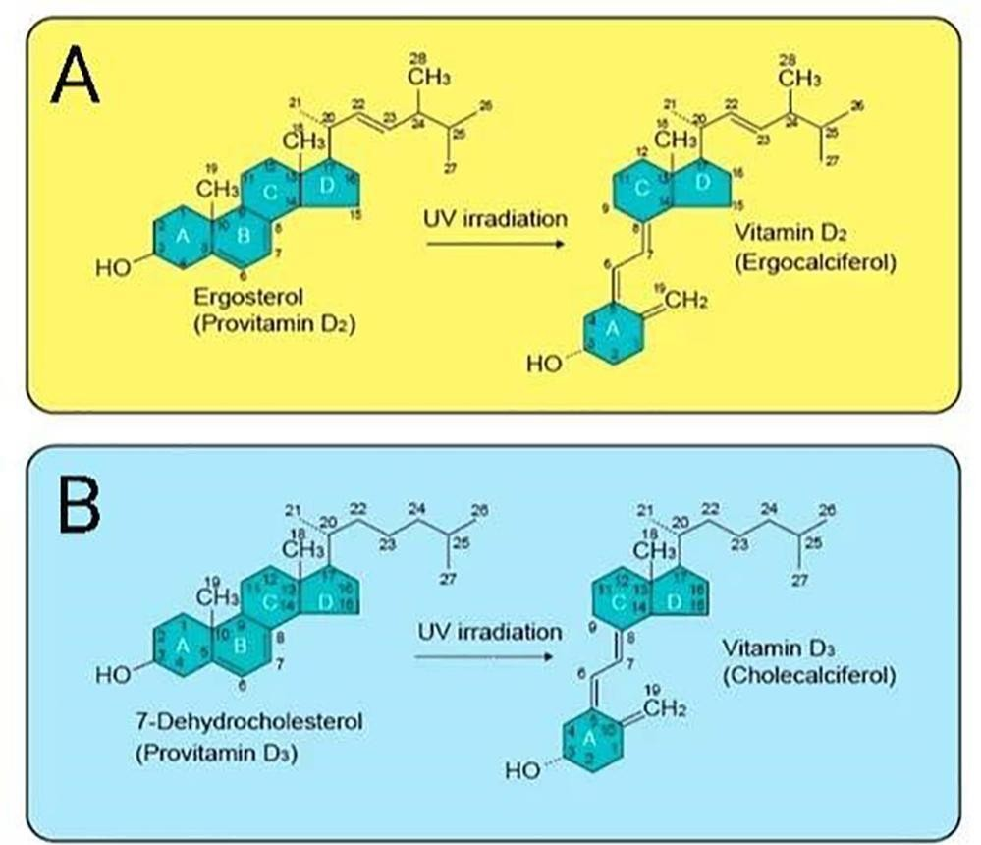

**Figure 1.** The structure of vitamin D2, vitamin D3, and their precursors (Sirajudeen et al. 2019)

Vitamin D2 and vitamin D3 are the forms that are physiologically very important (Logan, 2011). Vitamin D2 is found in plants, and vitamin D3 derived from cholesterol (Ahmed and Shoker, 2010) is of animal origin. Vitamin D2 has been identified in lower organisms such as algae, fungi, as well as, in plants infected with specific fungi types. Alternatively, vitamin D3 is can be found primarily in dairy products, beef liver, egg yolks and fatty fish (Nair and Maseeh, 2012).

Ergocalciferol and cholecalciferol undergo two-step hydroxylation reactions, in the liver and kidneys, respectively, to generate the bioactive forms of the vitamin, as shown in Figure 2 and 3. The two hydroxylase enzymes could catalyze the conversions of both vitamin D2 and D3, but it has been indicated that the body absorbs and uses vitamin D3 more efficiently than vitamin D2, and thus, consuming the former is more beneficial for health and wellbeing, and also, as a supplementation treatment in vitamin D deficiency (VDD) (Armas et al., 2004)**.**

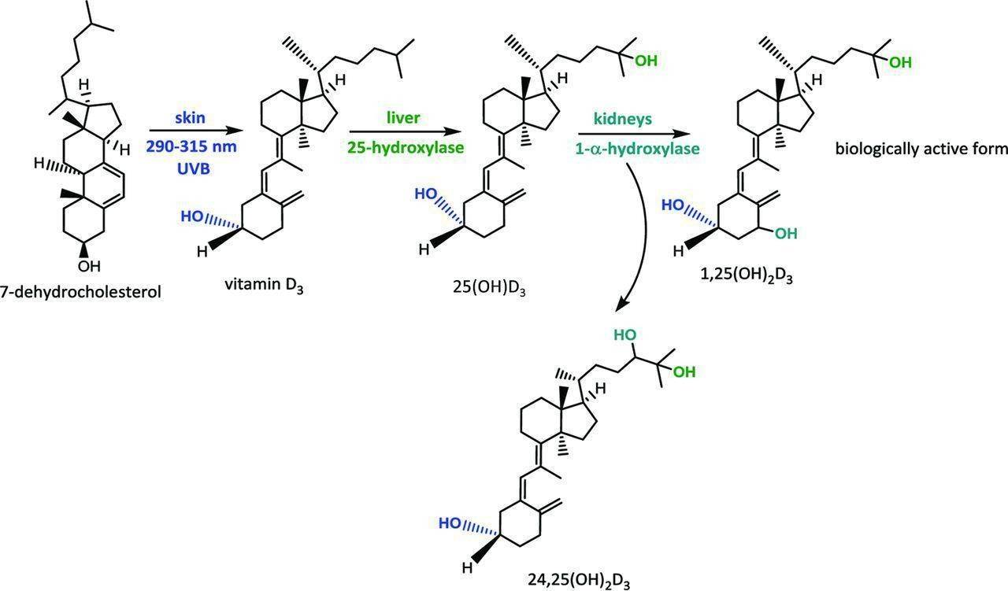

**Figure 2**. The metabolic pathway of vitamin D (Müller and Volmer, 2015).

The vitamin D status of a person depends mutually on a dietary intake and a cutaneous synthesis, after exposure to sunlight. To reveal the vitamin D status of an individual, calcidiol or 25(OH)D concentrations are measured in the bloodstream. A suitable indicator of vitamin D status is the serum 25(OH)D concentration and it is known to have a relatively long circulating half-life of 15 days (Liu et al., 2018).

In contrast, calcitriol 1,25(OH)2D is the active form of vitamin D and acts as a steroid hormone on targeted organs, including the bone, intestine and kidneys, considered as the primary targets. Vitamin D calcium regulation and phosphate homeostasis represent the key endocrine actions. Likewise, 1,25(OH)2D could conduct autocrine and paracrine effects in extra-renal tissues such as the cardiovascular tissue (Pilz et al., 2016) (Figure 3). However, more recent findings suggest that the active form of vitamin D acts on a variety of other tissues, including the brain, skin, hematopoietic (i.e., blood), muscle, pancreas, and the immune system (Goodman et al., 2015a,b). Moreover, research data indicate that vitamin D might inhibit the propagation and growth of cancer cells (Chakraborti, 2011; Krishnan et al., 2010). The binding of 1,25 (OH)2 D to vitamin D receptor (VDR), a transcription factor that and most, if not all properties of its effects, are mediated through VDR, which acts primarily by regulating the expression of genes which promoters contain specific DNA sequences known as vitamin D responsive elements (Bikle, 2014)**.**

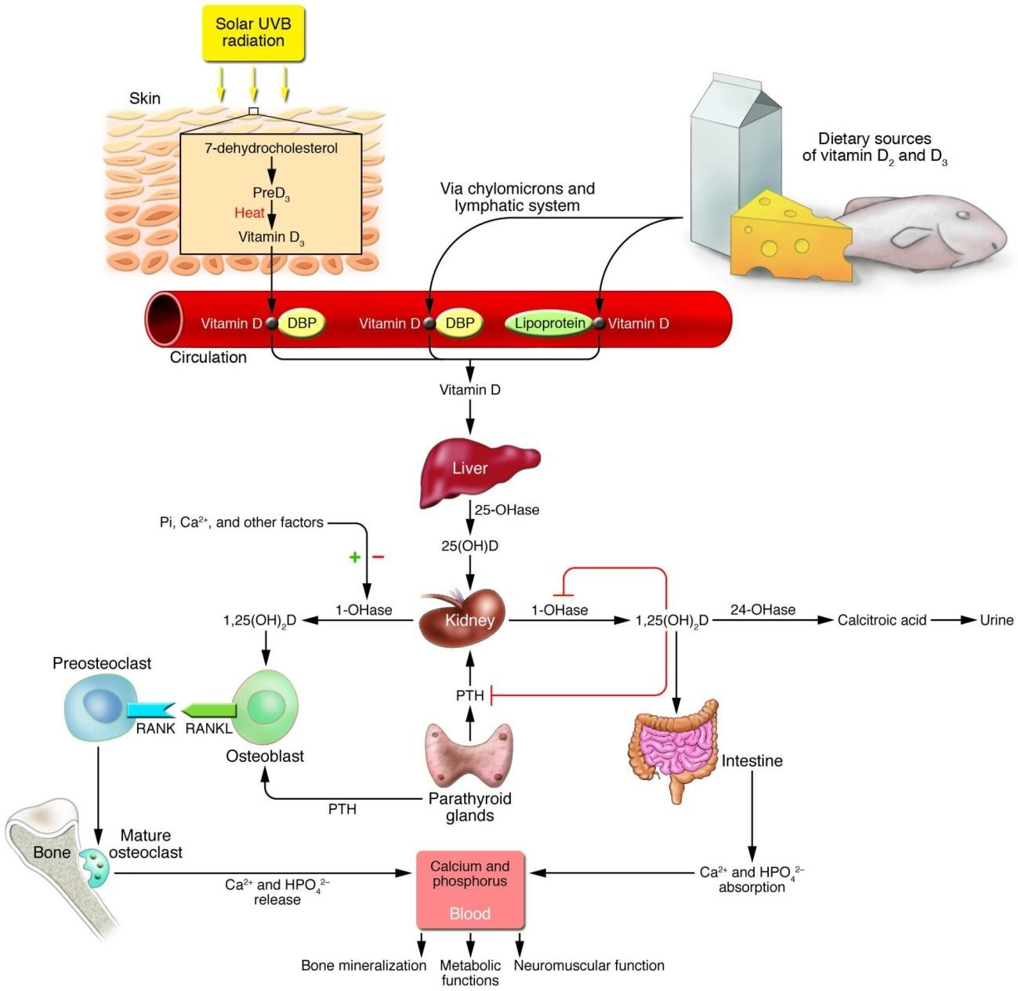

**Figure 3.** Metabolism of vitamin D (Holick, 2006)

The degradation of 25 (OH) D to 24,25 (OH)2 D and 1,25 (OH)2D to 1,24,25 dihydroxy vitamin D is the rate-limiting step in vitamin D catabolism. Subsequently, they are metabolized to calcitriol acid and excreted (Figure 3).

##### The functions of vitamin D

The principal biological function of vitamin D is to act in combination with the parathyroid hormone (PTH) to ensure serum calcium and phosphorus homeostasis (Cranney et al. 2019). Thus, if this homeostatic mechanism is perturbed in a way that the blood calcium concentration is low (a condition known as hypocalcaemia), it signals PTH secretion to stimulate the conversion of 25(OH)D to 1,25(OH)2D3, primarily in the kidneys, which, sequentially, turns on target tissues such as the intestine and bone, to increase serum calcium concentrations.

Therefore, calcitriol and PTH both play crucial roles in sustaining blood calcium levels. The role of calcitriol in other organs of the body could be summarized, as follows: 1) In the intestine, it enables increased absorption of phosphorus and calcium 2) It stimulates calcium and phosphorus reabsorption, induced by PTH, in the distal renal tubule of kidneys 3) Calcitriol, together with PTH, aid in mobilizing calcium and phosphorus from the bone to ensure homeostasis of blood calcium levels 4) The differentiation of hematopoietic cells, made by calcitriol, impacts osteoclasts production. Consequently, osteoclasts facilitate the bone resorption process, the bone tissue gets broken down to release calcium into the circulation. 5) In addition, besides its interactions with calcium and phosphorus, calcitriol networks with vitamin K, because vitamin K-dependent proteins are responsible for the binding of calcium in kidneys and bones (Goodman et al. 2015a,b).

In addition to vitamin D primary benefits, research has proven that this vitamin plays a critical role in reducing the risk of developing multiple sclerosis (Bolland and Grey, 2010), heart disease (Wang et al., 2008) and helps in diminishing the chances of developing flu infections (Urashima et al., 2010). Reports have also shown that vitamin D plays a crucial role in the regulation of mood and warding off depression, fibromyalgia, and helps with weight loss (Wilson et al., 2020). Vitamin D has some additional roles in the body, which include cell growth modulation, immune role, neuromuscular function and reduction of inflammation (Lee et al., 2020). Several genes encoding proteins that control cell differentiation, proliferation, and apoptosis are modulated to some extent by vitamin D, and thus, vitamin D/VDR dysfunction could jeopardize the modulation of these important cellular processes (Jeon, 2018; Lamprecht and Lipkin, 2003; Zinser et al., 2005)**.**

##### Sources of vitamin D

Vitamin D fits into a group of fat-soluble vitamins and the class of steroid hormones. It can be acquired both through skin exposure to sunlight (primary source), as well as through regular food intake. Therefore, its status is regulated by both factors (Wilson et al., 2020). People in cold regions characterized by high latitudes achieve the required amounts of vitamin D mainly through dietary sources rather than through cutaneous synthesis, due to limited opportunities to be exposed to sunlight, especially during the winter months (Webb, 2006). Consequently, the proper intake of vitamin D through food is of great importance for maintaining an adequate concentration of plasma vitamin D levels.

* + 1. Cutaneous synthesis of vitamin D

According to various researchers, the human skin could supply the body with about 80-100% of the needed level of vitamin D when exposed to sunlight (Qatatsheh et al., 2015). Exposing the arms and legs to direct sunlight in the interval of five to ten minutes, with a 0.5 minimal erythemal dose (MED) of UVB of wavelength 290 - 315 nm, results in obtaining approximately 3000 IU of Vitamin D3 (Seckmeyer et al., 2013).

* + 1. Dietary sources of vitamin D
       1. Natural dietary sources

In nature, vitamin D is found in a limited number of foods. The best sources are flesh fatty fish such as tuna, mackerel, salmon tuna, and fish liver oils. Small amounts of vitamin D are found in liver, beef, egg yolks, and cheese. In these foods, vitamin D is primarily in the form of vitamin D3 and its metabolite, 25(OH)D3. On the one hand, certain types of mushrooms and yeasts contain vitamin D2 in different amounts. Mushrooms with boosted levels of vitamin D2 are also available. The table below shows different food sources of Vitamin D, ranked according to the amounts of vitamin D and energy per 100 g of foods and per standard food servings (Robien et al., 2013).

**Table 1.** Food sources of Vitamin D2 and Vitamin D3.

|  |  |
| --- | --- |
| NATURAL SOURCES | VITAMIN D CONTENT IU = 25 ng |
| Cod liver oil | ~400 – 1,000 IU/tsp vitamin D3 |
| Salmon, fresh wild-caught | ~600-1,000 IU/3.5 oz vitamin D3 |
| Salmon, fresh farmed | ~100-250 IU/3.5 oz vitamin D3, vitamin D2 |
| Salmon, canned | ~300-600 IU/3.5 oz vitamin D3 |
| Sardines, canned | ~300 IU/3.5 oz vitamin D3 |
| Mackerel, canned | ~250 IU/3.5 oz vitamin D3 |
| Tuna, canned | 236 IU/3.5 oz vitamin D3 |
| Shiitake mushrooms, fresh | ~100 IU/3.5 oz vitamin D2 |
| Shiitake mushrooms, sun- dried | ~1,600 IU/3.5 oz vitamin D2 |
| Egg yolk | ~20 IU/yolk vitamin D3 or D2 |
| Sunlight/UVB radiation | ~20,000 IU equivalent to exposure to suit 1 MED in a bathing. Thus, exposure of arms and legs to 0.5 MED is equivalent to ingesting ~ 3,000 IU vitamin  D3. |
|  |  |
| FORTIFIED FOOD SOURCES | VITAMIN D CONTENT IU = 25 ng |
| Fortified milk | 100 IU/8 oz usually vitamin D3 |
| Fortified orange juice | 100 IU/8 oz vitamin D3 |
| Infant formulas | 100 IU/8 oz vitamin D3 |
| Fortified yogurts | 100 IU/8 oz usually vitamin D3 |
| Fortified butter | 56 IU/3.5 oz usually vitamin D3 |
| Fortified margarine | 429/3.5 oz usually vitamin D3 |
| Fortified cheeses | 100 IU/3 oz usually vitamin D3 |
| Fortified breakfast cereals | ~100 IU/usually serving vitamin D3 |
|  |  |
| PHARMACEUTICAL SOURCES (USA) | VITAMIN D CONTENT IU |
| Vitamin D2 (Ergocalciferol) | 50,000 IU/capsule |
| Drisdol (vitamin D2) liquid | 8000 IU/cc |
|  |  |
| SUPPLEMENTAL SOURCES | VITAMIN D CONTENT IU |

|  |  |
| --- | --- |
| Multivitamin | 400, 500, 1000 IU vitamin D3 or vitamin D2 |
| Vitamin D3 | 400, 800, 1000, 2000, 5,000, 10,000, and 50,000 IU |

IU, international unit. Table adopted from Holick et al., 2011.

The Dietary Guidelines for the USA (USDA, 2015) stated that the nutritional needs of an individual should be met primarily from food. It is believed that food, in nutrient-dense forms, encompass important minerals and vitamins, and dietary fiber, as well as other substances that might improve health. In some instances, fortified foods and dietary supplements might be needed to provide sufficient amounts of vitamin D.

* + - 1. Vitamin D fortified foods

Vitamin D is available in two forms both in supplemental form, and in fortified foods as D2 and D3, and chemically, they differ only in their side-chain structure. Vitamin D2 is produced via ergosterol irradiation by UV in yeast, while vitamin D3 is manufactured by the UV irradiation of 7- DHC in lanolin and subsequent chemical conversion of cholesterol (Progress and Holick, 2007). The two forms of the vitamin have traditionally been regarded as being equivalent, as they are both capable of curing rickets and, indeed, the majority of the steps that occur in the metabolism and modes of action of vitamin D2 and vitamin D3 are the same. All forms of vitamin D, in addition to vitamin D in foods and vitamin D from cutaneous synthesis increase serum 25(OH)D levels effectively (NIH, 2021). To date, no firm conclusions are drawn regarding any differences in effects of the two forms of vitamin D. However, it seems that, at the level of nutritional doses, vitamins D2 and D3 are of equal efficiency, but when provided at higher doses, vitamin D2 is less effective (NIH, 2020)**.**

In the United States, foods such as milk, yogurt, cheese, margarine, are often fortified; this means that vitamin D is added to the food. Specifically, milk and orange juice are fortified with ~ 400-500 IU of vitamin D per quart, providing 100-125 IU/8 oz of glass, while most cereals are fortified with

~ 40-140 IU of vitamin D/serving (Calvo et al., 2004). Although fortified cereals provide limited amounts of vitamin D compared to other sources, their consumption is still a good way of boosting vitamin D intake. Since getting enough vitamin D from a diet alone is challenging, it is necessary to take vitamin D supplements, eat plenty of foods that are rich sources of vitamin D, and the best way is to spend some time outside to have an exposure to the sun to obtain the recommended daily dose, sufficient to meet the body’s vitamin D requirements.

##### Assessment of vitamin D intake

* + 1. Dietary recommendations for vitamin D intake

The Canadian and American government agencies collaborated to establish the dietary reference intake values, which contain adequate intake (AI) of vitamin D and tolerable upper limit (UL) values (Wallingford, 2009). The amount of vitamin D intake recommended in the United States and Canada is 400 IU/day for children, 600 IU/day and for adults over 70 years of age 800 IU/day. In the cases of pregnant and breastfeeding women, the recommendation is that they take 600 IU/day, and babies who are on exclusive breastfeeding are recommended to receive a supplement of 400 IU of vitamin D/day. Vitamin D intakes recommended by the IOM and the Endocrine Practice Guidelines Committee are presented in Table 2.

**Table 2.** Recommended dietary allowance for Vitamin D.

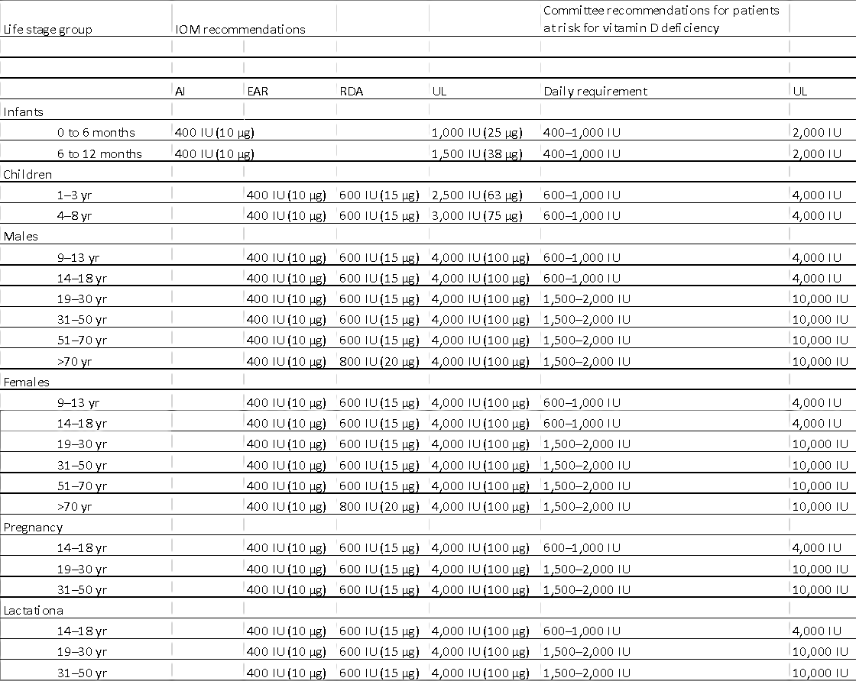

AI, adequate intake; EAR, estimated average requirement; RDA, recommended dietary intake; UL, tolerable upper intake level. Mother's requirement, 4,000–6,000 IU/d (mother's intake for infant's requirement if infant is not receiving 400 IU/d). Table adopted from Holick et al., 2011.

According to the guidelines from both Health Canada and the NIH Office of Dietary Supplements, the recommended intakes for both males and females should be as follows: 400 IU/day (5μg/day) for the age range of 0-50 years, 600 IU/day (10μg/day) for ages 51-70, and 800 IU/day (15μg/day) for those over 70 years of age. The tolerable UL is ranging between 2500-4000 IU/day for all age groups, except for infants up to 1-year-old who are suggested to have an intake under 1000 IU/day (25μg/day) (Health Canada, 2013).

The European Food Safety Authority (EFSA) recommends a slightly lower intake of 600 IU/day for all age groups with an upper level of 4000 IU/day (EFSA 2016). Recommendations for vitamin D intakes for people at risk of developing VDD are in the range between 2000-10000 IU/day depending on the age group (Table 2).

In conclusion, various countries and professional societies worldwide have provided slightly different guidelines for vitamin D intakes. These discrepancies are a consequence of an incomplete understanding of vitamin D biology and clinical manifestations of this important vitamin (Bouillon et al., 2017), which entails additional investigation.

* + 1. Methods used to assess vitamin D intake
       1. Food frequency questionnaire

In a typical food frequency questionnaire (FFQ), there is a list of questions about the frequency of food intake over a specific period and, sometimes, about portion sizes of the consumed foods. Even though the portion size data add more precision to a dietary intake assessment, it has been shown that they give limited information on food variance, so it seems that it is appropriate to assign standard portion sizes to intake frequencies (Keyzer, 2014).

In the food frequency approach, the respondents need to report how often they consume each type of food from a list of foods provided, over a specified period. The focus is on the frequency of consumption, but not so much on other factors, such as cooking methods, or food combinations in a particular meal. In many FFQs, there are questions about portion sizes or the portion size is already indicated. To get an estimate of the entire nutritional intake, one needs to calculate an overall food intake, report the frequency of products for each food by the amount of nutrient in a specified (or assumed) portion of that food, to get an estimation of daily intake of nutrients, dietary ingredients, and food groups. Typically, FFQs are performed to get a rough estimate of total intakes over a specified period (Thompson and Subar, 2017). In general, there are three types of FFQs: 1) qualitative, 2) semi-quantitative, and 3) quantitative.

Quantitative FFQs have been used frequently to assess long-term dietary intake of certain foods of interest, i.e., foods that are known to act as contributing factors to the development of certain cancers and CVDs (Jackson et al., 2011). As it measures dietary intake over a longer period of time, the use of FFQs is recognized typically as an appropriate tool for assessing the quality of diets in studies involving epidemiological and chronic diseases (José et al., 2008; Weikert et al., 2005)**.** Moreover, FFQs are known to be relatively inexpensive, easy and quick to administer, in comparison to other known dietary intake assessment tools (Cade et al., 2002). As widely used dietary assessment tools, FFQs need to be validated further in order to ensure the accuracy of the data captured. Three reference methods have been suggested, which include weighed food records, 24 h dietary recalls (24HDRs), food diaries, and blood biomarkers (Djekic-Ivankovic et al., 2016). Predominantly, FFQs must be validated among a specific population group while taking into consideration their country of origin, sex, age, list of food items eaten, aiming to capture the common respondent's eating habits (Misra et al., 2006).

For each quantitative FFQ, there must be a database that allows the evaluation of nutrient intakes for a presumed or reported portion size for each examined food. For example, there are many different recipes for macaroni and cheese FFQ items, but in the database, there needs to be only one nutrient composition profile for it. There are numerous ways to build such a database. One is to use pieces of information on the quantitative dietary intake from a target population to state the representative nutrient density of a specific food group category. For example, for macaroni and cheese food groups, a mean or median nutrient composition (by portion size, if needed) can be estimated from all individual food codes reported in a population survey. Likewise, values could be calculated by gender and age. Then nutrient intakes for individual respondents can be calculated by using dietary analysis software (Zekovic et al., 2017)**.** The amounts of food consumed by individuals are significant in estimating dietary intakes, but it is still uncertain if they should be included in FFQs. It has been shown that the variance in intake of most foods depends more on the frequency of consumption than on the serving sizes, so that is why many people prefer not to include reporting serving sizes in FFQs. Others believe that FFQ performance is slightly improved if respondents report on the usual serving size for each food item consumed (Thompson and Subar, 2017).

Some FFQs combine portion size and frequency estimations into one question by asking respondents how often they consume specific servings of food. The information about the portion size on FFQs, could be beneficial, depending on the study objective and the population

characteristics. Additional issue regarding FFQ design is an investigation of the time frame of the food intake (Zaleha et al., 2015). Many instruments consider the usual intakes during the previous year; however, it is possible to assess the intakes from the past month or week, depending on a specific research situation. Even when the previous year’s intake is evaluated, some studies have shown that the season during which the questionnaire is administered affects the reporting during the entire year. The advantage of FFQs is that they are not expensive to administer, and the process is such that respondents are asked about their typical intake of foods over an extended period.

Unlike other instruments, FFQs record recent changes in a diet (e.g., because of a disease state) and avoid asking respondents to recall their diet for long-standing periods. Thus, retroactive reports about food regimes almost always use the food frequency approach, and the responses are used to rank individuals based on their typical consumption of nutrients, foods, or food groups. Almost all FFQ instruments could be self-administered; it takes 30-60 min to be completed, depending on the respondent and the instrument and the questionnaires are either optically scanned paper versions or automated, to enable electronic administration to minimize the costs of data collection, processing, and the respondent burden for multiple diet records or recalls. Owing to these benefits, FFQs are often used by epidemiologists studying associations between dietary habits and a particular disease (Zaleha et al., 2015; Thompson and Subar, 2017).

Unfortunately, a substantial disadvantage of FFQs is that several measurement errors exist in the reports, many details of a dietary intake are unmeasured, and the quantification of intake is not as precise as with long-term recalls or records. This happens because the listing of all possible foods turns out to be incomplete, and also, errors in frequency and usual portion size estimations occur. Additionally, the estimation tasks required for FFQ are complex and challenging, which is why the scale for 13 nutrient intake estimates from an FFQ might shift considerably, resulting in inaccurate estimates of the average intake for a group (Feskanich et al., 1993). According to a recent report, longer food frequency lists might result in overestimation, whereas shorter lists might underestimate the intake of fruits and vegetables (Thompson and Subar 2017). Hence, there is a need to establish a defined time frame in order to get the most accurate estimation of a dietary intake.

* + - 1. 24 h dietary recall

In the 24HDR, the respondent is asked to remember and report all the foods and beverages consumed in the last 24 hours. The recall is typically led via an interview, in person, or by telephone, employing either a computer-assisted device or using a paper-and-pencil form, even though self- administered electronic implementation has lately become possible (Foster et al., 2019)**.** With the interviewer-administered ones, it is crucial to have well-trained interviewers because dietary information is mainly obtained by asking probing questions. Preferably, interviewers should be dietitians with education in food and nutrition; but, non-nutritionists who have training in the use of a standardized instrument could also be effective. All interviewers are required to be knowledgeable about foods offered in the marketplace and about food preparation and processing practices, including prevailing regional or ethnic food compliances (Subar et al., 2012; Thompson and Subar 2017).

A 24HDR is an open-ended interview; thus, it is the type of dietary intake assessment method that requires standardization of the interview approach in order to obtain all relevant information (Keyzer, 2014). In an interview, there are usually specific probe questions to help respondents remember all food items they consumed throughout the day. The interviewer-probing respondents’ approach was reported to lead to a 25% higher reported dietary intake than a non-probing interview.

The ‘probing’ technique is particularly useful in collecting essential details such as information on how foods are prepared, and in the recovery of many questionnaire items like the intake of common food additives not reported initially, and consumption of food additions (e.g., butter, peanut butter or jam on toast, beverages, fruits, and snacks) that were not originally reported. It is advised

that all recall interviews are done in the respondent`s home because the respondent is more encouraged to participate and recalls the food consumed better if he/she is in a familiar setting; also, it is more accessible for the interviewer to calibrate the recalled food items with household utensils. In the end, the success of the 24HDR depends on the subject's memory, how accurately the subject can estimate portion sizes consumed, how much the respondent is motivated, and the persistence of the interviewer. Certain typical food intake items that are usually forgotten, and hence, not reported are snacks and beverages (Thompson and Subar, 2017). Therefore, it is critical for interviewers to provide standardized, unbiased probing questions to avoid leading the respondent to certain answers if the respondent could not remember or does not know the answer, but to motivate the respondent to recall all the foods and beverages consumed (Foster et al., 2019).

For a probing interview, a four-stage, multiple-pass, interviewing procedure is often used. Initially, a complete list of all foods and beverages consumed during the previous day is collected. In the second pass, a comprehensive description of each food and beverage consumed, together with preparation methods and brand names (if possible), is made. Uniform probing questions are used to elicit more specific details for each food item. For example, for milk products, probe questions may include the kind of dairy product, brand name (where necessary), and a percentage fat (as butterfat or milk fat) (Shiundu et al., 2006)**.** In the third pass, estimates on the quantity of each food and beverage item consumed are collected, usually in household measures, and entered in the data spreadsheet or computer-based data-entry form. Photographs, a set of measuring cups, spoons, and rulers, local household utensils (calibrated types for use), or food reproductions of various types could be used as a memory aid or to assist the respondent in evaluating portion sizes of consumed food items. Similarly, information on the ingredients within the mixed dishes is collected at this time. Finally, in the fourth pass, the recall is reviewed to ensure that all items, including the intake of vitamin and mineral supplements, have been documented appropriately (Shiundu et al., 2006)**.**

Nowadays, most developed countries utilize available computerized data collection software systems for direct coding of most foods recorded during the interview. This is highly efficient when it comes to standardizing interviews, dealing with dietary data, and minimizing the number of missing data. If a direct coding of an interview is done, there are available methods the interviewer could use to enter these foods not found in the system but interviewer training and quality control procedures should be done to reinforce these methods (Subar et al., 2012). Automated self- administered data collection systems are another technological improvement in the 24HDR methodology. These systems differ when it comes to the number of foods in their respective databases; the approach to ask about portion size, the inclusion of inquiries regarding details of foods consumed, and probable add-ons. With the web-based Automated Self-Administered 24HDR established at the National Cancer Institute, respondents can complete a dietary recall with the assistance of multimedia visual prompts, cues, and animated characters, which is different from standard methods where a trained interviewer is needed. The system uses the most current United States Department of Agriculture (USDA) survey database and includes several elements of the AM/PM 24-hour interview created by USDA and it is currently used in the National Health and Nutrition Examination Survey (NHANES). Portion sizes are assessed using digital photographs with up to eight different sizes for each food item (Subar et al., 2012; Thompson and Subar, 2017).

24HDR interviews can be done with children who are 8 years old and with the majority of adults, except for persons with poor memories (e.g., some disabilities or an elderly with memory loss). Children who are 4-8 years old should be interviewed in the presence of their primary caretaker, usually the mother. It might be necessary to interview several people to obtain adequate information if the children are not at home full day; they might be at school or play outside their own homes where they might eat, so all the foods eaten away from home must be reported. For this younger age group, inquiries should always be directed to the parent or a caretaker. Very often, family members help the respondent to remember the amounts of food consumed, which is called a consensus recall. This consensus approach often improves the precision of dietary recalls (Osadchiy et al., 2020).

The 24HDR has many advantages: 1) For instance, for the probing interview, it is not necessary for the respondent to be literate if an interviewer administers the tool and records the responses. However, for self-administered versions, there could be a problem if the respondent is not literate.

2) Since the recall period is immediate, respondents are generally able to remember most of their dietary intake. 3) Since there is a rather little burden on the respondents, those who agree to give 24HDRs are more likely to represent the population than those who agree to keep food records, making this method useful with a wide range of populations. 4) Interviewers can be trained to record specific details so that new foods reported could be researched later by the coding staff and coded appropriately. 5) Unlike the recorded methods, dietary recalls occur after the food has been consumed, so it is less likely that the assessment method will affect dietary behavior. The main disadvantages of the 24HDR approach is that individuals might not report their food consumption correctly for many different reasons related to knowledge, memory, and the interview situation, and the risk that the participant might be influenced by the interviewer to give socially desirable answers (Thompson and Subar, 2017).

* + 1. Classification of vitamin D status

An individual’s vitamin D status is best evaluated through the measurement of concentrations of the circulating 25(OH)D (Holick et al., 2011)**.** There is a general agreement that VDD should be defined by serum 25(OH)D levels of < 10 ng/mL, and insufficiency at levels ranging from 10-30 ng/ml. Preferably, the recommended level of serum 25(OH)D is > 30 ng/mL, whereas an UL of > 100 ng/mL is considered as vitamin D toxicity. However, slightly different guidelines have also been proposed, the normal blood vitamin D concentration as 30-100 ng/ml; an individual with < 20 ng/ml is considered vitamin D deficient, 20-29 ng/ml, insufficiency, whereas a constant level of 25(OH)D > 200 ng/ml is an indication of vitamin D toxicity (Alshahrani and Aljohani, 2013)**.** Nonetheless, most agree that a 25(OH)D concentration < 50 nmol/L (20 ng/mL) is a sign of VDD, while 51-74 nmol/L (21-29 ng/mL) shows insufficiency, and 75 nmol/L (30 ng/mL) is considered sufficient (Holick and Chen, 2008). Existing data, obtained through studies on bone mineral density, lower extremity function, fracture cancer prevention, propose a target serum level of 75 nmol/L (30 ng/mL) 25(OH)D (Christakos et al., 2016; Holick et al., 2011). The rationale for these different opinions on 25(OH)D sufficiency or deficiency was based largely on the effects of vitamin D on bone health, muscle functions and mineral homeostasis (Christakos et al., 2016)**.** Correspondingly, the factors affecting the vitamin D status and the evidence associating vitamin D levels with the non-skeletal disease have been considered. A suggestion for setting the threshold values specifically for age groups was also put forward. Besides the defined recommendations of vitamin D sufficiency, and vitamin D status are still controversial. The different cut-off values of 25(OH)D deficiency and sufficiency are presented in Table 3.

**Table 3.** Vitamin D deficiency cut-off thresholds proposed by various international authorities.

|  |  |  |
| --- | --- | --- |
| **Authority** | **Country** | **Deficiency cut-off threshold (nmol/L)** |
| IOM 2011 report | USA and Canada | < 30 |
| Scientific Advisory Committee on Nutrition 2016 report | UK | < 25 |
| Nordic Nutritional Recommendations 2012 report | Nordic countries | < 25 |
| EFSA | EU | < 30 |
| Scientific Advisory Committee on Nutrition | UK | < 25 |
| European Society for Paediatric Gastroenterology, Hepatology. | EU | < 25 |
| The Society for Adolescent  Health and Medicine | USA | < 50 |
| Endocrine Society | Worldwide | < 50 |

Table created based on data provided by: Smith, 2018 and Laird, 2020.

In this research project, Vitamin D status was analyzed according to the cut-off values proposed by the IOM inadequate: 25(OH)D level between 30 and 50 nmol/L; sufficient: 25(OH)D level > 50 nmol/L (Manson et al. 2011)**.**

* + - 1. Measurement of serum 25(OH)D concentration

To determine vitamin D status, the laboratory test for serum 25(OH)D concentration is used, because most circulating vitamin D is in the form of 25(OH)D with a half-life of ~ 2-3 weeks (Holick, 2009), and thus, it gives an accurate picture of the vitamin D measurements (Kennel et al., 2010). It is considered as a reasonable method to identify people with vitamin D toxicity, even though toxicity is rarely reported to occur. Vitamin D toxicity generally arises by taking excess supplements and in hypercalcemia conditions with symptoms of intensified thirst and urination, belly and bone pain, muscle weakness, confusion, and fatigue. Periodic examination of serum calcium levels among individuals who receive large doses of vitamin D as therapy is suggested.

There are several different methods available for measuring 25(OH)D, including competitive protein binding assay (Belsey et al., 1974), high-performance liquid chromatography (HPLC), radioimmunoassay (Hollis and Napoli, 1985), enzyme-linked immunoassay (ELISA) (Lind et al. 1997) and the most recently developed assays based on the liquid chromatography-tandem mass spectrometry (LC-MS/MS) (Maunsell et al. 2005)**.**

Moreover, in 2015, the Endocrine Society issued clinical practice guidelines by which only those who represent risk groups for VDD are recommended for screening (Holick et al., 2011). People with the following lifestyle practices, ethnicity or age, are at risk of suffering from VDD: malnourished, individuals with a sedentary lifestyle, obese, dark skin, limited sun exposure, and the age ≥ 65 (IOM, 2010). Additionally, conditions causing gastrointestinal malabsorption, including short bowel syndrome, amyloidosis, pancreatitis, liver disease, nephrotic syndrome, inflammatory bowel disease, bariatric surgery, celiac sprue, renal insufficiency, and cystic fibrosis. Further,

individuals on medications that modify vitamin D metabolism, such as anticonvulsants and glucocorticoids are believed to be at risk of acquiring VDD (Grober and Kisters, 2012).

* + - 1. Vitamin D deficiency

The VDD is a global epidemic with recent estimations signifying that > 50 % of the worldwide population is at risk. A high prevalence of VDD exists across all age groups in all populations studied in countries around the globe and the estimate is that one billion people worldwide suffer from either vitamin D insufficiency or deficiency (Brett et al., 2018; Nabeta et al., 2015)**.** This can occur when the usual daily vitamin D intake is lower than the daily recommended level, when exposure to sunlight is limited, when the kidneys cannot convert 25(OH)D to its active form or when there is a kidney malfunction resulting in increased excretion or inadequate vitamin D absorption from the digestive tract due to impairment. Typically, vitamin D insufficiency or deficiency is the result of dietary inadequacy and/or lack of sunlight exposure. If an adult is exposed to 1 MED of UV irradiation, a slight pinkness of the skin was observed 24 hours later, with an amount of exposure producing almost 10,000-25,000 IU vitamin D. On the contrary, in the absence of sunlight exposure, a minimum of 1000-2000 IU/day is required for children and adults to maintain a 30 ng/ml vitamin D in circulation (Holick et al., 2011).

There have been several questions arising regarding VDD, even among the Near East Countries such as Libya and other North African countries, despite both having enough sunlight for exposure. There are several reports from the Near East and North Africa (NENA) region that demonstrate the high prevalence of micronutrient deficiencies and inadequacies, including vitamin D, predominantly in children and women of childbearing age **(**Hwalla et al., 2017; World Health Organization, 2011) The key challenges in the identification of population nutritional status and micronutrient deficiency in the region are the absence of regular monitoring and evaluation practices. High levels of VDD in children of the following regions have been reported– Qatar: 76%, Iranian school-aged children: 76%, Saudi girls: 81%, Saudi women: 85%, Bahrain: 90%. The highest VDD was reported among the Bahrain population, followed by Saudi women (FAO, 2016). In an observational study by Chaktoura and coworkers (Chakhtoura et al., 2018) on the prevalence and risk factors for hypovitaminosis D in the Middle East and North Africa (MENA), the authors found that noteworthy predictors of low serum 25(OH)D levels were: gender, older age, and body mass index (BMI), full- body covering, winter season, sunscreen usage, lower socioeconomic status, higher latitude, and concluded that nutritional rickets which is still prevalent in these regions are attributable to “peculiar lifestyle.” However, population-based studies in the MENA region to deduce specific statistics are still lacking. Another parallel study found that VDD is common across Africa and the Middle East (Green et al., 2015). Further, in Nigeria, 83% of Fulani women were reported to experience VDD, while in the United Arab Emirates, in a study that reported VDD prevalence of 50% in pregnant women (Muhairi et al., 2013). Another study in Saudi Arabia found that 59% of healthy 4-15-year- old schoolchildren are deficient and 28% insufficient in vitamin D (Green et al., 2015). Further, another study performed among individuals in Africa and the Middle East also revealed alarming results, Vitamin D insufficiency and deficiency were seen in 30 – 90% of participants, with rickets and osteomalacia still occurring in the province (Bassil et al., 2013). The exposure of African and Middle Eastern residents to sunlight could be much higher than in some other regions experiencing mostly cold weather, and still, Nigeria reported that 83% of its Fulani women are deficient (Glew et al., 2010). On the other hand, a study in the United Arab Emirates revealed that 50% of pregnant women were vitamin D deficient (Dawodu et al., 2001)**.** The reason for VDD prevalence in these regions might, in part, be attributable to the full clothing covering of their bodies at all times, which is a requirement by their culture.

Finally, the study demonstrated that the occurrence of VDD in Libya is linked to the high incidence of rickets among infants, due to cultural habits primed by severe limitations of sunlight exposure by pregnant and nursing women and their infants (Markestad and Elzouki, 1991). A few

recent studies on vitamin D status have been performed among Libyans. In 2017, Omar et al. (2017) examined the status of vitamin D and the contributing factors among patients at outpatient clinics in Benghazi Libya, using a cross-sectional study with a stratified random sampling method. The authors found that VDD is common among the females in the older age group of the residents, an observation that calls for community-based intervention and prevention strategies. As VDD prevails over the years, more and more studies have been conducted to assess and evaluate the possible causes and factors that contribute to its occurrence. In another study by Omar's group (Omar et al., 2018) performed in Libya, the authors aimed to identify associations of exposure to the sun with cultural influences on vitamin D status. Data on participants’ attitudes and behaviors relative to sun exposure, cultural, and skin tone preference were collected using interviews and questionnaires. It was discovered that parameters measured such as the duration of sun exposure, wearing long sleeves, the belief that lighter skin is more attractive than darker skin, use of sunblock or sunscreen, and feeling of unhappiness if the sun made the skin darker, were all significantly different among the different serum vitamin D level groups, and the predicted lower vitamin D level group. Accordingly, it was concluded that culture, attitudes, and sun exposure behaviors are factors that contribute significantly to the observed high prevalence of VDD in the population. Further, circulating concentrations of 25(OH)D were substantially lower in subjects with lower sun exposure and those exhibiting negative attitudes towards sunlight. It has been suggested that more accurate measurements of cultural, behavioral practices, and knowledge related to sun exposure are needed to confirm these findings.

The majority of Libyan women wear traditional attire and have an indoor lifestyle, or avoid sun exposure due to cultural customs, thus their vitamin D status depends greatly on their dietary habits. However, the dietary intake of vitamin D may not be adequate to meet the requirements. Currently, very limited data is available on the dietary intake of vitamin D in the Libyan population. The key obstacles in the identification of population nutritional status in this region are the lack of appropriate dietary assessment tools that could be used for monitoring practices and evaluation of vitamin D intake. Currently, there is no validated FFQ for the assessment of vitamin D intake in the Libyan population. The absence of harmonized data for evidence-based policymaking hinders the implementation of new policies and approaches for addressing the nutritional VDD problem in this region (Bassil et al., 2013, Omar et al., 2018).

Furthermore, as Libya became a country of conflicts and unrest, many Libyan civilians have been forced to seek refuge, mostly in European countries. Migrants are faced with numerous health challenges associated with stress, changes in lifestyle, climate, cultural and physical environment (Lassetter et al., 2008), so it would be beneficial to determine the way intake and status of vitamin D of migrants is affected.

Andersson et al. (2013) conducted a study on vitamin D intake and status in immigrant and native Swedish women. The study included 31 females from the Middle East, Africa, and 30 from Sweden, measuring vitamin D intake with the use of a modified FFQ. Their results revealed that VDD (plasma 25(OH)D < 25 nmol/L) was prevalent among immigrant women. Only one immigrant and a half (15/30) of the Swedish women in the study population had optimal levels (plasma 25(OH)D > 50 nmol/L). There was a direct positive link between the plasma 25(OH)D levels and intake of vitamin D from food. Only three women, all Swedish, had the recommended intake of vitamin D from the food. Overall, the immigrant women had a lower intake, compared to Swedish women. The foods that contributed most to vitamin D intake were fortified milk, fatty fish, and margarine. Immigrant women consumed lower amounts of fortified milk and margarine but higher amounts of meat. Irrespective of origin, patients with plasma 25(OH)D < 25 nmol/L consumed less margarine but more meat. The conclusion made from the study was that VDD was common among the immigrant patients due to the lower intake of vitamin D. This highlights the need to mark information about vitamin D to immigrant women in order to decrease the risk of developing VDD (Bassil et al., 2013).

Likewise, an evaluation of Vitamin D status, dietary intake, and its associations with metabolic health were performed in a national sample size representation of 980 Austrians using data from the Austrian Study on Nutritional Status 2012 (Elmadfa et al., 2018). Participants dietary intake was assessed by 24HDR in adults and elderly and a 3-day food record in children; plasma 25(OH)D concentrations were determined, anthropometric data of the participants, as well as plasma lipid profile fasting glucose, and HbA1c by standard procedures (Chowdhury and Chakraborty, 2017; Sollid et al., 2014)**.** Their findings revealed that insufficient 25(OH)D levels were found in 59% of the children and 64% of the elderly, while no significant differences were observed between the sexes. The season had a strong effect; better vitamin D status was obtained during summer and early autumn, which underlines the importance of endogenous synthesis. Median dietary vitamin D intake was below the recommended daily value but correlated weakly with plasma status. In children and the elderly, plasma 25(OH)D showed weak inverse correlations with BMI and some metabolic health markers. The results showed that vitamin D is a potentially critical nutrient in children and the elderly (Elmadfa et al., 2018)**.**

* + 1. Causes of vitamin D deficiency

The most common reasons for VDD in people are: insufficient exposure to sunlight, extensive use of sunscreen products, and being associated certain cultural, especially dress habits together with inadequate dietary intake of vitamin D. The following figure is showing factors that could cause VDD and the likely consequences of inadequate dietary intake and status of this important nutrient (Figure 4).

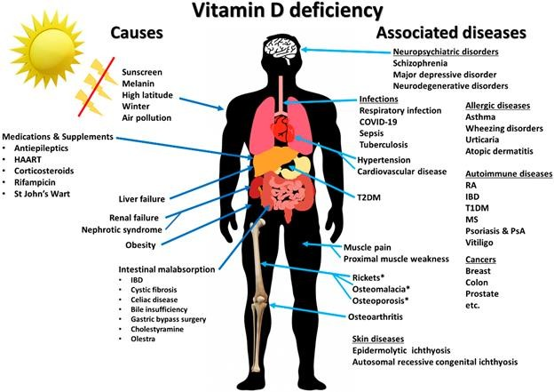

Figure 4. Causes and consequences of vitamin D deficiency (Figure adopted from Charoenngam and Holick, 2020)

Cultural factors such as clothing style, long sleeves, veils, type of residence, indoor activities, and lack of physical activity are all seen as risk factors for developing VDD (Bahijri, 2001; Laleye et al., 2016)**.** Cultural practices and norms are the most common reasons why Middle Eastern women keep their whole body covered (Hammoud et al., 2005; Mahmoud et al., 2017). Due to these norms and practices, individuals in countries including India, Australia, Brazil, and the Middle East have a high incidence of VDD (Bassil et al., 2013; Maalouf et al., 2009)**.** Certain norms and cultural practices might contribute to limited sun exposure, especially among women (Maalouf et al., 2009). Furthermore, an underlying perception of skin coloration and its connection with certain views about beauty is also an additional factor that contributes to the desire to keep the skin light-colored. When examining the opinions on beauty among Indonesians, research shows that this perception is built transnationally due to the transfer across national boundaries. In other Asian countries, including the Middle East, skin whitening beauty products are advertised and promoted. According to a study on VDD among Arab Muslim women living in Denmark, most native Arab Muslim women, regardless of whether veiled or unveiled avoid sunlight exposure and wear modest clothing when they go outside (Glerup et al., 2000a).

* + - 1. Malabsorption and vitamin D deficiency

In 2017, Kerr and Jacquelyn (Michael Kerr and Jacquelyn, 2007) stated that the small intestine plays a central role in absorbing nutrients from food and their transport into the bloodstream. Malabsorption happens when the small intestine could not absorb enough nutrients and fluids or

both. Factors that might trigger malabsorption include the following: damage of the intestine due to an infection, inflammation, trauma or surgery, and prolonged use of antibiotics. Furthermore, certain health conditions cause malabsorption, including celiac disease, Crohn’s disease, cystic fibrosis, and chronic pancreatitis. Moreover, individuals with lactase deficiency or lactose intolerance, as well as people with specific congenital or congenital disabilities such as biliary atresia, liver disease, and short bowel disorder, experience malabsorption. Further, malabsorption might be present in people with the parasitic disease, in those who undergo radiation therapy, those who have diseases of the gallbladder, pancreas, and as a result of intestinal surgeries. Malabsorption associated with VDD could be managed with reasonable and practical treatment using calciferol intermittently (Alyaarubi and Rodd, 2005; Nwosu and Maranda, 2015). Finally, it is believed that the rates of VDD are higher amongst people with celiac disease, exocrine pancreatic insufficiency, inflammatory bowel disease, short bowel syndrome, and cystic fibrosis, conditions know to produce problems with malabsorption (Eileen and Geier, 2020)**.**

* + - 1. Association between age and vitamin D deficiency

Elderly people have a higher possibility of having VDD as a result of several reasons, including reduced sunlight exposure due to minimal outings, low vitamin D food intake, decreased absorption of vitamin D from sunlight due to decreased skin thickness (Janssen et al., 2002)**.** Gallagher et al. (2013) demonstrated that aging affects the intestinal concentration of VDR and causes a reduction in calcium absorption. Another study conducted on a small group of older people > 65 years old on vitamin D and aging displayed a decrease in intestinal VDR concentration with age but no change in serum 1,25(OH)2D. In a comparable study performed on women 65 years old, with 10 respondents

> 75 years old, it was observed that there were no variances in intestinal VDR concentration, compared with 59 younger women aged < 35 years old (Gallaher et al., 2012).

An additional age-related factor that can cause VDD is a perturbation in renal function. As previously reported (Gallagher et al., 2013), renal function declines with age, with the resultant decrease in the activity of the renal enzyme 1α hydroxylase that translates 25(OH)D into 1,25(OH)2D. Besides, serum 1,25(OH)2D levels are contrariwise related to serum creatinine and glomerular function rate (GFR), and a GFR of 50 mL/min is a level that affects 1,25(OH)2D production. Unfortunately, many people > 80 years have GFR < 50 mL/min, which, in turn, results in diminished creation of 1,25(OH)2D. To examine the effect of age and GFR on the 25(OH)D– 1,25(OH)2D axis, biological active intact PTH was infused for 24 hours in women of different ages. The results showed that an increase in serum 1,25(OH)2D was ~ 50% lower in the older participants, demonstrating decreased renal receptiveness of PTH with age. Measurements of serum 1,25(OH)2D in the elderly showed a clinical impact of reduced renal production of the hormone. Similarly, in a study of women participants aged 80-95 years, residing in nursing homes who had normal serum 25(OH)D levels, the serum 1,25(OH)2D levels were much lower than in women 65-75 years of age (Gallagher, 2013). To sum up, there is an age-related reduction in calcium absorption that is, in part, dependent on reduced efficiency of serum 1,25(OH)2D levels, resulting from an age-related deterioration in renal function.

All age-related changes in vitamin D metabolism are exaggerated with concomitant VDD, as deficiency limits the 25(OH)D substrate supply and, eventually, 1,25(OH)2D. Substrate 25(OH)D deficiency is a common problem in the elderly and it is vital for the condition to be recognized, as it is preventable and treatable. VDD could arise either from inadequate dietary intake or from lack of sunlight, causing a decrease in serum 25(OH)D, which further limits 1,25(OH)2D production, especially in the presence of renal dysfunction. Serum 1,25(OH)2D levels decrease when the 25(OH)D level falls under 10 ng/mL in both younger and older people (Gallagher, 2013).

* + - 1. Association between anthropometric parameters and vitamin D deficiency

According to a study by Santos et al. (2015) individuals who are considered as overweight or obese according to their BMI are at the highest risk of developing VDD (Pereira-Santos et al., 2015). Although the association is not well understood, experts have suggested that poor dietary habits and lack of sunlight exposure might be contributory factors.

Additionally, obesity is associated with the disruption in the function of the vitamin D- endocrine system (Wallingford, 2009). The investigation proved that the morbidly obese stage with high BMI ranging from 44-79 or bigger waist circumference (WC) and the enlarged number of skin folds are directly linked to reduced 25(OH)D levels. Also, total body fat is inversely associated with serum 25(OH)D levels. Moreover, increases in PTH and 1,25(OH)2D are seen among obese individuals, additionally proving the evidence that measurements of body fat content are important determinants of vitamin D levels. It is also believed that an individual with a high BMI has greater pools of fat deposits and a higher quantity of chylomicrons carrying dietary vitamin D around the body. Furthermore, an obese individual has a greater ability for sequestration of fat-soluble vitamin D in adipose tissues and is likely to have reduced sun exposure due to restricted mobility and heavy clothing coverage. Lastly, it is considered that obese individuals have boosted production of 1,25(OH)2D and increased PTH levels than normal-weight adults, as well as lower blood peak concentration of vitamin D2 which acts indirectly to reduce 25(OH)D synthesis from provitamin D in the liver (Divasta et al., 2011). Accordingly, the authors hypothesized that the metabolic clearance of vitamin D increased in obesity because of improved uptake by adipose tissue, resulting in vitamin D insufficiency. Hence, this relationship between serum vitamin D concentrations and adiposity has been supported by other investigations (Divasta et al., 2011)**.**

* + - 1. Prevention and treatment of vitamin D deficiency

The first step in the prevention of VDD is the identification of risk groups and screening of those individuals for serum 25(OH)D levels, utilizing the most precise methods available. Different recommendations were given by the IOM and the Endocrine Practice Guidelines Committee concerning different age groups, as published at the US Preventive Services Task Force website (Yawn, 2016).

According to the American Association of Clinical Endocrinologists, to keep the required concentration of serum 25(OH)D, it is necessary to supply the body with an average daily dose of 800 IU/day of vitamin D3. Certain ethical groups and elderly people are required to take higher amounts of this vitamin. Besides, people with specific conditions such as obesity or malabsorption, and transplant patients require higher doses of vitamin D3 (Cesareo et al., 2018).

VDD cannot be rectified solely by a higher intake of this vitamin via food. It is necessary to take vitamin D supplements, especially vitamin D2 or D3 (Bandeira et al., 2006). The Endocrine Society Clinical Practice Guidelines have created a plan for the treatment of VDD relative to specific age groups and individuals’ medical conditions. They propose that ages between newborns to toddlers should have a daily intake of 400-1000 IU or a weekly intake of 5,000 IU in 6 weeks to reach serum 25(OH)D concentration >30 ng/ml (Bordelon et al., 2009). Besides, they should continue with a maintenance treatment of 400-1,000 IU/day. Children aged 1 to 18 years should take the daily intake of 600-1000 IU in a minimum period of 6 weeks or a weekly intake of 50.000 IU for 6 weeks in order to reach serum 25(OH)D concentration > 30 ng/ml, and should continue the maintenance treatment of 600-1.000 IU/ day (Holick et al., 2011). Furthermore, adults should have a daily intake between 1500-10000 IU or a weekly intake of 50,000 IU for 8 weeks in order to reach serum 25(OH)D concentration >30 ng/ml, and should continue with the maintenance treatment of 1.500-

2.000 IU per day.

People with certain disorders of the gastrointestinal tract (i.e., acute and chronic pancreatitis, inflammatory bowel disease) require a higher daily intake of vitamin D due to reduced gastrointestinal surface area for absorption of vitamin D. Much higher doses of supplemental vitamin D are recommended for this group of patients, 50,000 IU vitamin D every other day until normalization and a maintenance dose of 20.000 - 40.000 IU vitamin D3/week (D metabolism, 2016).

A combination of insufficient dietary intake of vitamin D and lack of skin exposure to sunlight is likely to result in VDD. Accordingly, Holick and coworkers (Holick et al. 2011) proposed two protocols for rectifying VDD. Patients are required to have a weekly intake of 50.000 IU for 8 weeks, and then carry on with a maintenance dose of 50.000 IU, prorated every 2 weeks. Following 2-3 months of the therapy, the serum concentration of 25(OH)D should be checked and provided that the concentration is > 30 ng/mL; the patients should keep taking the dosage for maintenance treatment.

Following the completion of this lapse period, serum 25(OH)D levels should be checked and provided that the concentration is > 30 ng/mL, patients should keep taking the maintenance dose of monthly intake of the recommended daily intake of vitamin D3. During this therapy, it is necessary to monitor serum PTH concentration to make sure its level has not increased, because it is common for concurrent primary hyperparathyroidism to accompany VDD. The replacement should be repeated in cases of persistent deficiency, where the concentration of 25(OH)D is < 30 ng/mL after completion of the treatment period of 10 - 12 weeks (Iraj et al. 2012).

* + - 1. Effects of vitamin D deficiency on health

Insufficient vitamin D intake primarily causes the bone to become brittle, thin and/or deformed. Vitamin D insufficiency is a risk factor for developing bone abnormalities like rickets in children and osteomalacia in adults (IOM, 2010). Moreover, the effect of VDD on muscle tissue is known to cause muscle weakness (Holick, 2006; Holick and Chen, 2008), and it is supported by the fact that VDR and DBP expression have been detected in smooth muscle tissues (Boland, 1986). Also, a Korean cross-sectional study completed on 2258 men and 3005 women aged 50 years and older disclosed that sarcopenia (loss of muscle mass and its function) had a strong reverse relation with serum 25(OH)D levels in women but not in men (Sunmin et al., 2014). Additionally, vitamin D was significantly associated with muscle performance and force in adolescent girls (Ward et al., 2009). Furthermore, in Denmark, a study on veiled Arab women with osteomalacia myopathy demonstrated that muscle strength returned to normal after six months of vitamin D treatment (Glerup et al., 2000b) and a positive correlation has been observed between serum 25(OH)D levels and skeletal muscle mass in men (Wang et al., 2017).

In the human genome, vitamin D regulates over 1000 genes, and gene polymorphisms, as well as epigenetics, impacts their mechanisms of action, suggesting that transcriptomics, metabolomics, and epigenetics studies of vitamin D status and supplementation are promising in gaining insights into critical disease outcomes (Moraes et al., 2015). It is known that a high dose of oral vitamin D3 improved even mortality in patients who demonstrated severe VDD along with their conditions (Prasad et al., 2015).

* + 1. Vitamin D and cardiovascular diseases

Vitamin D has gained attention as it is considered to play a vital role in the health of the cardiovascular system. Several studies have found that VDD is related to an increased risk of CVD in a person. In a review by Judd and Tangpricha (2009), VDD was examined as a cardiovascular risk factor and potential mechanisms for the cardioprotective effect of vitamin D were explored. The study concluded that vitamin D showed potential in the prevention and/or treatment of CVDs.

Vitamin D participates in numerous physiological and pathological processes. Most of the tissues within the human body have VDRs and vitamin D is an important regulator of gene expression (Gouni-Berthold et al., 2009). The presence of VDRs and vitamin D metabolizing enzymes in the heart and blood vessels proposes that vitamin D has a role in the cardiovascular system (Pilz et al., 2011). VDD has been associated with many chronic diseases, such as CVD, which is the principal cause of death in both women and men. Observational studies and epidemiologic evidence reveal a relation between VDD and CVDs (Temmerman, 2011).

Gouni-Berthold et al. (2009) mentioned that CVDs are the leading cause of morbidity and mortality globally. VDD has been recognized as a potential risk factor for many diseases rarely associated with vitamin D, such as cancers and CVDs (Pilz et al., 2011).

According to the World Health Organization (WHO), CVDs remain the number one cause of death globally. In 2016 alone, it is estimated that 17.9 million individuals globally died due to CVDs. This represents about 31% of all deaths globally in that year, with about 82% of deaths being caused by heart attacks and stroke (WHO, 2020)**.** With this alarming figure on global mortality rates, prevention of CVDs remains one of the top priorities of the health care system. The WHO has created a global action plan for the prevention and control of noncommunicable diseases (NCDs) 2013-2020. This strategy aims to reduce the number of premature deaths from NCDs by 25% by 2025 through nine global targets (WHO, 2020).

Several studies over the years examined the role of vitamin D on cardiovascular health. It was shown that vitamin D can reduce the activity of the renin-angiotensin system and inflammation, lower blood pressure, and reduce the risk of developing type II diabetes mellitus (Debreceni and Debreceni, 2014). Moreover, an association between VDD and CVDs was proven. The low levels of vitamin D are apparent in about 30 - 50% of the world’s population; thus, VDD is becoming a major risk factor for the development of both CVDs (Coardz and Breland, 2006) and peripheral arterial disease or PAD (Chua et al., 2011). Among subjects with VDDs, CVD events are about 53% to 80% higher (Wang et al., 2008).

Another study demonstrated that adequate vitamin D intake can reduce mortality rates by about 6%; however, further analysis of the obtained data showed that the “correlation between high vitamin D levels and low risk of CVD and stroke is only ‘suggestive’ and not conclusive’’ (Bjelakovic et al., 2014). This means that the link between vitamin D status and CVD is still unclear. Thus, it cannot be said with certainty that the use of vitamin D supplements has a favorable impact on cardiovascular health (Debreceni and Debreceni, 2014). The IOM showed that there is inconsistent and inconclusive evidence in establishing the relationship between calcium and vitamin D intake with the prevention of CVD, diabetes and other cardiometabolic outcomes (Ross et al., 2011) pointing out that further research in this area is needed.

In addition, it was revealed that VDD has been related to CVD risk factors such as hypertension and diabetes mellitus, with subclinical atherosclerosis markers such as intima-media thickness and coronary calcification along with cardiovascular events such as stroke, myocardial infarction, and

congestive heart failure. Nevertheless, direct effects of vitamin D on the cardiovascular system might also be involved. VDRs are expressed in different tissues, including cardiomyocytes, vascular smooth muscle cells and endothelial cells and vitamin D has been shown to affect inflammation, cell proliferation and differentiation. (Gouni-Berthold and Berthold, 2020). Furthermore, some studies support a potential anti-atherosclerotic effect of vitamin D, however, prospective, placebo- controlled randomized as well as mechanistic studies are needed to confirm these associations. Kheiri et al. (2018) mentioned that VDD has been linked to numerous cardiovascular risk factors. Through the increased renin and angiotensin II synthesis, VDD can raise the production of G protein RhoA and reactive oxygen species (ROS) resulting in inhibition of the pathways required for intracellular glucose transporter and development of insulin resistance and metabolic syndrome (MetS). Moreover, a direct influence of vitamin D on smooth muscle calcification and proliferation could lead to their effects on cardiovascular health (Kheiri et al., 2018).

As cited by Kheiri et al. (2018), in the Inter 99 study of 6784 individuals, high vitamin D level was related to a favorable lipid profile and lower occurrence of MetS (Kheiri et al., 2018). Similarly, in an analysis of NHANES III 1988-1994, it was discovered that low vitamin D level was associated with CVDs and selected CVD risk factors (McQuillan et al., 2015).

* + - 1. Association of risk factors for development of cardiovascular diseases with vitamin D intake and status

As CVDs are the number one cause of mortality among people worldwide, it would be worthwhile to look at the risk factors related to their development. Three very important risk factors most commonly associated with CVDs are: 1) increased body mass together with fat mass distribution, 2) disturbed serum lipid levels, and 3) changes in glucose homeostasis.

Obesity is associated with an increased risk of non‐communicable diseases including CVDs. At the same time, the prevalence of VDD in obese subjects is a well-documented finding (Vranić et al. 2019). In a recent article Paschou et al. (2019) reviewed the literature data regarding the association between VDD, CVDs and the presence of obesity. The authors revealed that obesity showing high prevalence in VDD and being strongly associated with both vitamin D status and CVD, may act as a critical confounder for a relationship between VDD with CVD. So, it is concluded that a preventive vitamin D supplementation strategy for CVD could be particularly useful in obese adults having increased risk for developing CVDs (Paschou et al., 2019).

The distribution of lipid status is considered as one of the major factors associated with CVD. The association between serum lipids and vitamin D status as a risk factor of CVD was investigated by Wang et al. (2016) involving a large number of participants. This study showed that that the serum 25(OH)D concentrations were inversely associated with triglycerides (β coefficient = -0.24, p < 0.001) and low-density lipoprotein (LDL) cholesterol (β coefficient = -0.34, p < 0.001) and directly associated with total cholesterol (β coefficient = 0.35, p < 0.002) in men. Moreover, male subjects with VDD had a higher atherogenic index of plasma (AIP) than those with the adequate status of vitamin D. Furthermore, the levels of 25(OH)D were found to be closely correlated with the AIP (Wang et al., 2016).

The association between VDD, which can be efficiently treated with vitamin D supplements, with the development of type 2 diabetes and diabetic complications was investigated in a recent case-control study (Ahmed et al., 2021). One of the main findings of this study was that VDD is rather associated with the duration of type 2 diabetes than with glycemic control in patients.

The National Cholesterol Education Program (NCEP) Adult Treatment Panel III defines

MetS in an individual as a condition that presents at least three of the following risk factors: 1) Abdominal obesity, with WC > 102 cm for men, and > 88 cm for women. High triglycerides levels (≥ 150 mg/dL). 2) Low high-density lipoprotein (HDL) cholesterol levels (< 40 mg/dL in men or <

50 mg/dL in women), 3) High blood pressure (≥ 130/85 mmHg on at least two separate measurements), 4) High fasting glucose ≥ 100 mg/dL (≥ 5.6 mmol/L) (Kassi et al., 2011).

While the prevalence of MetS is increasing, global studies have demonstrated that dietary modifications, such as low-fat diets, diets rich in fibers, low carbohydrate diets, Mediterranean diet (Dostalek et al., 2017; Kastorini et al., 2011) and diets rich in phytochemicals such as phenolic acids and flavonoids reduce one or more risk factors of MetS (Dostalek 2017; Francini-Pesenti et al. 2019). Another intervention aimed to reduce the risk of developing MetS might be an increase in the relative abundance of omega-3 (n-3) polyunsaturated fatty acids (PUFA) in the diet (Simopoulos 2016)**.**

In 2017, Al-Dabhani and coworkers performed a cross-sectional study of 1205 Qataris participants from the Qatar Biobank (Al-Dabhani et al., 2017) to investigate the association between MetS and the prevalence of VDD. Their multivariate linear regression analyses, after various parameters had been adjusted, including age, sex, ethnicity, the season of blood sample collection, participants’ physical activity, and education, revealed that VDD positively correlated with MetS, and thus, the two conditions are closely linked. Additionally, Prassad & Kochhar (2016) stated that VDD is a crucial element in the pathophysiology of the risk factors of MetS that affects the cardiovascular system, increases insulin resistance, and stimulates the renin-angiotensin-aldosterone system that leads to hypertension. The discovery that the VDR is expressed ubiquitously in body cells such as the immune, vascular, and myocardial, neural, pancreatic beta, and bone cells (osteoblasts), (Agrawal et al. 2012; Janik et al. 2017) suggests the involvement of vitamin D- mediated MetS outcomes. Moreover, VDD, and related risk factors for the development of CVDs often co-occur, underlining the importance of understanding the role of vitamin D in the context of MetS.

Chloe et al. (2017) also discovered that VDD is prevalent in this Qatari population, and the presence of MetS was associated with the occurrence of VDD (Chloe et al. 2017). A recent cross- sectional cohort study conducted by Nahas (2018) discovered that MetS is more common among postmenopausal women with VDD, compared with women with vitamin D sufficiency. Additionally, levels of 25(OH) D < 20 ng/mL were related to a greater probability of having high serum triglycerides and low HDL cholesterol. These results suggested that the preservation of adequate serum levels of 25(OH)D in postmenopausal women might reduce the risk of developing MetS, a condition, as indicated earlier, known to be related to CVDs and mortality. Further, a study conducted by Schmitt and coworkers (Schmitt et al., 2018) discovered that women with low 25(OH)D levels had higher levels of total cholesterol, triglycerides and insulin. Postmenopausal women experienced VDD that was closely associated with a high prevalence of hypertriglyceridemia and low levels of HDL, indicating a much higher risk of MetS in this group than in those with adequate levels of vitamin D.

* + - 1. Association of other risk factors for cardiovascular disease with vitamin D status

According to literature data relationship between increased body mass, dyslipidemia and glucose homeostasis, all together representing the components of MetS, with vitamin D status is well- documented in many studies (Al-Dabhani et al., 2017; Chloe et al., 2017; Nahas, 2018; Schmitt et al., 2018; Prassad and Kochhar, 2016). There are still many other important risk factors for CVD and association of these factors with VDD need to be investigated in further studies.

* + - * 1. Erythrocyte fatty acid composition, cardiovascular disease and vitamin D

Considered as the building blocks of fat, fatty acids play a key role in storing energy in the body. In case of the unavailability of glucose, the body gets its energy from the fatty acids. However, this is not the only role these fatty acids play in the human body. Fatty acids are the main components

of the cellular membranes; thus, they are responsible for the permeability of the membranes and the passive transport of proteins in and out of the cells (Nagy and Tiuca, 2017).

Fatty acids are divided into four general categories: saturated (SFA), monounsaturated (MUFA), PUFA and trans fats. Both SFA and trans fats were associated with an increased risk of CVDs (White 2009). Conversely, the presence of MUFA and PUFA lowered the risk of CVDs; albeit not unanimously supported by the literature (White, 2009).

Nutritional epidemiological studies demonstrated that the measurement of concentrations of fatty acids in the blood provide more accurate and precise data on fatty acid intake as compared to data obtained via FFQ and diet records (Hedrick et al., 2012).

In a comparative study by Sun et al. (2007), the erythrocyte and plasma fatty acids were compared in order to identify which among the two is a better biomarker of fatty acid content. Fatty acids in plasma and erythrocytes were measured using capillary gas-liquid chromatography in 306 US women 43 to 69 years old. The results of the study displayed that docosahexaenoic acid (DHA, 22:6n−3) in erythrocytes and plasma provided the strongest correlations with its dietary intake, but the erythrocyte DHA were superior to plasma DHA concentrations as a biomarker. With this, the researchers concluded that the erythrocyte n-3 fatty acids of marine origin and trans fatty acid content are appropriate biomarkers in assessing the long-term fatty acid intake (Sun et al., 2007).

However, not only are the erythrocyte fatty acids measured as potential biomarkers for food intake, PUFA is considered to have strong correlations in assessing fatty acid composition. Many clinical studies have shown that n-6 fatty acid, linoleic acid (LA), eicosapentaenoic acid (EPA), the n-3 fatty acids, linolenic acid (ALA) and DHA jointly protect against coronary heart disease. Furthermore, the balance between n-3 and n-6 fatty acids plays an important role in influencing cardiovascular health. The study by Wijendran et al. (2004) suggested that “the consumption of ~6% of LA, 0.75% of ALA and 0.25% of EPA + DHA represent suitable and doable intakes for majority of healthy adults and recommended the ratio of n-6/n-3 of ~6:1.

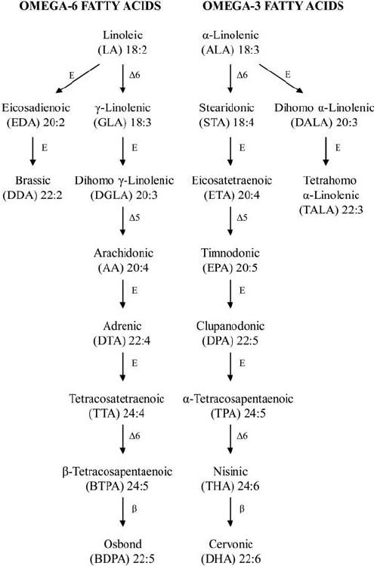

Figure 5. Names and abbreviations of the omega-6 and omega-3 fatty acids (Steer 2012)

Balanced fatty acid levels are essential for good health. Omega-3 fatty acids are seen as important elements for good cardiovascular health and appropriate brain functioning. They are also crucial for diminishing the symptoms of immune dysfunction and joint pain discomfort (de Lorgeril and Salen, 2012). Furthermore, metabolism of fatty acids is vital for the development of insulin resistance and MetS. Elevated concentrations of total non-esterified fatty acids predispose to an atherogenic lipoprotein profile. The individual properties of specific fatty acids are also of importance for the manifestation of MetS, and their composition may contribute to the development of the disease. The spectrum of fatty acids in the body could be influenced both by the quality of dietary fat and the metabolism of fatty acids (Fisher and Sjögren, 2013). The study of Fisher (2013)

summarized and demonstrated that the quality of dietary fat is of importance relative to the development of cardiovascular risk factors associated with the MetS. Improved understanding of the impact of the fatty acids composition in the diet on MetS and related cardiovascular risk factors is of importance from a public health perspective. Numerous efforts are being made to combat VDD, however, the insufficiency is still observed.

An adequate absorption of vitamin D requires the presence of certain amounts of dietary fat in a diet (Dawson-Hughes et al., 2015). As presented, several studies have evaluated various populations, different vitamin D supplementation regimes, duration of an intake, and indicated that n-3 fatty acids might impact the bioavailability of vitamin D. There is still inconclusive evidence on the associations between vitamin D and fatty acids status, and therefore this interaction requires further research.

* + - * 1. Vitamin D, magnesium, zinc and risk of developing cardiovascular diseases

Vitamin D is not the only dietary nutrient demonstrated to have a potential positive role in CVD prevention. In a meta-analysis on CVD outcomes, it was found that there is moderate-or low-quality evidence for protective benefits of certain micronutrients (folic acid for total CVD, folic acid and B-vitamins for stroke), no effect (multivitamins, vitamins C, D, β-carotene, calcium, and selenium) (Jenkins et al., 2018)**.** A study by Klevay et al. (2004) identified mineral elements related to cardiovascular health showing that lower dietary magnesium intake (less than 186 mg per day) was associated with a higher risk of coronary heart disease. Inversely, having higher magnesium intake was found to help improve the metabolism of cholesterol and prevent cardiac arrhythmia (Klevay et al., 2004)**.**

Magnesium has an essential role in the synthesis and metabolism of vitamin D. In a large population-based cross-sectional study, it was shown that a high intake of magnesium (either from natural dietary sources or dietary supplements) was correlated with a reduced risk of VDD or vitamin D inadequacy (Deng et al., 2013)**.** Another study described a direct positive relationship between the serum vitamin D and magnesium concentrations in type 2 diabetic patients (Gandhe et al., 2013).

Apart from magnesium, zinc is also considered to have a role in the prevention of CVDs. An association between zinc intake and status with the pathogenesis of CVDs is demonstrated by several experimental and clinical studies (Huang et al., 2017; Choi et al., 2018). Imbalances in zinc homeostasis contribute significantly the development of CVDs, such as coronary heart disease, congestive heart failure, ischemic cardiomyopathy, myocardial infarction, sudden cardiac death and CVD mortality in general (Huang et al., 2017). A direct association between serum zinc and metabolic risk factors for the development of CVD, i.e., serum lipids, tzpe 2 diabetes melitus, and obesity has been shown (Vashum et al., 2013; Ahn et al., 2014; Yary et al., 2016). Zinc controls the arteriosclerotic process and inadequate zinc intake leads to increased oxidative stress, disrupted nitric oxide (NO) and NF-kB signaling and contributes considerably to endothelial damage and development of arteriosclerosis (Choi et al., 2018). Antioxidant and pro-oxidant functions of zinc have various positive effects on CV health and could prevent the development of CVDs (Choi et al., 2018). A study by Chu et al. (2016), examined the association between zinc intake and prospective incidence of CVD and Type 2 diabetes mellitus, demonstrating that higher serum zinc levels were associated with a lower risk of developing CVDs (Chu et al., 2016). In addition, direct associations between low serum zinc concentrations and vitamin D levels have been found (Ziaei et al. 2007, Shams et al., 2016).

Further research is needed to clarify the role of magnesium and zinc in the development of CVDs and the precise mechanisms by which inadequate dietary zinc and magnesium and low zinc and magnesium status contribute to VDD and various CVDs.

* + - * 1. Sphingolipid and cholesterol content of erythrocyte membranes, cardiovascular diseases and vitamin D status

Cholesterol and sphingolipids represent major components in the plasma membrane of eukaryotic cells. Furthermore, sphingolipids help modulate cellular processes through the production of their bioactive signaling molecules. Sphingolipids are new candidates for biomarkers of cardiovascular health (Poss et al., 2020) and the positive association of its content with membrane cholesterol was found in some studies (Chen et al., 1992, Slotte et al., 1988).

A review on the plasma membrane organization through high-resolution secondary ion mass spectrometry studies revealed that cholesterol is evenly distributed within the plasma membrane (Kraft, 2017). The mean total plasma concentration of membrane cholesterol determined in dry lipid extract was found to be 4.44 ± 1.019 mmol/L in 58 females (Memon et al., 2003). Furthermore, a study on the total cholesterol concentrations of erythrocyte membranes in patients with the acute coronary syndrome (ACS) was done by Tziakas et al. (2007). In this study, the authors hypothesized that there is an increase in cholesterol content in the erythrocyte membranes of patients with ACS and that cholesterol levels may be a marker of clinical stability. Results of the study confirmed the hypothesis showing that ACS patients had higher membrane cholesterol levels compared to chronic stable angina ones (Tziakas et al., 2007). Thus, it was concluded that erythrocytes' cholesterol can be used as an indicator of atheromatous plaque growth and susceptibility (Tziakas et al., 2007). Another study on the association of the level of the cholesterol content of erythrocyte membranes and the severity of coronary artery disease was done by Namazi et al. (2014)**.** The direct statistically significant correlation between erythrocytes' cholesterol content and the severity of coronary artery disease was seen in coronary artery disease patients.

As shown, few recent studies revealed the existence of an association between vitamin D intake and status with the plasma content of sphingolipids. To our best knowledge, the literature data for relationships of vitamin D status and erythrocytes' sphingolipids are still missing, although their possible associations could play an important role in vitamin D mediated effect on cardiovascular health.

* + - * 1. Redox stress parameters, cardiovascular diseases and vitamin D status

The VDD displayed negative effects on the body’s mitochondrial functions such as cell death, aberrant cell proliferation, accelerated aging, and development of neurodegenerative diseases which results in increased oxidative stress and systemic inflammation (Wimalawansa, 2019). Oxidative stress is the key factor in the development of rhythm disturbances especially in the early stages of coronary artery bypass grafting (Press, 2014).

Likewise, a recent meta-analysis and systematic review by Sepikardish et al. (2019), looked at the effect of vitamin D supplementation on oxidative stress parameters. The study found that across thirteen clinical trials, supplementation of vitamin D has aided to the increased serum levels of total antioxidant capacity and [glutathione.](https://www.sciencedirect.com/topics/pharmacology-toxicology-and-pharmaceutical-science/glutathione) In conclusion, the study has shown that vitamin D supplementation helped in improving oxidative stress parameters; but this finding should be confirmed with larger prospective clinical trials (Sepidarkish et al., 2019).

Another study by Anandabaskar et al. (2018) involved 103 patients with Type 2 diabetes who were tested for VDD. The study evaluated the effect of vitamin D supplementation on vascular functions and oxidative stress among study subjects. It was found that about 73% of the subjects had VDD. Additionally, it was shown that there is a significant fall in the serum malondialdehyde levels as the total antioxidant status increased due to vitamin D supplementation. Thus, it was concluded that oral vitamin D supplementation of 60. 000 IU/week for 8 weeks has enhanced both the vascular functions and reduced oxidative stress among VDD type 2 diabetic patients (Anandabaskar et al., 2017; Anandabaskar et al., 2018)**.**

Several reports showed the involvement of oxygen-derived radicals such as superoxide dismutase (SOD), in the pathogenesis of gynecological disorders (Pejić et al. 2008). Accordingly, another study examined the changes in the activities of levels of zinc/copper SOD and lipid hyperoxides (LOOH) on patients diagnosed with benign, hyperplastic and malignant endometrium and compared results to healthy subjects. The study found that patients with hyperplasia simplex, hyperplasia complex and adenocarcinoma had a reduction in both SOD levels and activity as compared to those with myoma or polyps. Additionally, LOOH levels of the former set of patients were greater. Both findings suggest that the decrease in SOD level and activity and increase in LOOH levels may make patients more prone to oxidative damage which is deemed to be caused by ROS. Additionally, this led researchers to suggest that SOD may be a promising therapeutic target for cancer treatment. However, additional studies are needed to further understand and provide conclusive evidence of how alterations to SOD may contribute to the development of new therapeutic approaches in clinical practice (Pejić et al., 2008)**.**

The effects of vitamin D on erythrocyte catalase and SOD activities in patients with atopic dermatitis have been examined. The increase in ROS production is presumed to be a contributing factor that leads to atopic dermatitis. Atopic dermatitis patients were randomly allocated into four groups and were given a mix of Vitamin D and E supplements for 60 days. The result of the study showed that erythrocyte SOD activities improved in groups of patients taking 1600 IU vitamin D3 plus vitamin E Additionally, the results showed that there is a direct statistically significant correlation between SOD activity and serum 25 (OH) D (r = 0.378, p = 0.01). The conclusion was that vitamin D is equally potent as vitamin E in improving the erythrocyte SOD and catalase activities among atopic dermatitis patients (Javanbakht et al., 2010).

Vitamin D is known to play a key role in the strengthening and support of the body’s skeletal tissues, particularly the muscles. Thus, in cases of VDD, the presence of preferential atrophy of type II fibers in human muscle are expected. By using a rat model Bhat & Ismail (2015) examined if VDD could induce muscle oxidative stress. The results of the study showed that there is an increase in activities of the glutathione-dependent enzymes and a decrease in SOD and catalase enzymes in the rat muscle as a consequence of VDD. The study then concludes that VDD leads to mild oxidative stress in the muscle, which consequently triggers increased proteolysis in the vitamin D deficient muscle (Bhat and Ismail, 2015).

The effect of high levels of catalase and glutathione peroxidase (GPx) and its effects on human alveolar macrophages was examined by Alveolar et al. (2004). Macrophages have an important role in introducing inflammatory responses by secreting proinflammatory cytokines. Results of the study supported the hypothesis that appropriate steady-state levels of hydrogen peroxide (H2O2) are needed to overcome the negative effects of high catalase and GPx expression. Additionally, the study showed a significant increase in catalase and GPx activities in alveolar macrophages alongside blood monocytes, which was relevant for the activation of signaling pathways and gene expression, which furthermore leads to the insufficient generation of H2O2 (Alveolar et al., 2004).

While certain data are already generated, a relationship between redox stress parameters and vitamin D dietary intake and status requires additional, more thorough investigation.

# AIMS

This PhD research project aims to create and validate a questionnaire for the assessment of vitamin D intake in Libyan women; to provide up-to-date data on the dietary intake and status of vitamin D of Libyan women living in the Misurata region (Libya) and Belgrade (Serbia). In addition, this project examines the relationship between vitamin D intake and status data with major risk factors for the development of CVDs.

Hypotheses:

* Vitamin D intake and status of Libyan women living in Libya and Serbia, as migrants, is below the recommended levels.
* Low intake/status of vitamin D among Libyan women increases the risk of developing CVDs.

##### The main scientific goals

* + 1. Goal 1. Creation, adaptation, and validation of a questionnaire for the assessment of vitamin D intake among Libyan women

The FFQs, widely used instruments for dietary intake assessment in epidemiologic studies, are designed to measure habitual consumption over an extended period. They vary in listed food items, a time frame of interest, response intervals specifying the frequency of consumption, portion size reporting, and manner of administration. The FFQs are used to assess the usual dietary intake during a defined period simply and cost-effectively with a relatively small burden imposed on researchers and respondents. A universal FFQ, which could be applied for all population groups and all research questions, does not exist. Demographic, socio-economic, geographical, climatic, cultural, and medical status factors influence the diet, and FFQ must be created or adapted following the characteristics of a particular study population. Furthermore, to ensure proper interpretation of data obtained by FFQ, it is important to determine the association between reported intakes from the FFQ and factual dietary intakes.

Literature review revealed that FFQ specifically developed and validated for the assessment of vitamin D dietary intake among Libyan women does not exist underpinning the need for adaptation of appropriate instruments following cultural and geographic characteristics of this population group.

List of specific objectives:

* Selection of food items that are significant vitamin D sources appropriate for dietary habits of the adult Libyan population, as well as lifestyle factors related to sun exposure that are relevant for cultural adaptation of nutritional tool that could be used for the assessment of dietary vitamin D intake.
* To examine dietary intake of vitamin D among women in Libya, in the Misurata region (n = 360) using FFQs and 24HDRs.
* To assess vitamin D status of Libyan women (n = 40).
  + 1. Goal 2. To determine the association between the dietary intake and status of vitamin D and the risk factors for the development of cardiovascular diseases in Libyan women

Libyan women are at high risk of developing VDD, mostly due to their lifestyle practices and low exposure to sunlight. In the last decade, Libyan residents have been forced to seek refuge in countries with a high incidence of cardiometabolic diseases (i.e. Serbia). Serbian residents tend to be deficient in vitamin D mostly due to the lack of vitamin D fortification policy.

The evaluation of the vitamin D intake and status of Libyan adult women living in Libya and those migrating to European countries such as Serbia has not been done previously. This is the first study that examines a range of cardiometabolic and nutritional biomarkers, including erythrocytes fatty acid composition, cholesterol and sphingolipid content of erythrocyte membranes, magnesium, and zinc status, and redox status parameters (SOD, catalase and GPx) in relation to vitamin D intake and status data. Finally, this is the first study that provides measurement and comparative analyses of the parameters of interest in both Serbian and Libyan women.

List of specific objectives:

* Assessment of vitamin D intake and status among Libyan women living in Serbia.
* Analyses of biological associations of vitamin D status among Libyan women and cardiometabolic biomarkers.
* To examine the correlations between the cardiometabolic parameters with the erythrocyte’s fatty acid composition (fourteen fatty acids from three different groups), PUFA index, and n-3/n-6 fatty acid ratio.
* To measure serum magnesium and zinc concentrations.
* To assess the vitamin D role in the homeostasis of sphingolipid and cholesterol content of erythrocyte membranes.
* To evaluate vitamin D role in redox stress parameters by measuring first-line defense antioxidants: enzyme levels of SOD, catalase and GPx.

##### Significance of the proposed research project

The development of an appropriate nutritional tool for the assessment of dietary vitamin D intake in the Libyan population is of crucial importance as it will help in evaluating the number of people affected by dietary VDD. In addition, an investigation of the vitamin D status of adult women (25- 64 years old) living in Libya will help in addressing the impending problem of VDD within this population promptly. The health consequences of low vitamin D status and its correlations with cardiometabolic risk factors are still limited. Therefore, the proposed study will improve the current understanding of these associations among specific population groups of Libyan women.

# MATERIAL AND METHODS

This chapter describes the settings in which the research was carried out, explains the research design, describes the data gathering procedures and statistical analyses performed.

##### Research sites

* + 1. Misurata, Libya setting

Misurata is a city in the Misurata District in Northwestern Libya, located 187 km (116 mi) to the east of Tripoli and 825 km (513 mi) west of Benghazi, on the Mediterranean coast near Cape Misurata. The city’s location creates a dualism of the sea and sand, confined by the sea to the east and north, and bordered by golden sands, dotted with palm and olive trees towards the south. Besides the distinct location that makes it a center for the exchange of supplies and materials with the rest of the cities of the country, Misurata has modern infrastructure, with paved roads, electricity, and tele- and internet communications. The estimated number of people living in Misurata in 2016 was 328,448; 178,613 males and 149,835 females (Bureau of Statistics and Census Libya 2016). The current population in Libya is 6,954,410, with 386,120 in Misurata based on latest United Nations data (WPR, 2021).

The WHO has categorized Libya as a country with the widespread occurrence of micronutrient deficiencies, with VDD being one of them (WHO, 2017). The Libyan population is at a high risk of developing VDD, mostly due to their lifestyle and cultural practices (Omar et al., 2018).

* + 1. Belgrade, Serbia setting

In the past decade, Libya has been a country full of conflicts and unrest. Libyan residents have sought refuge in other neighboring countries, mainly located in Europe (i.e., Serbia). Officially, Serbia is known as the Republic of Serbia. It is a country located in the west-central Balkans, with a total area of about 29,957 square miles. It used to be part of Yugoslavia. Its capital city is Belgrade. As of 2018, Serbia has 6,987,000 residents (Debreceni and Debreceni, 2014).

Since there is a vast difference in the elevation, proximity to the sea, and wind exposure, there are several significant climatic differences among the towns in Serbia. However, in general, the climate of the country is classified as continental, characterized by cold, dry winters and warm, humid summers (Debreceni and Debreceni, 2014).

Similar to Libya, Serbia is a country with a high incidence of cardiometabolic diseases; residents are tending to experience VDD, mostly due to the low dietary intake and the absence of vitamin D fortification policy (Djekic-Ivankovic et al., 2016)**.**

##### Research design

To achieve previously described aims and objectives two human trials were conducted. The objective of the first study was the creation of a nutritional tool (a FFQ specific for Libyan women) that will be used for the assessment of vitamin D dietary intake of Libyan women living in Misurata, Libya. Once developed and validated the dietary intake tool was used to assess the intake of macronutrients (proteins, carbohydrates, and fats) and micronutrients (minerals and vitamins) including vitamin D intake in 366 Libyan females. The acquired dietary intake data of Libyan women were compared with the data from Serbian women, n = 300.

The validation of the intake tools was performed using serum status vitamin D data analysis conducted on 40 (over 10% of intake data) females from Libya.

The second study assessed vitamin D intake and status and its impact on the development of CVDs. Comparative analyses were performed among Libyan women living in Belgrade as migrants and Serbian female residents.

Data on vitamin D status in 455 participants were taken from three different age groups – children and adolescents, adults, and the elderly. Respondents were classified as apparently healthy. The data were collected in Misurata Central laboratory and HIKMA Hospital Laboratory, between June and July 2015, and the main aim was to identify the most vulnerable groups for the development of VDD.

##### Study participants

A cross-sectional study was conducted between June and October 2015 to determine vitamin D intake (n = 366) and status (n = 40, validation group) and related factors among the Libyan population from Misurata, and Serbian residents (n = 300).

Data on Vitamin D status were analyzed from the available sample for 455 apparently healthy people taken from three different age groups, which are the following:

* Children and adolescents (1 to 18 years old) - 8 males and 59 females
* Adult (18 to 64 years old) - 64 males and 298 females
* Elderly (older than 64 years old) - 3 males and 23 females

Statistical analysis of vitamin D status data showed that females 25 to 64 years old were the most vulnerable group regarding the development of vitamin D insufficiency. In order to provide more insights into the data obtained initially, a total of 366 women from this age group were engaged in Misurata between August and September 2015 on a voluntary basis in the second study. A total of 316 women completed the FFQs and 24HDRs. A subsample of randomly selected participants from this group (n = 40, 12.7%) was additionally examined in October 2015. The investigation included evaluation of blood samples and serum vitamin D status in addition to the dietary questionnaires.

The comparative study between the Libyan women migrants and resident women of Serbia was also completed. The small-scale cross-sectional study was carried out in Serbia and included a total of thirteen Libyan and fifteen Serbian apparently healthy women (30-60 years of age; mean age 46.2

± 8.0) without any medical conditions requiring pharmacological support. Before the study commencement, the Libyan study participants had been residing in Belgrade for a minimum period of one year. The enrolment process was population-based and was executed in March 2017 during one working week, via word-of-mouth and newspaper announcements. The exclusion criteria were pregnancy or breastfeeding, the presence of pharmacologically treated chronic diseases, or the presence of three or more cardiometabolic risk factors defined by the NCEP Adult Treatment Panel III (Expert Panel on Detection, 2001). All participants provided written informed consent (Annex

4) before the enrolment, and the study was undertaken in line with the Declaration of Helsinki principles (Helsinki 1983; Kong and West, 2013). Together with blood sampling made by a professional nurse, anthropometric parameters were measured, along with the assessment of participants’ dietary intake. All study assessments were carried out in the laboratory facilities in the Centre of Research Excellence of Nutrition and Metabolism (CENM), National Institute of Serbia, University of Belgrade, Serbia.

##### Data gathering procedures

Several data gathering procedures were used in this research project: (1) Anthropometric measurements, (2) Blood analysis, including determination of serum vitamin d status, the analysis of serum magnesium and zinc concentrations, determination of blood erythrocytes cholesterol and sphyngolipids and the analysis of redox status parameters (3) Determination of erythrocytes phospholipid-derived fatty acid composition, (4) An assessment of the dietary intake of participants,

(5) Libyan women-FFQ (LW-FFQ) adaptation (Annex 6), (6) 24HDR (Annex 5). The procedures are explained in full detail in the subsequent sections.

##### Ethical considerations

The study was conducted following the Declaration of Helsinki guidelines, and approval for all procedures was obtained from the Ethical Committee of the Misurata Central Laboratory for Medical Analysis-Ethics Reference: Eth1103/18. Written informed consent (Annex 4) was obtained from all participants. The patients, patients’ relatives, and their significant others were informed about data collection anonymity, confidentiality, and the right to withdraw from participation at any point during the study. All procedures carried out in Serbia were approved by the Clinical Hospital Centre Zemun, Belgrade, Serbia (E0120/2017 and E0123/2017).

##### Anthropometric measurements

Anthropometric measurements are usually composed of a series of quantitative measurements of the bone, muscle, and adipose tissue. Specifically, the height, weight, body circumferences, body mass index, and skinfold thickness of the participants are the core elements of anthropometry (Kong and West, 2013).

The anthropometric measurements for Libyan women living in Libya were completed with participants standing upright without shoes and jackets, while heights were measured to the closest

0.1 cm (Perspective Enterprises, Kalamazoo, MI, USA) and weight to the nearest 0.5 kg with a calibrated weight scale. The WC for each of the participants was measured using soft tape to the nearest 0.1 cm. Anthropometric status was analyzed using the classification according to BMI categories (< 18.5 = underweight, 18.5 - 24.9 = healthy weight, 25.5 - 29.9 = overweight, and 30 = obese). The percentage of participants at risk of metabolic complications, according to the WC, is calculated based on the classification proposed by the WHO (Consultation, 2000).

In the comparative study between Libyan migrants’ women and resident women in Serbia, anthropometric measurements were collected in a private room, and the height of each participant was measured via a wall-mounted stadiometer. Participants stood with their shoes off, heels together, maintaining an upright posture. Measurements were taken to the nearest 0.1cm.

Weight, BMI, body fat percentage, participants’ body mass and composition were measured using a TANITA UM072 balance (TANITA Health Equipment H.K.LTD, Hong Kong, China). The BMI was calculated as weight (kg) / height (m2), representing a measure for the determination of total obesity. Before use, the machine was set up for each participant; 1.0 kg was deducted to take into account the weight of clothing. The information on gender and age was requested. Participants were asked to remove socks and shoes and stand on the scales for ~ 15 seconds until the scales had been stabilized and recorded a measurement.

Each of the measurements included data on body fat percentage, total body water, fat-free mass, and estimated basal metabolic rate. Reference ranges for a healthy population were used for comparison.

WC and hip circumferences were measured using a flexible tape and measured to the nearest 0.1 cm. Measurements of WC were taken directly round the navel, and hip circumference was measured around the broadest part of the hips using the same tape measure. Waist: Hip ratio was calculated as the waist measurement (cm) divided by the hip measurement and represented the measure of central adiposity. Participants rested in a supine position for 10 minutes in a quiet room before the blood pressure measurements were taken using the Sphygmomanometer by Romsons Mercury (GS-9013 B.P; Flipkart, Karnataka, India).

##### Blood sample analysis

For the assessment of vitamin D status among Libyan women in Libya, venous blood samples were collected and tested in Misurata Central Laboratory and HIKMA Hospital Laboratory, after 12 hours of fasting, from 40 randomly selected women who participated in the survey. The analysis for serum 25(OH)D was completed by electrochemiluminescence protein binding assay (ECLIA) using Roche Diagnostics, Cobas e411 analyzer (Key Figures 2012 n.d.)**.**

The Roche Diagnostics Vitamin D total assay is a competitive electrochemiluminescence protein binding assay used for the quantitative determination of a total of 25(OH)D in human serum and plasma. The assay employs a vitamin D binding protein (VDBP) as the capture protein, which binds to both 25(OH)D3 and 25(OH)D2 (Roche Diagnostics, Mannheim, Germany). The assay employs a 3-step incubation method, which has a duration of 27 minutes.

* In step 1, the sample is incubated with a pretreatment reagent, which releases bound 25(OH)D from the VDBP.
* In step 2, the pretreated sample is incubated with ruthenium labeled VDBP to create a complex between the 25(OH)D and the ruthenylated VDBP.
* The third incubation step involves a sandwich complex formation between streptavidin- coated microparticles and 25(OH)D labeled with biotin.

The free sites of the ruthenium labeled VDBP become engaged, producing a complex made of the ruthenium labeled vitamin D binding protein and the biotinylated 25(OH)D. The entire complex remains bound to the solid phase via the interaction of biotin and streptavidin (Abdel-Wareth et al., 2013)

Vitamin D status was determined according to the cut-off values proposed by the IOM in 2011: deficient < 30 nmol/L, inadequate 25(OH)D level between 30 and 50 nmol/L) and sufficient 25(OH)D level > 50 n/mol/L (Ross et al., 2012)**.**

In the comparative study between Libyan migrants and resident women in Serbia, the blood sample collection and analysis were performed at the CENM in Belgrade. After an overnight fast, blood samples were collected into sample tubes and treated with ethylenediaminetetraacetic acid (EDTA) as an anticoagulant for plasma collection. Serum samples were also obtained.

Lipid status and glucose concentration, together with other routine biochemical parameters, were determined from the serum samples on the same day they were collected. For this purpose, clinical chemistry analyzer Cobas c111 (Roche Diagnostics, Basel, Switzerland) and Roche Diagnostics’ kits were used, according to the manufacturer’s instructions. All methods for the determination of the measured parameters (glucose, triglycerides, LDL cholesterol, HDL cholesterol and total cholesterol) involved enzymatic spectrophotometric assays.

Glucose content was determined by a 2-step reaction initiated with the enzyme, hexokinase, measuring the concentration of the end-product (NADPH) which is proportional to the glucose levels (Kunst & Draeger 1984), as described in the reaction equations below:

Step 1: D-glucose + ATP → glucose-6-phosphate (hexokinase [HK] reaction) Step 2: Coupling reaction with glucose-6-phosphate dehydrogenase (G6PD) Glucose-6-phosphate + NAD(P)+ → 6-phosphogluconolactone + NAD(P)H

The change in the concentration of NAD(P)+ versus NAD(P)H is measured at an absorbance of 340 nm, using Perkin Elmer Optima 3200XL Spectrometer (New Life Scientific Inc., Cridersville, OH, USA).

The concentration of triglycerides in the serum included peroxidase-coupled reaction of the hydrolysis of triglycerides, after which the released hydrogen peroxide reacted with 4-chlorophenol catalyzed with peroxidase and created a red dyestuff, and the intensity of each sample is directly proportional to the triglyceride concentration) (Siedel & Schmuck 1993).

Triglycerides + water → 3 fatty acids + glycerol (by lipase) Glycerol + ATP → glycerol 3-phosphate (by glycerol kinase)

Glycerol 3-phosphate + O2 → dihydroxyacetone-PO4 + H2O2 (by glycerophosphate oxidase)

The H2O2 generated reactions with a red-color-forming-dye known as a red chromogen to yield an intense pink color with an absorbance maximum at 510 nm, in proportion to the triglyceride level in a serum sample.

The LDL cholesterol determination was based on the selective micellar solubilization of LDL cholesterol by a non-ionic detergent and the subsequent interaction of a sugar compound and lipoproteins; finally, the generated hydrogen peroxide reacted with 4-aminoantipyrine and N-(2 - hydroxy-3-sulfopropyl)-3.5-dimethoxyaniline (HSDA) and formed a purple-blue dye, measured at 505 nm absorbance, which was proportional to the concentration of the cholesterol (Rifai et al., 1992) Konelab™ / T Series, LabScientific, Tripoli, Libya**.** The steps involved in the assay are summarized in the following equation.

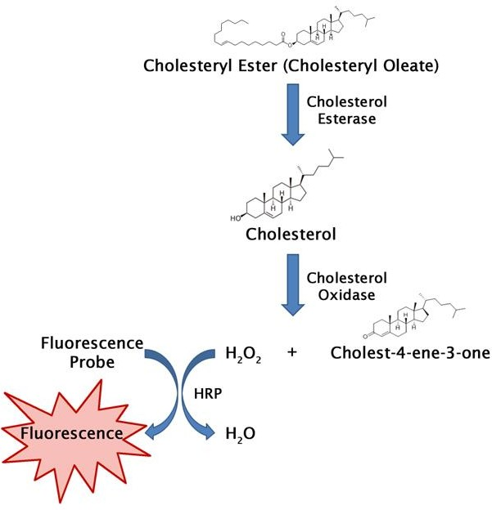

**Figure 6.** HDL and LDL/VLDL Cholesterol Assay Kit measures the cholesterol levels of HDL and LDL/VLDL fractions in serum or plasma. Figure taken from> htt[ps://www.c](http://www.cellbiolabs.com/hdl-and-)e[llbiolabs.com/hdl-and-](http://www.cellbiolabs.com/hdl-and-) ldlvldl-cholesterol-assay-kit.

HDL cholesterol measurement was based on the reaction with cholesterol esterase and cholesterol oxidase joined with polyethylene glycol to the amino groups; the final hydrogen peroxide released after this reaction reacted with 4-aminoantipyrine and HSDA, catalyzed by a peroxidase enzyme with the formation of a purple-blue dye, similar to the steps described above for the LDL cholesterol assay.

The intensity of the purple-blue dye generated in the reaction is proportional to the HDL concentration in the subject’s serum (Sugiuchi et al., 1995).

Finally, total cholesterol determination followed the same principle as the LDL and HDL cholesterol assays, based on the determination of 4-cholestenone after enzymatic cleavage of the cholesterol ester by cholesterol oxidase, and the following measurement of the colored reaction generated at the final, endpoint, hydrogen peroxide reaction step, known as the Trinder reaction (Huang et al. 1975).

##### The analysis of serum magnesium and zinc concentrations

Serum samples were used to analyze mineral concentrations of magnesium and zinc by using flame atomic absorption spectrometry on a Varian SpectrAA-10 instrument. This analysis was done in the Laboratory of Public Health Institute, Pozarevac, Serbia.

Magnesium and zinc concentration were determined using flame atomic absorption spectrometry (AAS) on a Varian SpectrAA-10 instrument (LabX, ON, Canada), as previously described (Jian-Xin, 1990). Briefly, a series of mixed calibration standards were prepared. Serum (1 mL) was diluted and transferred to a test tube, which was then placed in the autosampler carousel after mild shaking. Automated measurements were carried out, and the results were expressed as the average of two measurements consistent with the recommended standard calibration methods. To confirm the accuracy of the method, two control serums with certified concentrations of zinc and magnesium (ClinChek-Control, Recipe Chemical + Instruments GmbH; catalogue number 8882)

were analyzed. Method performance was monitored by analysis of the same control serums within each of the series. The obtained results were in line with the certified values.

##### The analysis of redox status parameters

The activity of erythrocyte enzymes catalase, SOD and GPx was determined. Commercially available kits for GPx (Randox reagents) and adrenaline autooxidation-based method for SOD were used (Misra and Fridovich, 1972). Catalase activity in erythrocyte hemolysates (1:100) was analyzed spectrophotometrically, monitoring the decrease of hydrogen peroxide concentration in the reaction mixture at 230nm (Clairborne, 1985).

##### Determination of blood erythrocytes cholesterol and sphingolipids

For sphingolipid content determination, phospholipid fractions in total lipid extracts of erythrocytes were separated on commercial thin-layer chromatography (TLC) plates using solvent mixture chloroform: ethyl-acetate: n-propanol: methanol: 0.25% KCl (25:25:25:13:9, v/v/v/v/v) (Bitman & Wood 1990). Phospholipid fractions were stained with copper sulphate reagent in methanol (phosphoric and sulphuric acid added) (Handloser et al., 2008).

The concentration of sphingolipids in lipid extracts on plates was quantified using an online available programme for gel and plate analysis Just Quantify Free (justquantify.eu).

Cholesterol was determined in total lipid extracts of erythrocytes by Liebermann-Burchard reaction (Coelho and Alves, 1946).

##### Determination of serum vitamin D status

Serum vitamin D status was determined using the RECIPE HPLC Complete Kit (order no. 35000; Waters, Milford, MA, USA), according to the manufacturer’s instructions, as described elsewhere. Briefly, the precipitation and extraction agents were added to the sample and control tubes. After centrifugation, the clear supernatant was transferred into a glass vial, and positioned in the sampler of the HPLC apparatus. The total vitamin D concentration was calculated based on the concentrations of 25(OH)D2 and 25(OH)D3, measured using the kit.

##### Determination of erythrocytes phospholipid-derived fatty acid composition

Erythrocytes’ (red blood cells) phospholipid-derived fatty acid composition was determined, following the standard protocol of the CENM, Belgrade, Serbia, using the GC 2014 gas chromatography instrument (Shimadzu chromatograph GC 2014, Kyoto, Japan).

In short, the lipids were extracted from the erythrocytes using the organic solvents chloroform and isopropanol (7:11v/v), as earlier described by Rose and Oklander (1965). Furthermore, phospholipids were separated by a thin layer chromatography using a mixture of petroleum ether, diethyl ether, and glacial acetic acid (87:12:1, by volume) on silica gel GF plates (Merck, Darmstadt, Germany). According to a previously published protocol (Christopherson and Glass, 1969) with slight modifications, performing direct transesterification of fatty acids, followed by the evaporation of hexane extracts under a stream of nitrogen, the final residue was dissolved in hexane and injected

into the Shimadzu chromatograph GC 2014 apparatus. The chromatograph was equipped with a flame ionization detector and Rtx 2330 column (60 m x 0.25 ID, 0.2 μm, Restek).

Adequate separation of methyl esters was gathered over 50 mins, first it was held at 140oC for 5 minutes. After that, the temperature was increased to 220oC at a rate of 3oC/minute, and kept at this final temperature for 20 minutes.

The identification of peaks was made by comparing peak retention times with standard mixtures, and the content of fatty acids from C16:0 through C22:6n-3 were expressed as a percentage of total fatty acids identified.

The percentage of total SFA was calculated as the sum of the percentages of C16:0 and C18:0, while the percentage of MUFA represented the sum of C16:1n-7, C18:1n-9, and C18:1n-7 percentages. The percentage of total PUFA was calculated from the percentages of the individual long-chain PUFA C18:2n-6, C20:3n-6, C20:4n-6, C22:4n-6, C20:5n-3, C22:5n-3, and C22:6n-3,

which were expressed as n-3 and n-6 PUFA separately.

##### An assessment of the dietary intake of participants

Nutrient intakes from LW-FFQs and 24HDRs were estimated using combined data from the West African Food Composition Database (FCDB), Turkish FCDB, USDA, and Serbian FCDB. The specialized Vitamin D FCDB created within the FP7 ODIN project was used as a reference for vitamin D food sources (Gavrieli et al., 2014). Dietary assessment tool validated by the EFSA, the Diet Assess and Plan (DAP), was used for calculations of the total daily intake of energy, macronutrients, vitamin D and calcium (Gavrieli et al., 2014; Gurinovic et al., 2015; Gurinović et al., 2018). Insufficiency of vitamin D intake was evaluated according to both dietary reference intake proposed by IOM (10 µg/day) and the newest EFSA recommendations (15 µg/day), while calcium inadequacy was assessed by dietary reference intake proposed by EFSA (750 mg/day) (European Food Safety Authority, Parma 2017; Ross et al., 2011)**.**

##### Creation and validation of a nutritional tool for assessment of vitamin D intake of Libyan women (Libyan women-food frequency questionnaire, LW- FFQ)

The research instruments used in this study were the Libyan women-FFQ (LW-FFQ) (Annex 6) and a 24HDR survey questionnaire (Annex 5). In order to produce the FFQ applicable to Libyan women, the existing questionnaire validated for assessment of vitamin D intake of young Serbian women was used. LW-FFQ was modified to follow Libyan traditional dietary habits and was enriched with vitamin D food sources typically consumed in Libya. Besides, specific questions associated with sun exposure were revised to be culturally acceptable for the region. The structural design of the LW-FFQ was to include a wide range of general questions: socio-demographic factors, lifestyle and physical activity, anthropometric measurements, consumption of supplements, and a unique set of questions associated with sun exposure with and without clothes and hijab. The composition of questions used for dietary intake assessment encompassed a wide selection of vitamin D food sources, foods traditionally consumed in Libya, and commonly consumed foods from all food groups.

All of the nutrients from each food group, classified into 311 food items, were obtained. Photographs of estimated food portion sizes of different food varieties were shown to the respondents to assist them in identifying portion sizes of consumed foods. Upon creation of the final

version of LW-FFQ, translation from English to Arabic was performed by two bilingual experts in nutrition and dietetics (Annex 6). The LW-FFQ reflected the intake in the previous 3 months and was carried out by a face-to-face interview with a trained dietitian.

The frequency of consumption and portion sizes of approximately 110 food items over the last three months were evaluated. The FFQ used consisted of 149 questions that focused on 10 food groups, known to contribute to dietary vitamin D intake, as follows: milk and dairy, meat or meat product, seafood or related product, egg or egg product, grain or grain products, nut, seed or kernel, vegetable or vegetable product, fruit or fruit product, cakes and confectionery, and miscellaneous (Annex 6). The interview lasted between 25-35 min. Participants were provided with necessary instructions related to frequencies of consumption and portion sizes in grams/milliliters presented on photographs as a part of the LW-FFQ. For the frequency of consumption, participants were able to choose one of the following options: ‘never,’ ‘once per month,’ ‘2–3 times/ month’, ‘once/week,’ ‘2–3 times/week,’ ‘4–6 times/week’ and ‘every day’ for each food item. All reported frequencies were changed to frequencies/day to enable comparison of the analysis based on daily food consumption and nutrient intake. The questionnaire contained 149 food items with 12 additional questions regarding the frequency of supplement(s) use, as well as the consumption of products that were voluntarily enriched with vitamin D and are available on the Libyan market (Annex 6).

##### 24 h dietary recall

Participants' dietary intake was assessed using validated 24HDR questionnaires (Annex 5) distributed on two different days (separated by at least one week). Besides, the demographic data were also collected. The first 24HDR was conducted within the structured face-to-face interview on the same day as LW-FFQ. The second 24HDR was conducted by a telephone interview within three weeks. Women reported all the foods and beverages they consumed in the previous 24 hours from breakfast until the next morning. A food picture book was used for the assessment of portion sizes. Participants were able to determine the portion size of consumed foods by choosing one of the four photos depicting small, medium, a large and extra-large portion for the 145 food items, and 11 different household measures and utensils.

During the dietary recall interviews, a multiple-pass method was utilized in which respondents were initially asked to provide an overview of all food or beverage items consumed on the previous day. The list was then reviewed for the possible meal, beverage, or food item omissions. Lastly, the portion sizes and the preparation methods of certain dishes were collected. Additional information on cooking methods, brand names, and recipes were obtained where appropriate. The time available for interviewing was unlimited; therefore, participants were not rushed, and the interviews were completed in a relaxed atmosphere. Each dietary recall lasted approximately 15-20 minutes. The food records were encoded and entered using the DAP platform for standardized and harmonized food consumption collection, comprehensive dietary intake assessment and nutrition planning (Gurinovic et al., 2018; Gurinovic et al., 2020).

Nutrient calculations (including total energy, macronutrients, and vitamin D intake) were performed using the EFSA validated dietary assessment tool, DAP (Gurinović et al., 2018).

##### Food composition database

In order to extrapolate the food consumption data obtained via the questionnaires used in the study for both the 24HDRs and FFQs data, a FCDB was needed.

Thus, the local FCDB tables were created, which included a list of all food items consumed by participants. The FCDB included a wide range of foods available on the market, including raw ingredients, as well as processed food items.

The FCDB included a list of approximately 368 food items where the composition per 100 g of each item was given in terms of the following: Energy, Water, Protein, Fat, Carbohydrate, Fiber, Calcium (Ca), Iron (Fe), Magnesium, Phosphorus (P), Potassium (K), Sodium (Na), Zinc (Zn), Copper (Cu), Vitamin A-RAE, Retinol, ß-carotene equivalent, Vitamin D, Vitamin E, Thiamin, Riboflavin, Niacin, Vitamin B6, Folate, Vitamin B12, and Vitamin C.

The FCDB was compiled using data taken from many published food composition databases, as follows: FAO - West African food composition Table, Food Composition Tables for Egypt 2006 NNI, USDA FCDB, and Turkish FCDB. The specialized Vitamin D FCDB created within the FP7 ODIN project was employed for vitamin D food sources. The database loaded onto the software DAP, was designed for the input and analyses of the questionnaires used in the study.

##### Statistical analysis

Data on vitamin D status were analyzed according to age, gender, and 25(OH)D level categories, defined by cut-offs, using chi-square test. The mean and standard deviations (SDs) were calculated for energy, macronutrients (total carbohydrates, fat, and protein), vitamin D, and calcium intake.

Several techniques were applied to validate LW-FFQ against 24HDR and vitamin D status levels as reference methods. Pearson correlation coefficients determined the relationship between LW- FFQ and 24HDR for normal distribution variables, while the Spearman correlation coefficient was used for variables that did not follow a normal distribution. The Bland-Altman analysis (1996) was employed as an alternative statistical approach based on a graphical technique in addition to the correlation coefficients to assess the agreement between LW-FFQ and 24HDR (Bland & Altman 1986). For the subset of 40 participants, a cross-classification analysis was applied to determine the agreement between both the LW-FFQ and the reference methods. A cross-classification analysis was performed using the vitamin D intake from LW-FFQ and 24HDR, as well as the status data, classified as belonging to the same quartiles, same adjacent (±1) quartiles, opposite quartiles (±2), or entirely misclassified (1st vs. 4th quartile). Linear trends between vitamin D intake assessed by LW-FFQ and vitamin D status were calculated using linear regression analysis. A p-value < 0.05 was considered statistically significant. All statistical analyses were performed using the R software package (R Foundation for Statistical Computing, Vienna, Austria).

The normal distribution of data was checked by the Shapiro-Wilk test. For normally dispersed variables, the independent sample t-test was applied, while The Mann-Whitney test was employed to compare non-normally distributed variables. Relations of vitamin D status and other analyzed parameters were evaluated by Spearman coefficient of correlation, as vitamin D level values did not follow a normal distribution.

Vitamin D status of individuals is significantly affected by age, older individuals are prone to deficiency as they have lower levels of provitamin D3 in the skin and are less efficient in producing the vitamin (Meehan and Penckofer, 2014). Thus, the partial Spearman correlation was performed taking into account age as a controlling variable, as well as age together with either anthropometric or lipid indices as controlling variables. The intention-to-treat protocol was employed for completing the analysis. SPSS software (ver. 20.0) was used and p values < 0.05 were considered statistically significant. Normally distributed data are presented as mean (SD) and non-normal variables as median [interquartile range].

# RESULTS

The general aim of this PhD research project was to provide up-to-date data on the dietary intake and status of vitamin D of women living in the Misurata region (Libya) and Belgrade (Serbia).

In addition, this project examined the relationship between vitamin D intake and status with major risk factors for the development of CVDs, including the status of magnesium, zinc, PUFA, erythrocytes' sphyngolipids and cholesterol, as well as redox status, e.g., levels of SOD, GPx and catalase.

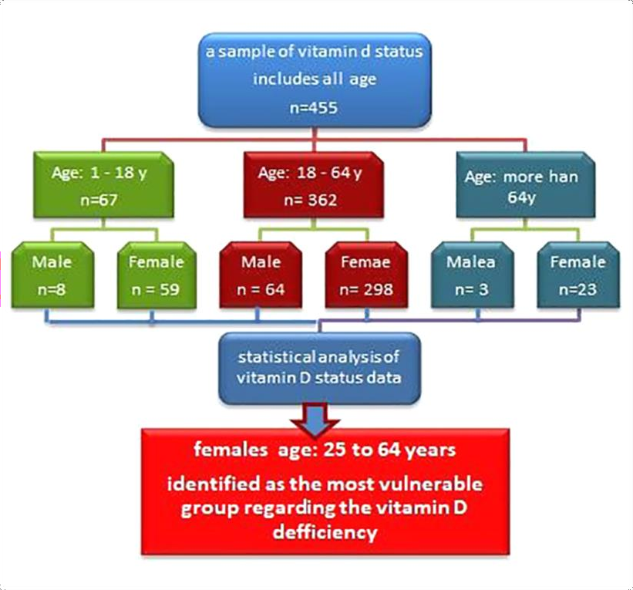

**Figure 7.** The study flow chart, first part.

##### Cross-sectional study of vitamin D intake and status in Libyan women

The Vitamin D intake and status of Libyan women were evaluated by a cross-sectional study. Data were collected and analyzed from the available sample of 455 apparently healthy children and adolescents from 1 to 18 years old (8 males and 59 females), 18 to 64 years old adults (64 males and

298 females), and the elderly 64 years and older (3 males and 23 females). Females from 25 to 64

years of age were recognized as the most susceptible group regarding vitamin D inadequacy (Figure 7).

A total of 366 women from this age group were engaged in Misurata between August and September 2015, to voluntarily take part in the study with 316 of them completing the FFQ (Annex

6) and repeated 24HDR (Annex 5).

A subsample of randomly chosen participants from this group (n = 40, 12.7%), in the following text–validation group, was further inspected in October 2015, which encompassed blood sample and serum vitamin D status assessments, along with the dietary questionnaires.

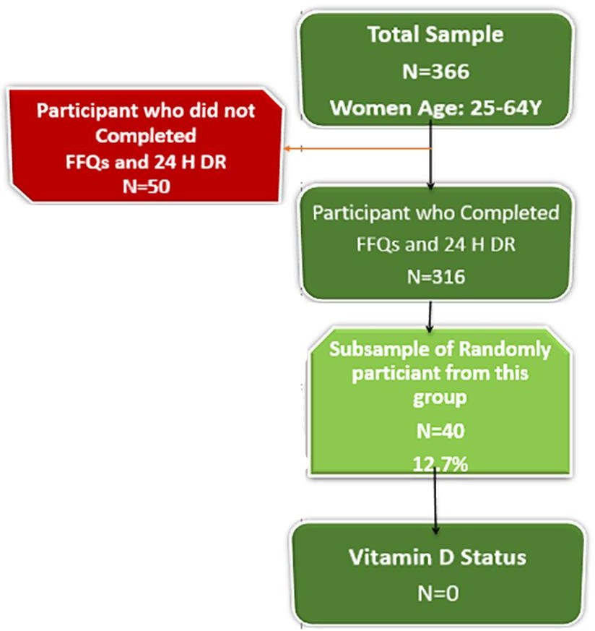

**Figure 8.** Second part of the study flow chart.

In addition, this study assessed the profile of the vulnerable population in terms of age, educational attainment, anthropometric measurements, usage of supplements, physical activity levels, and sun exposure.

##### Evaluation of Vitamin D status in children, adults and elderly people in Misurata region, Libya

The study sample of 455 participants, for which vitamin D status was analyzed, was separated into four groups based on age: 1-10, 11 -24, 25-64, and 64+. The mean value of vitamin D status among females was 52.8 ± 29.3 nmol/L while amongst males it was 52.8 ± 30.0 nmol/L. Interestingly, 79.4% of women had vitamin D status below 50 nmol/L, compared to 52% of male participants (p < 0.001) ([Figure](https://www.tandfonline.com/doi/full/10.1080/19932820.2018.1502028%23F0001) 9).

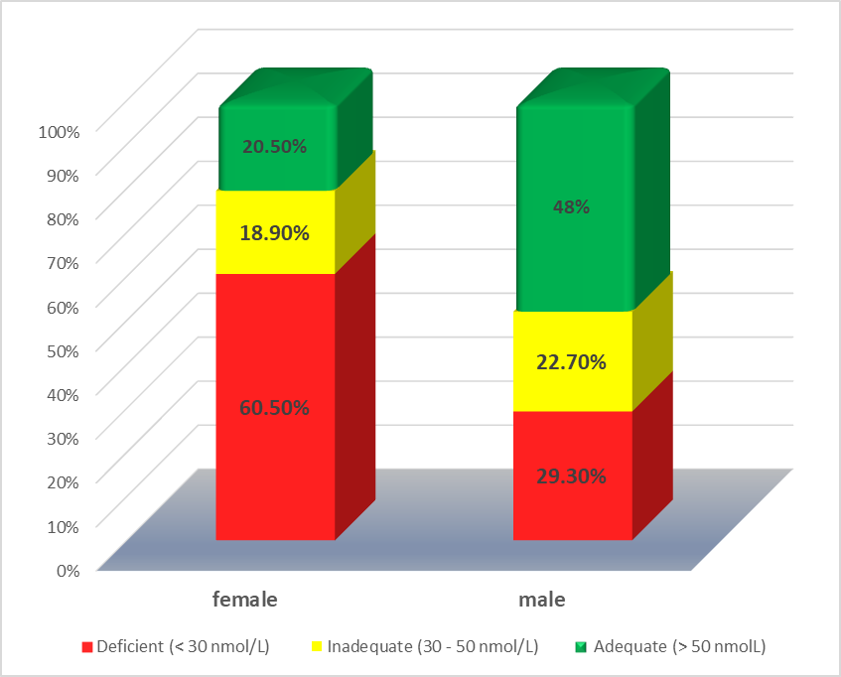

**Figure 9.** Distribution of participants according to the 25(OH)D cut-off levels by gender (chi-square test was used for comparison between gender and vitamin D status categories).

##### Identification of the most vulnerable populations for the development of Vitamin D deficiency in Libya

Based on previously presented findings, female participants were additionally examined according to age groups and the mean value of vitamin D intake was at the lowest level among women between 25 and 64 years of age (33.1 ± 28.4 nmol/L) followed by adolescents and young adults between 11 and 24 years (34.7 ± 28.2 nmol/L), elderly group (43.0 ± 32.6 nmol/L) and children (51.6 ± 36.0 nmol/L). The higher number of adult females (81.8%) were found to be deficient or to have insufficient vitamin D status levels compared to other age groups (Figure 10), which was analyzed by chi-square test with Bonferroni alteration (p = 0.024).

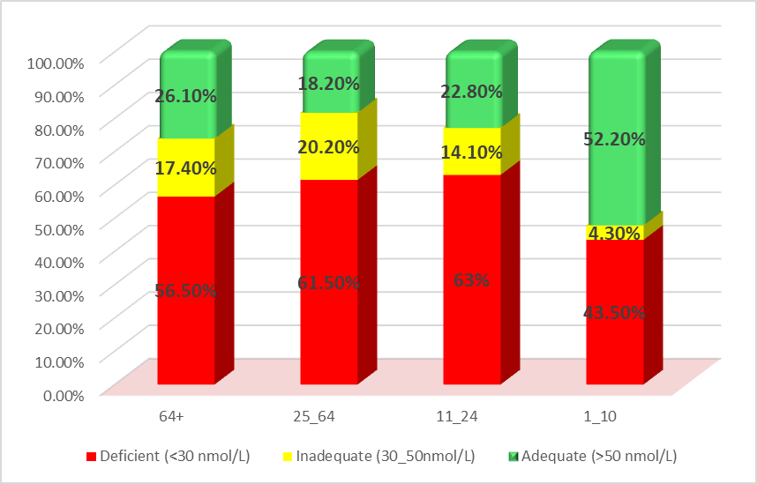

**Figure 10.** Percentage distribution of female participants according to 25(OH)D level and age groups (chi-square test was used for comparison between age groups and vitamin D status categories).

##### Analysis of anthropometric measures, physical activity and sun exposure behaviors as contributing factors to development of vitamin D deficiency

In the subsequent phase of this study and following the identification of the most vulnerable population group concerning vitamin D status levels, the associated factors, such as vitamin D dietary intake, sun exposure, obesity status, and supplementation were inspected on the sample of 316 women 24-64 years old. The average age of participants was 33.0 ± 9.3 years, distributed into three different age groups 24-34 years (39.6%), 35-49 years (45.6%), and older than 50 years

(14.9%).

According to anthropometric measurements of participants, 60.4% of subjects were obese, 23.1% overweight, 15.8% had normal weight, while 0.6% were underweight. As a result of the high percentage of obese women, this group was further examined for the obesity classes. Out of 191 obese women, 59.2% belong to the obese Class 1, 33.5% to the obese Class 2, while 7.3% fit to the obese Class 3 (Table 4).

**Table 4.** Anthropometric measurements of study participants (n = 316).

|  |  |  |
| --- | --- | --- |
|  | Mean | SD |
| Weight (kg) | 78.1 | 13.8 |
| Height (cm) | 158.4 | 4.6 |
| BMI (kg/m2) | 31.2 | 5.7 |
|  | 94.0 |  |
| WC (cm) |  | 16.8 |
| *Nutritional status by BMI kg/m2* | *N* | *%* |
| Underweight (< 18,5) | 2 | 0.6 |
| Normal range (18,5 - 24.9) | 50 | 15.8 |
| Overweight (25.0 - 29.9) | 73 | 23.1 |
| Obese (>= 30) | 191 | 60.4 |
| Obese class 1 (30-34.9) | 113 | 59.2 |
| Obese class 2 (35.0 - 39.9) | 64 | 33.5 |
| Obese class 3 (>= 40.0) | 14 | 7.3 |
| *Obesity co-morbidity risk (by WC)* |  |  |
| normal WC | 62 | 19.6 |
| risk level 1 (WC >80cm) | 58 | 18.4 |
| risk level 2 (WC >88cm) | 196 | 62.0 |

Moreover, the use of supplements was explored and it was found that 14.9% of women were taking supplements, with most of the respondents consuming multivitamins (44.7%). Only 2.2% consumed vitamin D supplements, but 53.2% did not state the type of consumed supplement.

Similarly, a low level of physical activity was seen among study participants. At the time, 71.2% reported low physical activity, 4.7% stated walking for less than 30 min per day as only physical activity, 13.9% walked between 30 and 180 min per day, while 6.3% walked every day for more than 3 hours. In contrast, only 3.8% of participants specified practicing vigorous physical activities.

The majority of participants (53.5%) was with tertiary education (including postgraduate studies), 13.6% of them were with secondary education, 15.2% had primary education while 17.7% were illiterate.

In line with the observed sedentary lifestyle among Libyan women, low sun exposure seems to be another significant reason for low vitamin D status. Only 56 participants (17.7%) were sunbathing in the previous three months, 73.2% of them were wearing hijab in the sun, 21.4% were wearing short clothes and sleeves, while 10.7% used sunblock creams.

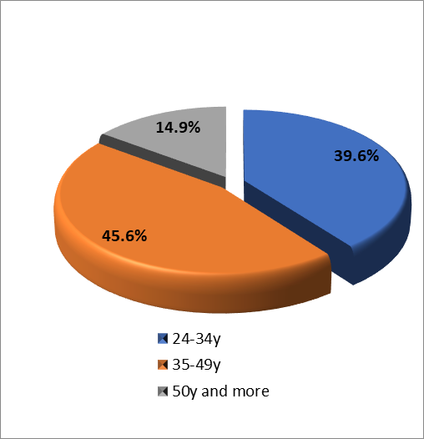

**Figure 11.** Classification of the study sample according to the age.

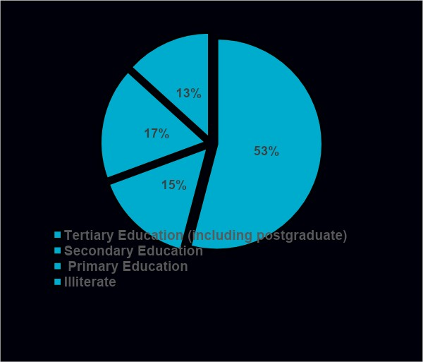

**Figure 12.** Classification of the study sample according to the level of education.

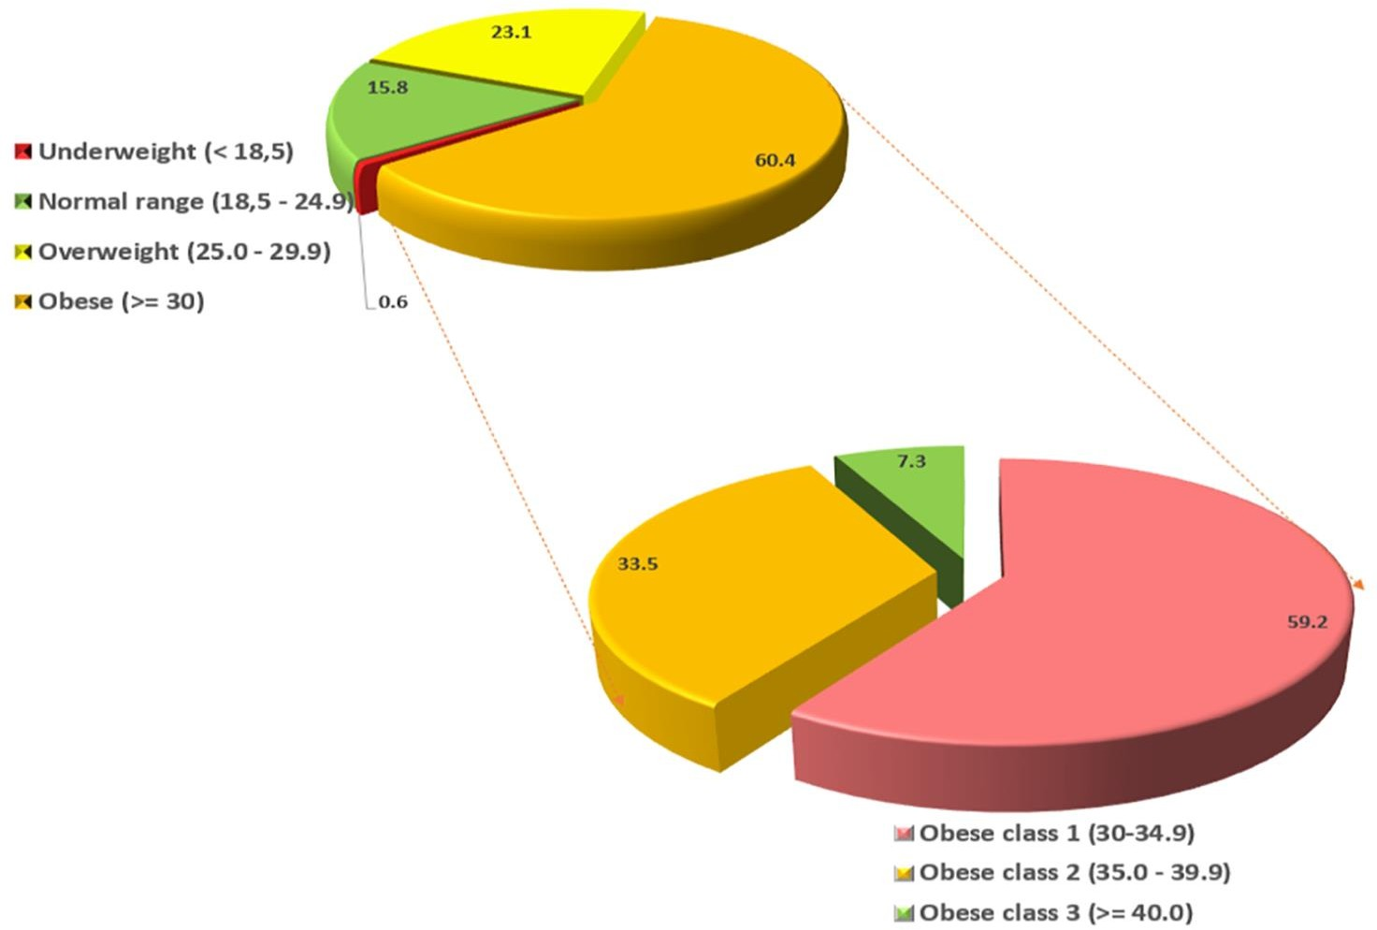

**Figure 13.** Classification of the study sample according to BMI category.

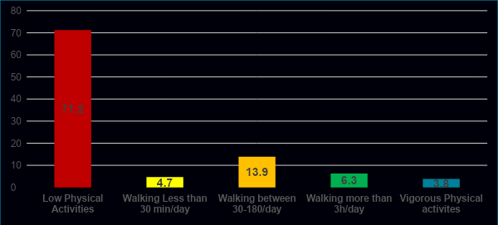

**Figure 14.** Distribution of study sample based on physical activity

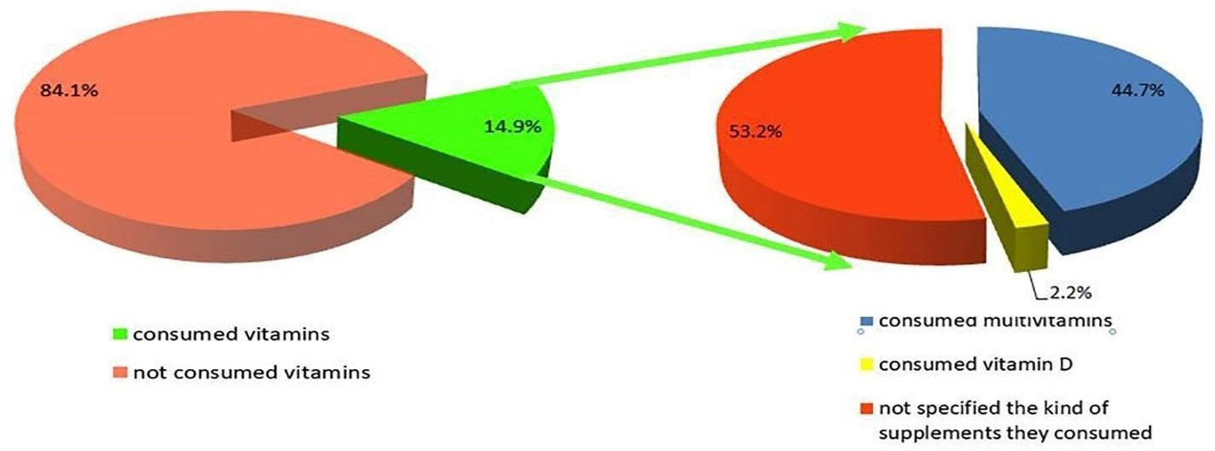

**Figure 15.** Classification of study sample according to the consumption of vitamins.

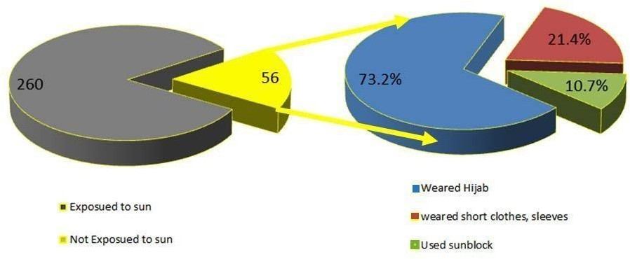

**Figure 16.** Classification of study sample based on sun exposure.

##### Assessment of vitamin D and daily energy and nutrient intake among women in Misurata region using food frequency questionnaires and 24 h dietary recalls

The average daily energy, macronutrient, vitamin D, and calcium intake evaluated by LW-FFQ (Annex 6) and 24HDR (Annex 5) are shown in Table 5. Correlations between intakes estimated by LW-FFQ and 24HDRs were statistically significant for all investigated nutrients. This was the initial step in the LW-FFQ validation process. The average vitamin D intake was 3.9 ± 7.9 µg/day and 4.4

± 5.2 µg/day assessed by 24HDRs and LW-FFQ, correspondingly. Calcium intake assessed by 24HDRs was 726.9 ± 286.8 mg/day, while the intake assessed by the LW-FFQ was 751.2 ± 297.6 mg/day. Insufficient vitamin D intake, according to the recommendations proposed by IOM for adult females (10 µg/day), was detected in 88.6% and 91.4% of participants based on LW-FFQ and 24HDRs, respectively. The same data were compared to the newest EFSA recommendations (15 µg/day), and 92.4% of participants had inadequate vitamin D intake, assessed by LW-FFQ, while 91.8% were below the recommended values when evaluated by 24HDRs. Calcium intake under 750 mg/day was observed among 55.1% participants when assessed by LW-FFQ, and among 59.5% participants, when calcium was estimated by 24HDRs.

**Table 5.** Daily energy and nutrient intake assessed by the average of the repeated 24HDR and LW-FFQ with correlations between the estimates by applying questionnaires among Libyan women.

Nutrient

Total sample (n = 316) Validation group (n = 40)

24HDR LF-FFQ 24HDR LF-FFQ

Correlation

Correlation

Mean SD Mean SD

Mean SD Mean SD

coefficient coefficient

Energy (kcal) 2870.

3

1104.

5

2904.1 888.

4

0.405*** 3050.

0

1051.

3

2631.0 59

3.2

0.569***

Carbohydrates (g) 330.3 126.3 251.5 76.5 0.435*** 359.8 110.2 231.7 60.

6

Fat (g) 105.1 55.6 146.3 65.3 0.383*** 108.0 53.6 129.2 36.

5

Protein (g) 122.2 40.8 99.7 25.9 0.418*** 127.7 34.7 96.6 22.

7

0.524**

0.313*

0.457***

Vitamin D (µg) 3.9 7.9 4.2 5.2 0.600*** 5.7 10.8 5.1 5.7 0.606***

Vitamin D (µg/1000kcal) 1.5 4.2 1.6 2.3 0.591*** 1.6 2.8 2.1 2.5 0.714***

Calcium (mg) 726.9 286.8 751.2

* p value < 0.05, ** p value < 0.01, ***p < 0.001

297. 0.590*** 744.5 247.7 706.4

6

21 0.492***

6.2

##### Assessing the agreement between the LW-FFQ and the average of repeated 24 h dietary recalls for estimation of vitamin D intake

Figure 17. describes the Bland-Altman analysis which indicated an agreement amongst LW-FFQ and the average of repeated 24HDRs.

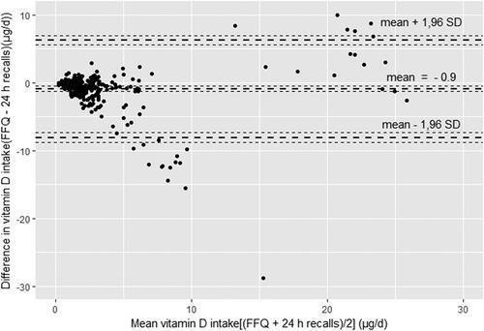

**Figure 17.** Bland-Altman plot assessing the agreement between the LW-FFQ and the average of repeated 24HDRs for estimation of vitamin D intake**.**

##### Cross-classification of vitamin D intake

Table below shows the classification of vitamin D intake and status into quartiles, which was used to evaluate the agreement between classes of subjects for LW-FFQ, 24HDRs, and vitamin D status (Table 6). The LW-FFQ classified more than 90% of subjects into the same or same and adjacent quartile as 24HDRs and 72.5% as vitamin D status level. Gross misclassification arose for 2.5% between LW-FFQ and 24HDRs and 7.5% between LW-FFQ and vitamin D status.

**Table 6.** Cross-classification of vitamin D intake into quartiles by LW -FFQ and validation methods (24HDR and status).

|  |  |  |  |  |
| --- | --- | --- | --- | --- |
| Vitamin D intake assessed by FFQ | | | | |
| Vitamin D intake/status assessed by | Same quartile (%) | Same or adjacent quartile (%) | Opposite quartile (%) | Grossly misclassified (%) |
| 24HDR | 45 | 90 | 7.5 | 2.5 |
| 25(OH)D | 30 | 72.5 | 20 | 7.5 |

##### Vitamin D status of Libyan women

Vitamin D status was studied on the validation group (n = 40) and obtained data confirmed the results from the first stage of the survey. Deficiency or inadequate vitamin D status was detected among 70% of participants. The mean 25(OH)D level on the validation sample was 40.8 ± 32.5 nmol/L. A significant increase of 25(OH)D concentrations was acknowledged with an increase of vitamin D intake (p = 0.015), as shown in Table 7.

**Table 7.** Estimated vitamin D status (25(OH)D nmol/L) and vitamin D intake estimated

by 24HDR by quartile of vitamin D intake estimated by LW - FFQ among Libyan women (n=40).

|  |  |  |  |  |  |
| --- | --- | --- | --- | --- | --- |
| 25(OH)D nmol/L | | | | | |
| Quartiles | Vitamin D intake (µg/day) – FFQ | *n* | Mean | 95% CI | *p* for Trend |
| 1st quartile | <1.7 (1.1) | 10 | 32.3 | 22.4–42.1 | 0.015* |
| 2nd quartile | 1.7–2.5 (1.9) | 10 | 25.3 | 16.0–34.5 |  |
| 3rd quartile | 2.5–6.6 (3.2) | 10 | 41.4 | 17.3–65.5 |  |
| 4th quartile | 6.6–20 (13.3) | 10 | 61.8 | 30.3–93.3 |  |

##### Identification of the food groups with a dominant contribution to the total daily vitamin D intake, and major vitamin D food sources assessed by 24 h dietary recalls

Table below presents the list of food groups with a fundamental contribution to the total daily dietary vitamin D intake of participants, as assessed by 24HDRs. Fish and fish products contributed the most (64%), followed by eggs (15.5%), meat (7%), and dairy (4%) [(Table](http://./Downloads/AssessmentofvitaminDintakeamongLibyanwomenadaptationandvalidationofspecificfoodfrequencyquestionnaire%20(1)-converted%20(6).docx#_bookmark39) 8). However, fish is consumed by 59% of women, while milk and chicken are consumed by 100% of them. Eggs are also an important source of vitamin D, consumed by the majority of women (83%).

**Table 8.** Daily intake of food groups and their contribution to total Vitamin D intake among Libyan women (n = 316).

|  |  |  |  |  |  |
| --- | --- | --- | --- | --- | --- |
| Intake of the food group (g/day) | | | | Contribution to total vitamin D  intake | |
| Food groups | Median | 5th percentile | 95th percentile | Percentag e | Vitamin D intake (µg/day) |
| Sea food and related products | 45.0 | 45.0 | 459.1 | 63.6 | 2.46 |
| Eggs and egg products | 30.0 | 30.0 | 123.4 | 15.5 | 0.6 |
| Meat and meat products | 211.4 | 211.4 | 423.0 | 7.2 | 0.28 |
| Milk and milk products | 142.5 | 142.5 | 332.1 | 4.4 | 0.17 |
| Other |  |  |  | 9.3 | 0.36 |

##### Major vitamin D food sources selected based on 24 h dietary recalls

As shown in table 9, fish is consumed by 59% of women, while milk and chicken are consumed by 100% of participants. In addition, eggs are an important source of vitamin D, consumed by the majority of women (83%).

**Table 9.** Major vitamin D food sources assessed by 24HDR.

|  |  |  |  |
| --- | --- | --- | --- |
|  | Total sample | Consumers  only |  |
| Food name | Vitamin D(µg/day) | Vitamin D(µg/day) | Percentage of  consumers |
| Gilthead bream, aquaculture | 1.21 | 31.82 | 3.8 |
| Sardine | 0.97 | 24.19 | 6.0 |
| Eggs | 0.60 | 3.33 | 83.2 |
| Fortified foods (cocoa, breakfast cereals) | 0.28 | 7.07 | 21.2 |
| Tuna | 0.23 | 0.39 | 58.9 |
| Chicken | 0.14 | 0.21 | 100.0 |
| Lamb meat | 0.10 | 0.46 | 72.2 |
| Milk | 0.08 | 0.26 | 100.0 |
| Butter | 0.06 | 0.14 | 41.8 |
| Bullet tuna (Auxis rochei) | 0.04 | 3.17 | 1.3 |
| Yoghurt | 0.03 | 0.07 | 42.4 |
| Processed cheese | 0.02 | 0.04 | 43.7 |

##### Cross-sectional study of vitamin D status in women in Serbia

A total of 300 women, 25-64 years of age living in Serbia were included in the study. The average age of participants was 34.7 ± 10.6 years, while the average age of Libyan participants was

33.0 ± 9.3. The majority of participants (59.3%) finished high school, 30.7% were with undergraduate studies/or with a high school diploma, 6.3% had primary education while 3.7% completed postgraduate studies.

**Table 10.** Demographic characteristics.

|  |  |  |
| --- | --- | --- |
|  | Mean | SD |
| Age (total sample) | 34.7 | 10.6 |
| Age groups | n | % |
| 18 - 24 | 41 | 13.7 |
| 25 – 34 | 92 | 30.7 |
| 35 - 44 | 111 | 37.0 |
| 45 - 49 | 56 | 18.6 |
| Education level |  |  |
| Primary school | 19 | 6.3 |
| High school | 178 | 59.3 |
| Undergraduate studies/high diploma | 92 | 30.7 |
| Postgraduate | 11 | 3.7 |

The anthropometric indices are shown in Table 11. 19.3% of Serbian women were obese, 24.3% overweight, 54.0% had normal weight, while 2.3% of them were underweight. Due to the high percentage of obese women, this group was further classified into various obesity-related classes. Out of 58 obese women, 63.8% belong to the obese Class 1, 34.5% to the obese Class 2, while 1.7% were in the obese Class 3 category.

Based on obesity co-morbidity risk (by WC) Serbian women were classified into three different categories: 38% normal WC, 39.3 % at risk level 1 (WC > 80cm), 62% at risk level 2 (WC > 88cm), while the Libyan participants were categorized as 19.6%, 18.4%, and 62% of participants in each of these groups, respectively.

**Table 11.** Anthropometric measurements (Serbian women).

|  |  |  |
| --- | --- | --- |
|  | Mean | SD |
| Mean weight | 65.91 | 12.9 |
| Mean height | 166.2 | 5.9 |
| BMI | 25.8 | 4.6 |
| Waist circumference | 84.44 | 14.8 |
| *Nutritional status by BMI kg/m2* | *n* | *%* |
| Underweight (< 18,5) | 7 | 2.3 |
| Normal range (18,5 - 24.9) | 162 | 54.0 |
| Overweight (25.0 - 29.9) | 73 | 24.3 |
| Obese (>= 30) | 58 | 19.3 |
| Obese class 1 (30-34.9) | 37 | 63.8 |

|  |  |  |
| --- | --- | --- |
| Obese class 2 (35.0 - 39.9) | 20 | 34.5 |
| Obese class 3 (>= 40.0) | 1 | 1.7 |
| *Obesity co-morbidity risk (by WC)* |  |  |
| normal WC | 114 | 38.0 |
| risk level 1 (WC >80cm) | 118 | 39.3 |
| risk level 2 (WC >88cm) | 68 | 62.0 |

##### Assessment of vitamin D and daily energy and nutrient intake among Serbian women using food frequency questionnaires and 24 h dietary recalls

The average daily energy, macronutrient, vitamin D, and calcium intake evaluated by FFQ and 24HDR are presented in Table 12. Correlations between the intakes estimated by FFQ and 24HDRs were statistically significant for all examined nutrients. The average vitamin D intake was 2.9 ± 1.1 µg/day and 3.1 ± 1.3 µg/day assessed by 24HDRs and FFQ, respectively. Calcium intake assessed by 24HDRs was 689.9 ± 221.8 mg/day, while the intake assessed by FFQ was 700.2 ± 247.7 mg/day.

**Table 12.** Daily energy and nutrient intake assessed by the average of the repeated 24HDR and FFQ with correlations between the estimates by applying questionnaires among Serbian women (n = 300).

|  |  |  |  |  |  |  |
| --- | --- | --- | --- | --- | --- | --- |
|  | Mean | SD |  | Mean | SD | coefficient |
| Energy (kcal) | 1829.9 | 976.5 |  | 1877.1 | 787.4 | 0.512** |
| Carbohydrates (g) | 231.3 | 69.4 |  | 237.5 | 68.1 | 0.464** |
| Carbohydrates %TEI | 50.6 | 9.6 |  | 50.6 | 9.1 |  |
| Fat (g) | 59.1 | 21.6 |  | 60.3 | 25.3 | 0.412** |
| Fat %TEI | 29.1 | 4.2 |  | 28.9 | 4.4 |  |
| Protein (g) | 93.2 | 34.8 |  | 96.1 | 30.9 | 0.419** |
| Protein %TEI | 20.4 | 3.4 |  | 20.5 | 2.7 |  |
| Vitamin D (µg)¥ | 2.9 | 1.1 |  | 3.1 | 1.3 | 0.398** |
| Vitamin D (µg/1000kcal)¥ | 1.6 | 1.2 |  | 1.7 | 1.3 | 0.343** |
| Calcium (mg) | 689.9 | 221.8 |  | 700.2 | 247.7 | 0.401** |

Nutrient 24HDR FFQ Correlation

¥Spearman correlation coefficient, * p-value < 0.01, ** p-value < 0.001; TEI, total energy intake.

##### Cross-classification of vitamin D intake

As shown in Table 13, 55% of the respondents’ vitamin D intake belongs to the same quartile for both assessments (24HDR and FFQ). Furthermore, according to FFQ 80% of participants were classified into the same or adjacent quartile as 24HDRs. Gross misclassification occurred for 3.5% between 24HDRs and FFQ.

**Table 13.** Cross-classification analyses of vitamin D intake estimates based on FFQ and average value of repeated 24HDR.

|  |  |  |  |  |
| --- | --- | --- | --- | --- |
| Vitamin D intake assessed by FFQ | | | | |
| Vitamin D intake/status assessed  by | Same quartile (%) | Same or Adjacent Quartile (%) | Opposite Quartile (%) | Grossly Misclassified (%) |
| 24HDR | 55 | 80 | 16.5 | 3.5 |

##### Estimated vitamin D intake

More than 90% of participants had vitamin D levels below the recommended values which was demonstrated by both FFQ and 24HDR data. More than 90% of this study group had vitamin D levels well below the values recommended by the IOM and EFSA.

Insufficient calcium intake was shown by both FFQ and 24HDR, with more than 50% of participants having levels below suggested values.

**Table 14.** Comparison of vitamin D and calcium intake assessed by FFQ and 24HDR with recommendations.

|  |  |  |  |
| --- | --- | --- | --- |
|  |  | FFQ | 24HDR |
| Vitamin D | µg/day | % below recommended level | % below recommended level |
| IOM | 10 | 94.6 | 92.4 |
| EFSA | 15 | 97.6 | 98.3 |
| Calcium | mg/day |  |  |
| EFSA | 750 | 54.1 | 58.5 |

##### Daily intake of food groups and their contribution to total vitamin D intake among Serbian women

**Table 15.** Food group contribution to total Vitamin D intake.

|  |  |  |  |  |  |
| --- | --- | --- | --- | --- | --- |
| Food groups | Intake of the food group (g/day) | | | Contribution to total Vitamin D  intake | |
|  |  |  |  |  |
| Median | 5th  percentile | 95th  percentile | % | Vitamin D intake (µg/day) |
| Sea food and related products | 105.8 | 45.0 | 388.1 | 48.6 | 1.41 |
| Eggs and egg products | 30.7 | 10.8 | 88.4 | 18.5 | 0.54 |
| Meat and meat products | 91.4 | 30.4 | 323.0 | 12.2 | 0.35 |
| Milk and milk products | 232.5 | 25.5 | 458.1 | 9.4 | 0.27 |
| Other |  |  |  | 11.3 | 0.33 |

##### Major vitamin D food sources and percentage of consumption assessed by 24 h dietary recall

Among the different food groups, seafood and related products contributed the most to the vitamin D intake of participants. On the other hand, although freshwater fish provides the highest amount of Vitamin D (~13 μg/day), it was consumed by only 4.8% of participants.

On the other hand, milk and milk-based products contain lower amounts of vitamin D but are consumed by almost 90% of people. Eggs and chicken meat were also good sources of vitamin D consumed by 78% and 61% of participants, respectively.

**Table 16.** Major vitamin D food sources assessed by 24HDR.

|  |  |  |  |
| --- | --- | --- | --- |
|  | Total sample | Consumers only |  |
| Food name | Vitamin D (ug/day) | Vitamin D (ug/day) | % of consumers |
| Fresh water fish (trout, carp and catfish) | 1.11 | 12.82 | 4.8 |
| Sardine | 0.75 | 14.19 | 6.9 |
| Eggs | 0.59 | 1.8 | 78.2 |
| Tuna | 0.22 | 0.41 | 58.9 |
| Chicken | 0.12 | 0.21 | 61.0 |
| Pork meat | 0.10 | 0.33 | 38.2 |
| Cheese | 0.10 | 0.27 | 59.8 |

|  |  |  |  |
| --- | --- | --- | --- |
| Milk | 0.08 | 0.21 | 89.0 |
| Butter | 0.03 | 0.14 | 16.8 |
| Yoghurt | 0.04 | 0.07 | 67.4 |

##### Comparison of dietary intake of Vitamin D in Libyan and Serbian women

Until recently there were no possibilities to compare dietary intake of Vitamin D in the Libyan population with populations of other countries. However, in this research project a validated FFQ questionnaire was developed (Annex 6) to assess vitamin D dietary intake of Libyan women. It was demonstrated that vitamin D intake in Libyan women residing in the Misurata region (n = 316) was 4.2% ± 5.2 μg/day and the intake in Serbian women was (n = 300) 3.1 ± 1.3 μg/day. There were no statically significant differences in dietary Vitamin D intakes among the groups.

##### Study of vitamin D status in Libyan emigrant women

An additional aim of this PhD project was to evaluate vitamin D status of Libyan adult women migrating to Serbia, with the assessment of cardiometabolic and nutritional biomarkers, including the fatty acid composition of erythrocytes, measurements of plasma zinc and magnesium concentrations and assessment of dietary intake. The same indicators were measured in Serbian women, and evaluations between the groups were made.

A total of 13 Libyan and 15 Serbian apparently healthy women (aged from 30 to 60 years; mean age 46.2 ± 8.0) not affected by medical conditions and not requiring any form of pharmacological treatment were involved in this study. The exclusion criteria were irregular dietary pattern, pregnancy, or breast feeding, presence of pharmacologically treated chronic diseases, as well as the presence of three or more cardiometabolic risk factors defined by NCEP Adult Treatment Panel III. The eligible participants were residing in Belgrade for at least 1 year. Magnesium status and biochemical parameters were measured and the correlations between vitamin D status and fatty acid composition were inducted.

##### Clinical characteristics and dietary intake of the study participants

General characteristics and dietary intake of study participants are presented in [Table 1](https://www.ncbi.nlm.nih.gov/pmc/articles/PMC6566497/%23T0001)7. Findings show that Libyan women had significantly higher waist/height ratio (mean difference, MD

= 0.062, 95% CIs: 0.006, 0.119; p=0.030), while other anthropometric parameters did not differ among the groups of women. There was a significant difference in the mean age of the two groups (MD = -10.948, 95% CIs: -15.562, -6.334; p < 0.001).

Serbian women had significantly lower total energy intake (p = 0.003). The intake of vitamin D was found to be far below the latest EFSA’ recommendations in both study groups, with no significant difference between them.

**Table 17.** Dietary intake, characteristics of the study groups, vitamin D status and biochemical parameters.

|  |  |  |  |
| --- | --- | --- | --- |
| Parameter | Libyan women | Serbian women | P value |
| Age (years) | 40.4 ± 5.7 | 51.3 ± 6.1 | <0.001 |
| Energy (kcal/day) | 2009.75 ± 486.49 | 1478.5 ± 357.74 | 0.003 |
| CHO (% TE) | 44.99 ± 8.61 | 42.41 ± 7.63 | 0.408 |
| Protein (% TE) | 15.68 ± 2.72 | 14.16 ± 3.16 | 0.188 |
| Fat (% TE) | 39.33 ± 2.32 | 43.43 ± 6.88 | 0.166 |
| Vitamin D (μg/day) | 1.52 [1.53] | 2.51 [2.23] | 0.928 |
| BMI (kg/m2) | 29.1 ± 5.5 | 25.3 ± 5.0 | 0.075 |
| Body weight (kg) | 77.8 ± 23.8 | 70.2 ± 13.2 | 0.310 |
| Waist (cm) | 91.7 ± 11.4 | 84.9 ± 12.2 | 0.145 |
| Waist/Hip | 0.82 ± 0.05 | 0.80 ± 0.06 | 0.510 |
| Waist/Height | 0.57 ± 0.06 | 0.50 ± 0.07 | 0.030 |
| Total vitamin D (nmol/L) | 43.75 [36.42] | 65.75 [40.29] | 0.058 |
| Magnesium (mg/ dL) | 1.66 [0.09] | 1.81 [0.08] | 0.003 |
| Zinc (mg/dL) | 0.81±0.18 | 0.75±0.13 | 0.31 |
| Triglycerides (mmol/L) | 0.86 ± 0.32 | 0.91 ± 0.41 | 0.757 |
| Total cholesterol (mmol/L) | 4.77 ± 0.70 | 5.81 ± 1.34 | 0.019 |
| LDL cholesterol (mmol/L) | 2.93 ± 0.68 | 3.65 ± 1.15 | 0.060 |
| HDL cholesterol (mmol/L) | 1.45 ± 0.36 | 1.79 ± 0.35 | 0.016 |
| Glucose (mmol/L) | 4.94 ± 0.44 | 5.04 ± 0.32 | 0.503 |

##### Vitamin D, magnesium status and biochemical parameters

Differences in the status of vitamin D, magnesium and gluco-lipid parameters between the groups are presented in [Table 1](https://www.ncbi.nlm.nih.gov/pmc/articles/PMC6566497/%23T0001)8. The concentration of total serum vitamin D was lower in the Libyan group in comparison to the Serbian group (p = 0.058, [Table 1](https://www.ncbi.nlm.nih.gov/pmc/articles/PMC6566497/%23T0001)8). Also, the proportions of deficient participants (vitamin D lower than 50 nmol/L in Libyan and Serbian groups were 69.23% (9 of 13) and 33.33% (5 of 15), respectively. There were no differences in serum zinc concentrations between the groups. However, Libyan females had significantly lower (p = 0.003) concentration of magnesium.

Serbian women had significantly higher levels of total cholesterol (MD = −1.042, 95% CIs:

−1.89, −0.188, p = 0.019), and HDL cholesterol (MD = −0.344, 95% CIs: −0.619, −0.069, p = 0.016)

compared with the Libyan. The concentration of LDL cholesterol tended to be higher in the Serbian group (p = 0.060).

##### Fatty acid composition

The results of fatty acid composition analyses are presented in [Table 19.](https://www.ncbi.nlm.nih.gov/pmc/articles/PMC6566497/%23T0002) Findings revealed that Libyan women had significantly with higher levels of total PUFA (MD = 4.576, 95% CIs: 2.695, 6.455; t (14.489) = 5.204, p < 0.001), n-3 (MD = 2.279, 95% CIs: 1.397, 3.162; t (26) = 5.309, p <

0.001) and n-6 (MD = 2.295, 95% CIs: 0.865, 3.726; t (26) = 3.298, p = 0.003) groups, compared

with Serbian women. The levels of individual fatty acids inclusive of EPA (C22:5n-3) (MD = 0.382, 95% C Is: 0.139, 0.625; t (26) = 3.232, p = 0.003), DHA (C22:6n-3) (MD = 1.901, 95% CIs: 1.305,

2.498; t (26) = 6.550, p < 0.001) and arachidonic acid (C20:4n-6) (2.006, 95% CIs: 0.894, 3.119; t

(28) = 3.696, p = 0.002) were significantly higher in Libyan in comparison to Serbian women. On the contrary, the ratio of n-6 to n-3 PUFA was considerably lower in Libyan group (MD = −1.789, 95%CIs: −2.687, −0.891; t (26) = −4.098, p < 0.001). Significantly higher levels of total SFA (MD

= −3.540, 95% CIs: −5.176, −1.905; t (26) = −4.450, p < 0.001) and palmitic acid (C16:0) (MD =

−4.089, 95% CIs: −4.886, −3.292; t (28) = −10.508, p < 0.001) and total MUFA (MD = −1.034,

95% CIs: −1.717, −0.352; t (26) = −3.134, p = 0.004) were observed in Serbian women.

##### Correlations between vitamin D status and fatty acid composition

As presented in Table 18. significant inverse correlations were observed for vitamin D status and n-6 PUFA content in both Libyan (r = 0.604, p = 0.029) and Serbian group of women (r = 0.579, p = 0.024). Considering the noteworthy between-group differences in age, the partial correlation test was performed controlling for age, and the associations remained significant. The associations remained significant when adjusting for either BMI or HDL together with age in both groups. When controlling for age with either waist/hip or waist/height ratio correlation remained significant only in the group of Libyan females. Only in Serbian women, the correlation remained significant when controlling for age with either total or LDL cholesterol.

**Table 18.** Fatty acid profile of erythrocytes' membrane phospholipids.

|  |  |  |  |
| --- | --- | --- | --- |
| Fatty acid (%) | Libyan women | Serbian women | P value |
| Saturated | 41.13 ± 2.99 | 44.67 ± 0.73 | <0.001 |
| 16:0 | 20.36 ± 1.37 | 24.46 ± 0.67 | <0.001 |
| 18:0 | 20.77 ± 2.22 | 20.21 ± 0.54 | 0.351 |
| Monounsaturated | 14.31 ± 0.90 | 15.35 ± 0.85 | 0.004 |
| 16:1n-7 | 0.23 ± 0.08 | 0.20 ± 0.10 | 0.418 |
| 18:1n-9 | 12.74 ± 1.01 | 13.46 ± 0.84 | 0.055 |
| 18:1n-7 | 1.34 ± 0.39 | 1.68 ± 0.42 | 0.032 |
| n-6 polyunsaturated | 36.84 ± 2.26 | 34.55 ± 1.37 | 0.003 |
| 18:2n-6 | 12.94 ± 1.87 | 12.36 ± 1.43 | 0.365 |
| 20:3n-6 | 2.03 ± 0.42 | 3.08 ± 0.46 | <0.001 |
| 20:4n-6 | 17.47 ± 1.73 | 15.56 ± 1.21 | 0.002 |
| 22:4n-6 | 4.40 ± 0.88 | 3.54 ± 0.34 | 0.002 |
| n-3 polyunsaturated | 7.71 ± 1.11 | 5.43 ± 1.15 | <0.001 |
| 20:5n-3 | 0.31 ± 0.10 | 0.31 ± 0.21 | 0.948 |
| 22:5n-3 | 1.76 ± 0.33 | 1.38 ± 0.30 | 0.003 |
| 22:6n-3 | 5.65 ± 0.80 | 3.74 ± 0.73 | <0.001 |

|  |  |  |  |
| --- | --- | --- | --- |
| Omega-3 index | 5.96 ± 0.85 | 4.06 ± 0.92 | <0.001 |
| Total polyunsaturated | 44.56 ± 3.02 | 39.98 ± 1.04 | <0.001 |
| n-6/n-3 ratio | 4.85 ± 0.60 | 6.64 ± 1.47 | <0.001 |

Data are presented as mean ± SD; Independent sample t test was applied for comparison.

**Table 19.** Spearman correlation coefficients between vitamin D status and erythrocytes' fatty acids in women from Libya and Serbia.

|  |  |  |  |  |  |  |  |  |
| --- | --- | --- | --- | --- | --- | --- | --- | --- |
| Vit D and n6 in Libyan women | | | Vit D and n6 in Serbian women | | Vit D and n3 in Serbian women | | Vit D and n6/n3 ratio in Serbian women | |
| Controlling variable | p- value | r-value | p-value | r-value | p-value | r-value | p-value | r-value |
| Crude model | 0.029 | 0.604 | 0.024 | 0.579 | 0.050 | 0.514 | 0.050 | −0.514 |
| Age | 0.001 | −0.631 | 0.002 | −0.542 | 0.011 | 0.463 | 0.011 | −0.463 |
| Cholesterol + Age | 0.163 | −0.452 | 0.026 | −0.612 | 0.052 | 0.549 | 0.045 | −0.563 |
| HDL c + Age | 0.033 | −0.643 | 0.012 | −0.671 | 0.084 | 0.498 | 0.075 | −0.511 |
| LDL c + Age | 0.093 | −0.530 | 0.048 | −0.557 | 0.097 | 0.480 | 0.091 | −0.487 |
| TAG + Age | 0.969 | −0.013 | 0.335 | −0.291 | 0.147 | 0.426 | 0.147 | −0.426 |
| Waist/Hip + Age | 0.036 | −0.634 | 0.121 | −0.473 | 0.248 | 0.362 | 0.248 | −0.362 |
| Waist/Height  + Age | 0.038 | −0.631 | 0.086 | −0.515 | 0.156 | 0.436 | 0.166 | −0.427 |
| BMI + Age | 0.038 | −0.629 | 0.031 | −0.621 | 0.028 | 0.630 | 0.030 | −0.624 |

##### Comparison of Vitamin D intake between women residing in Libya and Libyan emmigrants residing in Serbia for at least a full calendar year

The mean daily intake of Vitamin D for Libyan residents was 4.2 ± 5.2 μg/day, while in women residing in Serbia 1.52 ± 2.51 μg/day. There were no statistically significant differences among mean determined values between the groups. However, it was noted that there were notable standard deviations in both groups, suggesting potential interindividual differences in dietary intake of vitamin D.

##### Libyan migrants and Serbian women sphingolipids and cholesterol content of erythrocyte membranes

Effective separation of most abundant phospholipids in erythrocytes’ membrane is achieved un- modified HPTLC silica gel 60 with chloroform: n-propanol: ethyl acetate: methanol: 0.25% aqueous potassium chloride (25:25:25:13:9, v/v/v/v/v) and obtained results are shown with Rf value for SL fraction of 0.169.

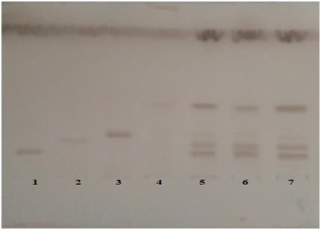

**Figure 18.** Separation of phospholipids on un-modified HPTLC silica gel 60 plates. 1: sphingomyelin, 2: phosphatydilcholine, 3: phosphatidylserine, 4: phosphatydilethanolamine, 5, 6, 7: total lipid extracts of erythrocytes phosphatidylserine

Staining of plates with modified copper (II) reagent provided higher response for sphyngomyelin compared to standard staining with sulfuric acid in methanol. Under the optimal conditions described in methodology section with SM concentrations ranging from 0.1-0.5 mg/ml there was the linearity of calibration curve [y = (2.406±0.147*107) + (3857560±420523), R=0.9925]. The precision of qTLC SM analysis was determined in five assays for each of the concentrations (0.10, 0.25, and 0.50 mg/ml) and the relative standard deviations of 4.7, 4.0, and 3.0 % were gained, respectively. The accuracy of the developed method was examined using the standard addition method and recoveries obtained were in the range from 97.1 - 102.2 %. Differences in erythrocytes’ levels of Omega-3 Index, sphyngolipids and cholesterol levels among the groups of Libyan migrants and Serbian women are presented in Figure 19., showing that Libyan women have higher Omega-3 Index values and lower erythrocytes’ sphyngolipids and cholesterol values.

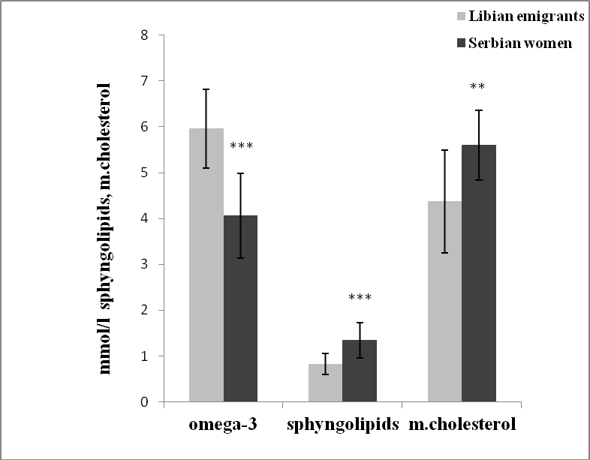

**Figure 19.** Erythrocytes’ content of sphyngolipids and cholesterol and omega-3 index in Lybian emigrants and resistant women in Serbia. ** p<0.01, *** p<0.001

Moreover, the association between erythrocytes sphyngolipids and cardio-metabolic risk factors (vitamin D level, omega-3 index, and membrane cholesterol) are found and presented in Figure 20. A significant negative correlation was seen between sphyngolipids content and Omega-3 index of erythrocytes (r = -0.492, p = 0.008). At the same time, positive correlations between sphyngolipids with vitamin D status (r = 0, 433, p = 0.021) and membrane cholesterol (r = 0, 474, p = 0.011) were found. Sphyngolipids were not associated with cardiovascular risk factors, total serum LDL and HDL cholesterol levels.

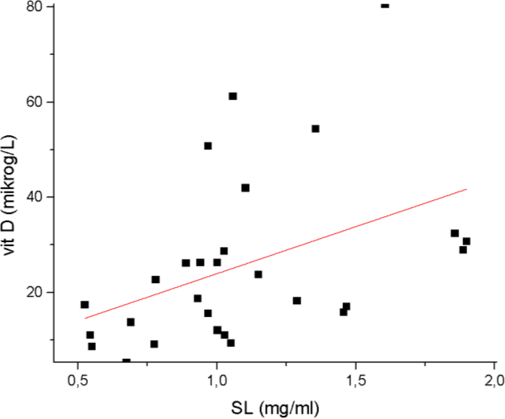

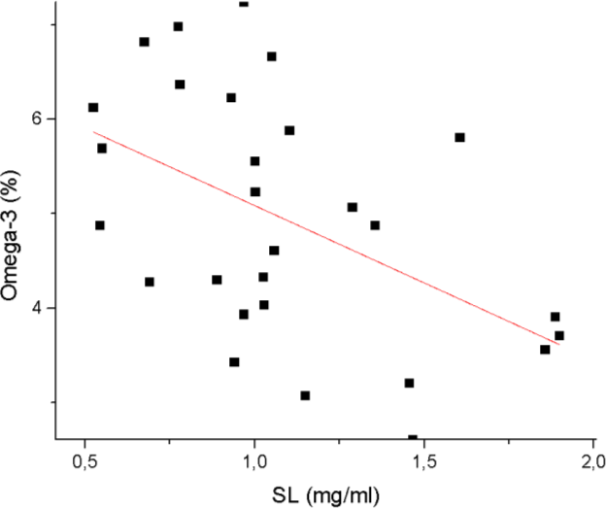

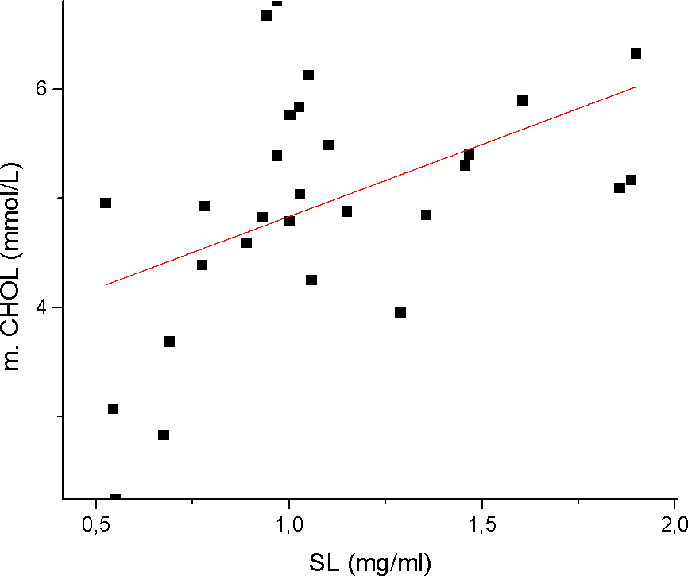

**Figure 20.** Correlations between sphyngolipids and a) vitamin D, b) omega-3 and c) membrane cholesterol.

##### Redox status parameters in Libyan emigrants and Serbian women

Data for erythrocyte levels of enzymes SOD, GPx, and catalase are presented in Table 20. SOD and GPx activities were significantly lower in Libyan women (p < 0.001, for both parameters). No significant correlations were observed between the erythrocyte levels of redox status enzymes and serum vitamin D levels, the correlation coefficients shown in Table 20.

**Table 20.** Redox status parameters in Serbian and Libyan group of women assessed measuring first line defense antioxidants: enzyme levels of SOD, catalase and GPx.

|  |  |  |  |
| --- | --- | --- | --- |
|  | Serbian women (a) | Libyan women (i) |  |
|  | n =15 | n = 13 | Correlation |
| SOD (U/mg HB) | 31.7 ± 8.0 | 18.6 ± 7.9*** | 0.322 |
| GPx (U/mg HB) | 125.8 ± 50 | 117 ± 14 | 0.160 |
| Catalase (U/mg HB) | 422 ± 93 | 245 ± 93*** | 0.221 |

HB, hemoglobin; ***p<0.001

Erythrocytes’ SOD content was 29.2 ± 7.5 U/mg HB in the group with total serum vitamin D > 50nmol/ L and 20.3 ± 11.1 U/mg HB for women with < 50nmol/ L of total vitamin D and values were significantly different among the groups (p = 0.022). There were no statistically significant differences for GPx and catalase levels between these groups.

# DISCUSSION

The major focus of this PhD project is on VDD, an ignored global epidemic, currently affecting over a billion people worldwide (Naeem, 2010). Near East, North Africa, and the Middle East region residents are significantly affected by this ailment despite the plentiful sunshine available throughout the year. VDD is particularly common among children and women in all NENA countries (Raimundo et al., 2015).

The deficiency of vitamin D has been linked to a wide range of health issues including various types of cancers, autoimmune and metabolic diseases. VDD can lead to obesity, hypertension, diabetes, depression, chronic fatigue syndrome, fibromyalgia, neurodegenerative diseases, and osteoporosis (Calvo et al., 2005). Vitamin D plays an important role in modifying the immune system and reducing the risk of developing diabetes mellitus, hypertension, and CVDs (Sung et al., 2012). The potential of vitamin D in the prevention and/or treatment of CVDs has biological credibility, however, the mechanism for how vitamin D improves CVDs outcomes is unknown, so the additional research on the links between various parameters (vitamin D and CVD factors such as serum magnesium, zinc, PUFA, redox status parameters, membrane cholesterol, and sphingolipids) would help in clarifying the protective role of vitamin D in the cardiovascular system.

The substantial scarcity of good quality data regarding vitamin D intake and status of Libyan residents’ hampers understanding the extent of the problem and subsequently prevents the establishment, and implementation of policies and actions towards eradicating VDD in this region (Bassil et al., 2013; Hwalla et al., 2016). Considering the wide-ranging consequences of VDD this health issue requires to be appropriately and timely addressed.

The general aim of this PhD research project was the development and validation of the tools that could be employed to provide up-to-date data on the dietary intake and status of vitamin D of people living in Misurata. In addition, this project examined the relationship between vitamin D intake and status with major cardiovascular risk factors including magnesium and zinc status, PUFA profile, erythrocytes phospholipids, and redox status parameters. Acquired data will create a basis for further research in this area, support the development of dietary recommendations for vitamin D intake among the Libyan population and contribute to the initiation of tailored nutritional interventions towards eradicating VDD within this population.

In this chapter, major study findings are discussed, highlighting the key research points and explaining certain limitations of the work presented in this thesis. The major contributions to knowledge obtained via this PhD project are once again summarized at the end of this chapter.

##### Research implications

This PhD project contributed to studies on VDD as a worldwide health problem and this was achieved via the following:

* Identification of the most vulnerable population group for the development of VDD in Misurata, Libya;
* Development and validation of a questionnaire for the assessment of vitamin D intake in the Libyan population and application of validated instruments among women, one of the most vulnerable populations for the development of VDD in this region;
* Assessment of vitamin D intake and status in more than 400 Libyan residents;
* Comparison of vitamin D intake and status between the Libyan women living in Serbia and apparently healthy Serbian women;
* Determination of the links between the vitamin D status and certain CVD risk factors in Libyan emigrant and Serbian resident group of women, by examining the following:

1. serum magnesium and zinc concentrations
2. sphingolipid and cholesterol content of erythrocyte membranes
3. redox stress parameters by measuring first-line defense antioxidants: enzyme levels of SOD, catalase and GPx.

##### General discussion and research implications

Vitamin D has gained a lot of public attention in recent years. There is an increasing understanding of the role of vitamin D and the consequences of inadequate intake of this important nutrient. Identification of the most vulnerable groups for the development of VDD is of crucial importance, as it would help in providing adequate support to those most in need. Therefore, the first objective of this study was to identify the most susceptible population group for the development of VDD in the Misurata region, Libya based on the vitamin D status of 455 residents from various age groups.

* + 1. Cross-sectional study of vitamin D status in Libya and identification of most vulnerable group for vitamin D deficiency

Several recent cross-sectional studies have shown that gender affects vitamin D status and that inadequate status of vitamin D was significantly more prevalent in women than in men (Vallejo et al., 2020; Yan et al., 2019; Muscogiuri et al., 2019). As the thigh association between 25 (OH) D concentrations and the percentage of fat mass was found in both females and males Muscogiuri et al. (2019) hypothesized that lower vitamin D status in females could be explained by the fact that percentage of fat mass is higher in females compared to males with comparable anthropometric measurements. The high prevalence of VDD has been recognized in studies conducted in the NENA region (Bassil et al., 2013; Green et al., 2015; El-Rassi et al., 2009; FAO, 2017). A few cross-sectional studies on vitamin D status conducted in Libya reported a high rate of VDD and identified women of childbearing age as the most vulnerable group for the development of VDD (Omar et al., 2017; Benhamed et al., 2017; Nasef et al., 2020).

Moreover, the multivariate analysis of obtained results for a recent study in the Central region of Libya (Nasef et al., 2020) has shown that VDD was significantly associated with gender and that being a female is an important risk factor related to inadequate vitamin D status. In line with these findings, analysis of the vitamin D status of more than 400 Libyan residents, performed in this study, revealed that the most vulnerable group for the development of VDD in the Misurata region were women between 25 and 64 years of age, with 81.8% of them being classified as deficient, or having inadequate serum 25 (OH) D levels.

* + 1. Prevalence of vitamin D deficiency in Libyan women

Similar findings were reported by others. In cross-sectional studies on vitamin D status suboptimal levels of biomarker 25 (OH) D were found in 73.4% of women in the Benghazi region (Omar et al., 2017), 69% of nursing mothers from Tripoli, 63% of men and women from the Central region of Libya and 98.7% of pregnant diabetic women in Western Libya (Murad et al. 2019). The prevalence of sufficient vitamin D status was only 1.3% in pregnant diabetic women in Western Libya (Murad et al., 2019). Furthermore, Helal et al. (2017) reported that VDD was highly prevalent in overweight and obese Libyan adult females in the Eastern region of Libya (Helal et al., 2017).

##### The study of dietary vitamin D intake in Libyan women

* + 1. Development and validation of LW-FFQ questionnaire

The absence of regular monitoring and evaluation practices, employment of diverse methodologies and lack of appropriately validated dietary intake/status assessment tools, are the key obstacles for suitable identification of population vitamin D nutritional status. Various nutritional assessment tools are used to obtain information on the prevalence and geographic distribution of a nutritional disorder within a community or a specified population group.

Several questionnaires are employed to identify high-risk groups and to assess the role of different epidemiological factors in the development of certain nutritional deficiencies. The general goal is not to examine the entire population in the community, but to create adequate assessment tools and limit the survey to a representative group so that the results can be generalized to the entire community (Beghin et al., 1988; Herder and Demmig-Adams, 2004).

The second objective of the present study was the development and validation of a questionnaire for the assessment of vitamin D intake in the Libyan population and the application of validated instruments among women, one of the most vulnerable population groups for the development of VDD in this region.

To achieve this aim, the FFQ applicable for Libyan women was developed and created (Annex 6). Quantitative FFQ represents a method that has been frequently used for the assessment of long- term dietary intake of foods (Thompson and Subar 2017). Djekic-Ivankovic et al. (2016) created and validated the FFQ questionnaire for the evaluation of dietary vitamin D intake in Serbian young women (Djekic-Ivankovic et al., 2016). LW-FFQ used in this study was changed for the Libyan traditional dietary habits and enriched with vitamin D food sources commonly consumed in Libya. Additionally, specific questions related to sun exposure were changed to be culturally suitable for the region. LW-FFQ covered a wide range of general questions: socio-demographic factors, lifestyle and physical activity, anthropometric measurements, consumption of supplements and a special set of questions associated with sun exposure with or without clothes and hijab. The set of inquiries used for dietary intake assessment encompassed a wide selection of vitamin D food sources, foods traditionally consumed in Libya, and included the most consumed foods from all food groups (Annex 6).

The initial step in the validation of LW-FFQ was the analysis of the association of the LW-FFQ's data for vitamin D intake with results obtained using 24HDR demonstrating a good agreement between these two methods. The vitamin D classification in quartiles to evaluate the agreement between LW-FFQ, 24HDR, and status showed that 90% of subjects were classified in the same and adjustable quartile with misclassification in only 2.5% of study participants. LW-FFQ was validated against 24HDR and vitamin D status, demonstrating a high level of agreement. High levels of agreement were observed between the intakes assessed with LW-FFQ and 24HDR, too.

* + 1. Dietary intake of vitamin D in Libyan women

Average dietary vitamin D intake in Libyan women was 3.9 ± 7.9 μg/day and 4.2±5.2 μg/day evaluated using 24HDR (Annex 5) and LW-FFQ (Annex 6) respectively. Inadequate vitamin D intake was observed in about 90% of women, according to the recommendations by IOM (10 μg/day) and EFSA recommendations (15 μg/day) for adult females.

According to literature data consumption of vitamin D supplements was low and only about 20% of the women in the Benghazi region were taking them (Omar et al., 2017). Vitamin D supplements were used by only 2.2% of participants in the present study.

There are few studies conducted in Libya that report on low vitamin D status in women. One study from the Benghazi region determined that 75% women had 25(OH)D < 50 nmol/L (Omar et al. 2017) while the other from Tripoli identified 61% nursing mothers had 25(OH)D < 30 nmol/l (Benhamed et al. 2017). Additionally, these studies report on very low consumption of vitamin D supplements and vitamin-D-rich food, which was also confirmed in the present study. There are several vitamin D fortified foods on the Libyan market, but the content of vitamin D is not specified on a product label, so these particular foods were not taken into account. Food fortification policies in Libya are not clearly defined. Fortification practices are on the voluntary basis and there are several fortified foods on the Libyan market with vitamin D, such as breakfast cereals, cocoa powder, milk, cheese and some others. This could be considered as the limitation of this study as 59.2% of participants reported consumption of fortified foods and the data could neither be added to the FCDB nor included in the Vitamin D intake calculations.

However, a major advantage of the present study is that dietary intake of vitamin D among Libyan women was, for the first time, estimated using the validated nutritional tool (Annex 6).

In the present study, major food sources of vitamin D were additionally identified based on 24HDRs. Fish and fish products were foods that contributed to total vitamin D intake with 64% followed by eggs with 15.5%, meat with 7%, and dairy with 4%. However, fish and fish products were not consumed by all participants, but only by 59% of Libyan women from the Misurata region. Furthermore, eggs, milk and chicken, important sources of vitamin D, were consumed by 83% and 100% of participants, correspondingly. The findings are in line with a Benghazi study that analyzed consumption of vitamin D food sources, and identified that dairy products (milk, butter, yoghurt) are consumed among the majority of women (72-89%), while fish is consumed less often by 50% of them.

* + 1. Factors that could affect vitamin D status in Libyan women

Besides dietary vitamin D intake, other important factors that could affect vitamin D status were explored including sun exposure, physical activity and anthropometric measurements as described in the Methods section (Annex 6).

* + - 1. Obesity and low physical activity

Sedentary, indoor lifestyle and high overweight and obesity rates were reported for up to 86% of women in Libya (Hwalla et al., 2017). According to literature data the prevalence of overweight women in Libya is 70%, with 40% of those being obese (Nations, 2003). The present study demonstrated that the prevalence of overweight and obesity in Libyan women was 23% and 60%, respectively, with WC at comorbidity risk level 2 in 62% participants. Obesity, and even more adiposity, have been positively correlated with low levels of 25(OH)D. Adipose tissue is a depot for 25(OH)D not easily released into the circulation, which explains lower values of serum 25(OH)D measurements in obese subjects (Snijder et al., 2005; Young et al., 2009).

* + - 1. Lack of exposure to the sun

Furthermore, numerous studies reported that clothing culture (veiling) and general avoidance of sun exposure, due to the cultural preferences and sun illumination intensity, are significantly contributing to the VDD problem (Holick and Chen, 2008; Hwalla et al., 2017; Omar et al., 2017). The high prevalence of sedentary lifestyle and low sun exposure were observed in this study. The majority of women in Libya wear traditional clothing and generally avoid sun exposure due to indoor lifestyle and cultural preference (Omar et al., 2017). NENA region is with plentiful sunshine throughout the year but inadequate sun exposure impedes cutaneous vitamin D synthesis (Anaizi, 2010; Bassil et al. 2013; El-Rassi et al., 2009; Omar et al. 2018; Hwalla et al., 2016). Thus, Libyan

women vitamin D intake/status relies greatly on its dietary sources, as confirmed in this study. Although the WHO is concerned about an increasing exposure to UV light, there is also an issue about VDD, especially among groups of people who cover their skin for religious or cultural reasons such as modest Muslim women (Fonseca et al. 1984). In one study in Morocco, it was found that although there is abundant sunlight in the nation, there is low sun exposure among people, as a result of excessive physical covering of the body related to socio-cultural and religious influences (Allali et al., 2009). Another study pertaining to Danish Muslim women reported a lack of sun exposure due to the skin coverage and was attributed to one of the factors related to VDD among Arab Muslim women (Glerup et al., 2000a). Consistent wearing of clothing that covers a large portion of the body is associated with lowered vitamin D levels and an increased probability of having hypovitaminosis D (Nichols et al., 2012). Wallingford (2009) reported that one of the main factors that hinders UV penetration, resulting in the alteration of the amount of vitamin D, is clothing coverage, diminishing vitamin D production by reducing the UVB rays reaching the 7-DHC in epidermal cells (Wallingford, 2009). Studies have demonstrated that skin coverage reduces vitamin D synthesis by 95-99% (Wacker and Holick, 2013). Clothing protection from UVB has been shown to vary up to 1000-fold with darker colors and tighter weaves of fabric having the highest potential for UVB protection. Like sunscreen use, extensive clothing coverage can contribute to vitamin D insufficiency and deficiency (Wallingford, 2009). All these findings point out that vitamin D intake and status of Libyan women depends significantly on their dietary eating habits and that appropriate assessment of dietary intake is of crucial importance.

* + - 1. Dietary intake of vitamin D in Serbian women

As has already been mentioned Djekic-Ivankovic et al. (2016) created FFQ questionnaire for evaluation and monitoring of dietary intake of vitamin D of young Serbian women and this validated tool was used to assess dietary intake of 300 Serbian women in this study. Similar to Libya, there is limited data available on the vitamin D intake/status in the Serbian population.

The high rates of VDD were discovered in 47% of pregnant women with and without pre- eclampsia (n = 60) and in 77% of their infants indicating that prenatal vitamin D supplementation is needed (Djekic Ivankovic et al., 2016). Miskovic et al. (2015) reported that VDD is common in patients with systemic lupus erythematosus in Serbia. In apparently healthy adults, low vitamin D status was inversely associated with obesity parameters (Pantovic et al., 2019). These results are in accordance with the low dietary vitamin D intake and status found in Serbian apparently healthy women in present study.

In summary, this study, for the first time, assessed dietary intake of vitamin D among Serbian and Libyan women using a validated nutritional tool –FFQ signifying an inadequate dietary intake of this vital nutrient among the examined groups of women.

##### The small-scale cross-sectional study in Libyan emigrant and Serbian resident women

The third objective of this PhD study was to evaluate vitamin D status in Libyan adult women migrating to Serbia. In addition, to assess a number of cardiometabolic and nutritional biomarkers related to dietary intake of vitamin D, such as erythrocytes fatty acid composition, serum magnesium and zinc concentrations, erythrocytes sphingolipids, and redox status parameters.

* + 1. Vitamin D intake and status in Libyan emigrants

The small-scale cross-sectional study on 13 Libyan emigrant women, 15 Serbian resident women once again confirmed that vitamin D intake of both groups of women was inadequate and far below the EFSA and IOM recommendations. The relationship between migration and health is complex and

always valuable to be investigated. Migrations in general can lead to both positive and negative changes of migrants' health. VDD is reported as more common in non-western immigrants and refugees than in native population (Lips and de Jongh, 2018). VDD was common in refugees moving from Pakistan to the UK (Preece et al., 1973). Comparable findings were reported for immigrant mothers from Pakistan, Somalia and Turkey and their infants living in Norway (Madar et al., 2009). Pakistani immigrant children and adults in Denmark had very low vitamin D status (Andersen et al. 2008). Sub-Sahara refugee women and children moving to Canada were vitamin D deficient (Aucoin et al., 2013). Immigrants from Africa, the Middle East and Asia living in Norway, were vitamin D deficient with a prevalence of VDD of 73% from Sub-Sahara Africa, 75% in those from South Asia and 81% in those from the Middle East (Eggemoen et al., 2013). Analogous findings were provided through this study, women migrating from Libya to Serbia had lower levels of vitamin D than native Serbian women. This finding is in line with data obtained from other cross-sectional studies that examined the same issue. Studies conducted in Dutch and Sweden compared the vitamin D status of residents and immigrants from Asia and Africa, demonstrating that VDD was more prevalent in all ethnic groups compared with the group of Dutch and Sweeden residents’ (Van Der Meer et al., 2008; Andersson et al., 2013).

The cultural and lifestyle differences of the two study groups explain observed discrepancies. Factors other than dietary intake influence the production of vitamin D in the serum, including skin pigmentation, darker pigmentation decreases the rate of conversion of this vitamin (Hwalla et al., 2016). Cultural or religious habits lead to skin-covering clothing style, additionally reducing the potential for cutaneous vitamin D production and 5 times higher risk of VDD (Erkal et al. 2006). Furthermore, premigration latitude is a significant aspect of VDD in migrants (Ruwanpathirana et al. 2014). Finally, the consumption of vitamin D supplements is low in immigrants (Lips and de Jongh, 2018), and this could be an extra factor contributing to higher rates of deficiency in immigrants.

* + 1. Association of vitamin D status with risk factors for cardiovascular diseases

Cardiometabolic diseases are a worldwide health problem, with both Serbia and Libya being identified as countries with a high incidence of cardiometabolic diseases (Mokdad et al., 2016; WHO 2011; Djekic-Ivankovic 2016; Pantovic et al. 2018) demonstrated by several studies VDD has been associated with cardiovascular risk factors (Coardz and Breland, 2006; Wang et al. 2008; Kheiri et al., 2018) so, link between CVDs and vitamin D intake and status needs to be explored further. Nevertheless, many other risk factors are contributing to the development of CVDs and they also require to be explored. In the present study, the erythrocyte fatty acid composition, serum status of magnesium and zinc, sphyngolipids, cholesterol levels of erythrocytes' membrane, and redox status antioxidant enzymes relationships with vitamin D status were examined.

* + 1. Fatty acids profiles of erythrocytes

In the Libyan group of women lower serum cholesterol concentrations and lower n-6/n-3 ratio was measured and a higher content of omega-3 fatty acids in erythrocytes. Therefore, it could be said that Libyan emigrant women had more favorable cardiometabolic status, according to the examined parameters. The important finding of this study is the difference in the fatty acid profile of erythrocytes between the groups. The high n-6/n-3 ratio in erythrocytes is associated with many diseases such as inflammatory, cardiovascular, autoimmune diseases, and cancers (Simopoulos, 2008). Some previous studies for the Serbian population have already shown that women in Serbia have a high n-6/n-3 ratio (Kardum et al. 2014a; Kardum et al. 2014b). At the moment, no literature data is showing the erythrocyte fatty acid composition in either Serbian or Libyan women, so this is a novelty of this study. An omega-3 index represents the sum of percentages of EPA and DHA is a known risk factor of coronary heart disease mortality and values higher than 8% present low-risk values. The mean omega-3 index in Libyan women was 5.65 ± 0.85 % and the group of Serbian women 4.06 ± 0.92%. Although the mean value for the omega-3 index was significantly higher in

Libyan women, Libyan women were at a lower risk of developing CVDs, but none of them reached optimal levels for omega-3 index. Thus, dietary intake of the n-3 fatty acids is recommended to be increased in both groups. The status of vitamin D was significantly inversely correlated with n-6 fatty acids in both groups. Some studies demonstrated that polyunsaturated fatty acids decrease vitamin D availability (Bouillon et al., 1992; Deng et al., 2013; Korkor and Bretzmann, 2009). Hence, lower vitamin D status in Libyan migrants could be related to higher levels of n-6 PUFA.

Average vitamin D intake for Libyan and Serbian women, was far below the proposed dietary reference values, the lower one being reported in the Libyan group. According to the latest EFSA’ recommendations intake of vitamin D should be no less than 15 μg per day, while the IOM recommends the intake of 10 μg per day or more for adult women (Bresson et al., 2016; Food et al., 2011). On the other hand, the selected group of Libyan women was with more favorable cardiometabolic status, as indicated through the lower serum cholesterol levels, and low n6/n3 ratio as well as a higher content of individual omega-3 fatty acids in RBC membranes. Irrespective of the group, the status of vitamin D was inversely correlated with the omega-6 group in RBCs. Overall, obtained data indicate associations of vitamin D status with fat metabolism in the groups of Libyan and Serbian women, irrespective of the low dietary intake of the vitamin and the fatty acid composition of erythrocytes’ membranes (Kardum et al., 2014a; Kardum et al., 2014b). In comparison with Serbian women, Libyan women had a significantly higher content of total, n-3 and n-6 PUFAs. While the contents of both n-6 and n-3 PUFA were higher in Libyan women, the relative ratio of n-6 and n-3 (n-6/n-3) was significantly lower in this group. The high n-6/n-3 ratio has been associated with the pathogenesis of inflammatory, cardiovascular, and autoimmune diseases, as well as cancers (Simopoulos, 2008). A diet ratio of 4:1 was shown to decrease the risk of mortality from CVDs by 70% (Simopoulos, 2008). In the group of Libyan females, a significantly higher omega-3 index, defined as a sum of erythrocyte EPA (C20:5n-3) and DHA (C22:6n-3) was observed.

Omega-3 index is considered to be a risk factor of coronary heart disease mortality, with values lower than 4% indicating high risk, between 4 and 8% intermediate risk and higher than 8% low risk. Significantly higher levels of total SFA, as well as palmitic acid (C16:0) were measured in the group of Serbian females. Advisory committees, such as EFSA recommend the limitation of saturated fats in the diet, due to their association with increased CVD risk. Similar findings were provided by Mu et al. 2014, an association between SFA in erythrocytes phospholipids and systemic inflammation, as a risk factor of many chronic conditions, such as CVD. The authors reported positive associations between erythrocytes’ total SFA, as well as palmitic (C16:0) and stearic (C18:0) content and levels of pro-inflammatory indicators among generally healthy adults (Mu et al., 2014).

Analysis of the association of vitamin D with other investigated parameters indicated a significant negative correlation between vitamin D and n-6 PUFA concentrations in both study groups. Previous human intervention studies demonstrated negative effects of PUFA intake on the success of vitamin D supplementation (Deng et al., 2013). Another intervention trial involving 16 long-term dialysis patients, confirmed that the addition of fish oil to vitamin D lowered the rate of this micronutrient compared with placebo (Korkor and Bretzmann, 2009).

One *in vitro* study showed that unsaturated fatty acids, particularly arachidonic acid (C20:4n-6) could interrupt the binding of vitamin D metabolites to vitamin D binding protein and, thus, decrease vitamin D availability (Bouillon et al., 1992). Considering these findings, lower vitamin D status among Libyan women could be related to higher levels of total n-6 PUFA and arachidonic acid in their erythrocytes.

Between-groups comparison of blood lipids revealed a significantly lower concentration of total cholesterol in the Libyan group, with the same trend for LDL cholesterol with the difference almost reaching statistical significance. Further on, Libyan women had significantly higher waist/height ratios, with no difference in other anthropometric indices. Applying anthropometric parameters, as additional controlling factors in the partial correlations, it was noted that different factors modulate

the observed correlation between vitamin D and n-6 PUFA in the two groups. For instance, in Serbian women, the correlation was lost in the model additionally controlled for the indices of central obesity (waist/hip or waist/height ratio) (Bener et al., 2013; Motamed et al., 2015; Pantovic et al., 2019). This finding is in accordance with a recent cross-sectional study in healthy Serbian adults, which has identified central obesity as an independent predictor of vitamin D status, specifically in adult women (Pantovic et al., 2019). Considering this, the higher vitamin D status that was observed among Serbian women could be associated with the lower waist/height ratio in this group.

* + 1. Magnesium status

Furthermore, a significantly lower concentration of magnesium was seen in Libyan women, while there were no statistically significant differences in plasma zinc concentrations between the groups. A direct correlation between vitamin D status and magnesium levels has been shown (Vidovic et al. 2019; Gandhe et al., 2013). This was explained by magnesium involvement in the regulation of vitamin D bioavailability (Vidovic et al., 2019). The important finding of the present study is that serum magnesium levels were significantly higher in resident Serbian women compared to Libyan emigrants. This was in accordance with previous studies that investigated the relation between magnesium and vitamin D levels demonstrating a significant positive correlation between vitamin D (25-hydroxy vitamin D3) and magnesium levels (Gandhe et al., 2013; Omar et al., 2017). A large population-based cross-sectional study (NHANES 2015) reported that high intake of magnesium correlated with the reduced risk of VDD (Deng et al., 2013). This could be explained by the magnesium's ability to enhance vitamin D bioavailability, which might be regulated by increasing the vitamin D binding protein levels, activating the synthesis of 25-hydroxy vitamin D, and by facilitating the activity of the PTH (Deng et al., 2013).

* + 1. Sphyngolipids content of erythrocytes

Sphyngolipids are involved in the pathology of numerous diseases including CVDs. The possible relationship between the content of sphyngolipids in erythrocytes and risk factors for development of CVDs in vitamin D deficient women has not been tested previously. This is the first time that such a relationship has been investigated. A positive correlation between vitamin D status and erythrocytes sphyngolipids is found.

Another important finding of this study is that erythrocytes sphyngolipids and cholesterol levels were significantly different among the groups of Libyan emigrant and resident women in Serbia. Moreover, the sphyngolipids levels were found to be associated with biomarkers of cardiovascular health, Omega-3 Index and membrane cholesterol suggesting that erythrocytes sphyngolipids could be an important marker of CVDs. At the same time, a positive correlation between the vitamin D status and erythrocytes sphyngolipids was found.

Cross-sectional studies have reported an association between the VDD and an increased risk of CVD, including hypertension, heart failure, and atherosclerosis (Judd and Tangpricha, 2009). Dietary intake and status of vitamin D in Libyan emigrants and Serbian resident women was shown to be inadequate. Interestingly, a direct correlation between their serum vitamin D status and erythrocytes' sphyngolipids levels was observed in this study. Obtained results are in accordance with the findings of two recent studies that explored the relationship between the serum sphyngolipids and vitamin D status. Al-Daghri and al. (2019) reported that total serum sphyngomyelins that comprise about 78% of total serum sphyngolipids were lower in normal weight and obese vitamin D deficient hyperlipemic individuals. At the same time, Chen et al. (2020) found that vitamin D3 supplementation increased serum levels of stearoil-ceramide and stearoil-sphyngomyelin in a dose-dependent fashion among overweight/obese African Americans. Results of these two studies indicated that vitamin D status is associated with sphyngolipids levels in serum, but there was no literature data for erythrocytes sphyngolipids. The initial hypothesis that vitamin D could play a role in sphyngolipids metabolism

by modifying the erythrocyte sphyngolipid content, has been demonstrated for the first time. An important finding of this study is that the sphyngolipid levels of erythrocytes are significantly associated with certain biomarkers of cardiovascular health, the Omega-3 Index, membrane cholesterol, and vitamin D levels. According to obtained data erythrocytes' sphingolipids level could be used as a promising biomarker of cardiovascular health, which certainly warrants further investigation in a larger population-specific context.

* + 1. Redox status parameters

A meta-analysis of Flores-Mateo et al. (2009) suggests that lower levels of antioxidant enzymes SOD, GPx, and/or catalase are associated with a higher risk of CVDs. According to the literature data, vitamin D supplementation could be used to improve oxidative status (Ansari et al. 2020; Afshari et al. 2015; Farhangi et al., 2017). Ansari et al. (2020) showed that vitamin D supplementation led to a favorable increase of GPx1 levels in prediabetes patients. Vitamin D affects levels of antioxidant defense enzymes GPx and SOD in granulosa cells of ovaries (Masjedi et al., 2020). Cardiac tissue concentration of GPx and SOD were increased and catalase activity levels reduced after vitamin D supplementation (Farhangi et al., 2017). In some studies, a correlation between vitamin D status and antioxidant enzymes were reported for GPx (Ansari et al., 2020) and SOD levels (Javanbakht et al., 2010). However, there were no significant associations between vitamin D status biomarker 25(OH)D with serum activities of GPx and SOD levels in ischemic stroke patients (Afshari et al., 2015).

In this study there were no significant correlations between serum vitamin D status with whole blood GPx and erythrocytes’ SOD and catalase contents, although there were significant differences in levels of GPx and catalase between the groups of Libyan migrants and Serbian women (p < 0.001). However, SOD levels were significantly higher in groups with adequate vitamin D status compared to those with inadequate and deficient. Obtained results suggest that vitamin D is associated with erythrocytes’ SOD content e.g., redox status in apparently healthy women from Libya and Serbia. The relationships between antioxidant enzymes and vitamin D status should be explored further in larger cohorts.

##### Significance of this PhD project

This PhD project contributes to the development of harmonized research infrastructure in nutrition by creating validated nutritional tools for the assessment of vitamin D intake in the NENA region (Annex 6). VDD in the whole NENA region, including Libya, has alarming proportions. Associated health implications such as obesity, non-communicable, and CVDs in the most susceptible groups, children, adolescents and women, demand multi-sectoral collaboration that will include dietary and lifestyle behavior modifications. Many of the applicable action plans are not realized on regional and national levels and there is an urgent need to reassure governments and various stakeholders to join efforts and actions towards creating innovative and targeted solutions, such as fortification and biofortification of staple foods to prevent VDD and associated health consequences.

Lower vitamin D status in Libyan migrant women residing in Serbia was found in comparison to Serbian residents, but the erythrocyte fatty acid composition together with blood lipids' concentrations showed lower cardiovascular risk in the group of Libyan women. According to the results, the discrepancy in the vitamin D status could not be attributed to the participants’ dietary intake of the micronutrient, rather it is possibly linked to ethnic-specific cardiometabolic profile, which should be confirmed in larger cohorts. The negative correlation between vitamin D status and n-6 PUFA content regardless of the group demonstrates the link between the liposoluble vitamin D and fat metabolism. Taken together, the data contribute to the rising importance of vitamin D as a promising cardiometabolic biomarker, which warrants further research in a larger population-specific

context. The intake of vitamin D was far below recommended values in both groups with a considerable proportion of study participants with plasma levels under 50 nmol/L, signifying the need for implementing public health strategies towards vitamin D food fortification, irrespective of the ethnicity or specific dietary habits.

In order to eradicate the triple burden of nutritional transition in the NENA region, The Regional Strategy on Nutrition 2010-2019 and Plan of Action sets the future targets:

* To reduce the incidence of micronutrient deficiencies (MND) incidence of calcium and VDDs among women of childbearing age, lactating women, children, and the elderly by 50%;
* To reduce the prevalence of diet-related NCDs: obesity in children, adolescents and adults by 35%.

The action plan endorses promotion of healthy food consumption patterns to ensure diet diversity, nutrition education and supplementation programs, specifically for children and women. It encourages the development of MND-sensitive food-based strategies such as food fortification and nutrition-sensitive agricultural interventions, i.e., biofortification of staple foods and local production of micronutrient-rich foods (Berti et al., 2014; WHO, 2011).

The main arguments for food fortification and biofortification are that the current food supply chains would allow reaching a wider range of consumers, predominantly those at risk, while they do not entail changes in present diet and food consumption patterns. These measures can address MNDs in situations where the existing food supplies fail to deliver adequate levels of certain nutrients in the diet due to the lack of infrastructure or underdeveloped market environments. Finally, both the health authorities and the private sector should encourage consumers to demand and obtain healthier diets**.**

# CONCLUSIONS

Summary of major achievements and main contributions to the knowledge presented within this thesis are the following:

1. Vitamin D status in Libyan women residing in the Misurata region is suboptimal

Assessment of vitamin D status in more than 400 residents of the Misurata region in Libya confirmed that VDD is very common with approximately 80% of the study participants being affected. Moreover, the most vulnerable group for the development of VDD are women between 25 and 64 years of age.

1. Prevalence of obesity, low physical activity, and poor sun exposure could contribute to inadequate vitamin D status in Libyan women

The prevalence of obesity was very high in Libyan women (63%) coupled with low intensity of physical activity. Libyan women have a sedentary lifestyle, they mainly stay indoors and have limited sun exposure, primarily due to their cultural costumes and avoidance of short sleeves and clothes. All these factors additionally contribute to poor vitamin D status in Libyan women.

1. Developed and validated nutritional tool (LW-FFQ) for assessment of vitamin D intake in Libyan population

There was a good agreement between the data obtained via LW-FFQ, 24HDR and vitamin D status. The vitamin D classification, performed in quartiles to evaluate the agreement between LW- FFQ, 24HDR, and status, revealed that 90% of the study participants belong to the same quartiles, with misclassification observed in only 2.5% of study participants, confirming a high accuracy of the FFQ, a newly developed tool for dietary intake assessment of Vitamin D in Libyan population (Annex 6).

1. Vitamin D intake in Libyan women is below the recommended values

Vitamin D intake of Libyan women was far below the suggested levels of 10 and 15 μg/day with the mean intake of 4.2 ± 5.2 μg/day and 3.9 ± 7.9 μg/day estimated using LW-FFQ and 24HDRs, respectively. Moreover, seafood and related products are the main dietary sources of vitamin D, but are not consumed daily. Furthermore, the intake of vitamin D supplements is very low, consumed by only 2.2% of the study participants. Overall, these findings indicate that even though Food Fortification policies in Libya are not clearly defined public health strategies towards vitamin D food fortification are needed.

1. Libyan women have a lower risk for the development of cardiovascular diseases

Libyan emigrant women, in comparison to women born in Serbia, had a lower risk for the development of CVDs due to the lower serum cholesterol levels and the favorable fatty acid composition of erythrocytes.

The negative correlation between vitamin D status and n-6 PUFA content in erythrocytes is shown in both groups of women (Libyan emigrants and Serbian residents). Similarly, the erythrocytes' sphyngolipids content correlated with vitamin D status in both groups. Status of n-3 and ratio of n-6/n-3 was associated with vitamin D status only in the Serbian group of women.

On the contrary, the mean serum magnesium level was lower in Libyan emigrant women. Finally, SOD levels were higher in women with optimal vitamin D status (> 50 nmol/L). Obtained results reveal that vitamin D could potentially be a promising cardiometabolic biomarker.

# REFERENCES

Abdel-Wareth, L., Haq, A., Turner, A., Khan, S., Salem, A., Mustafa, F., Hussein, N., Pallinalakam, F., Grundy, L., Patras, G., & Rajah, J. (2013). Total vitamin D assay comparison of the roche diagnostics “vitamin D total” electrochemiluminescence protein binding assay with the chromsystems HPLC method in a population with both D2 and D3 forms of vitamin D. *Nutrients*, *5*(3), 971–980. https://doi.org/10.3390/nu5030971

Agrawal, T., Gupta, G., & Agrawal, D. (2012). Vitamin D deficiency decreases the expression of VDR and prohibitin in the lungs of mice with allergic airway inflammation. *Experimental and Molecular Pathology*, *93*, 74–81. https://doi.org/10.1016/j.yexmp.2012.04.004

Ahmed, M. S., & Shoker, A. (2010). *Vitamin D metabolites ; protective versus toxic properties : molecular and cellular perspectives on om m er ci al us e om m er al*. *2*, 19–26. <https://doi.org/10.4081/nr.2010.e5>

Ahmed, L., Butler, A. E., Dargham, S. R., Latif, A., Ahmed, E. A., Hassan, A., & Atkin, S. L. (2021). Relationship between total vitamin D metabolites and complications in patients with type 2 diabetes. *Biomedical reports*, *14*(1), 18. https://doi.org/10.3892/br.2020.1394

Ahn, B.-I., Kim, M. J., Koo, H. S., Seo, N., Joo, N.-S., & Kim, Y.-S. (2014). Serum zinc concentration is inversely associated with insulin resistance but not related with metabolic syndrome in nondiabetic Korean adults. *Biological Trace Element Research*, *160*(2), 169–175. https://doi.org/10.1007/s12011-014-0045-1

Al-Dabhani, K., Tsilidis, K. K., Murphy, N., Ward, H. A., Elliott, P., Riboli, E., Gunter, M., & Tzoulaki, I. (2017). Prevalence of vitamin D deficiency and association with metabolic syndrome in a Qatari population. *Nutrition & Diabetes*, *7*(4), e263. <https://doi.org/10.1038/nutd.2017.14>

Al-Daghri, N. M., Torretta, E., Barbacini, P., Asare, H., Ricci, C., Capitanio, D., ... & Gelfi, C. (2019). Sphingolipid serum profiling in vitamin D deficient and dyslipidemic obese dimorphic adults. *Scientific reports*, *9*(1), 1-10.

Afshari, L., Amani, R., Soltani, F., Haghighizadeh, M. H., & Afsharmanesh, M. R. (2015). The relation between serum Vitamin D levels and body antioxidant status in ischemic stroke patients: A case–control study. *Advanced biomedical research*, *4*.

Allali, F., El Aichaoui, S., Khazani, H., Benyahia, B., Saoud, B., El Kabbaj, S., Bahiri, R., Abouqal, R., & Hajjaj-Hassouni, N. (2009). High prevalence of hypovitaminosis D in Morocco: relationship to lifestyle, physical performance, bone markers, and bone mineral density. *Seminars in Arthritis and Rheumatism*, *38*(6), 444–451. https://doi.org/10.1016/j.semarthrit.2008.01.009

Alshahrani, F., & Aljohani, N. (2013). Vitamin D: deficiency, sufficiency and toxicity. *Nutrients*, *5*(9), 3605–3616. https://doi.org/10.3390/nu5093605

Alveolar, H., Carter, A. B., Carter, A. B., Tephly, L. A., Venkataraman, S., Oberley, L. W., Zhang, Y., Buettner, G. R., Spitz, D. R., & Hunninghake, G. W. (2004). *High Levels of Catalase and Glutathione Peroxidase Activity Dampen H 2 O 2 High Levels of Catalase and Glutathione*

*Peroxidase Activity Dampen H 2 O 2 Signaling in Human Alveolar Macrophages*. *May 2014*. https://doi.org/10.1165/rcmb.2003-0377OC

Alyaarubi, S., & Rodd, C. (2005). Treatment of malabsorption vitamin D deficiency myopathy with intramuscular vitamin D. *Journal of Pediatric Endocrinology and Metabolism*, *18*(7), 719– 722.

Anaizi, Nasr. 2010. “Rediscovering Vitamin D.” The Libyan Journal of Medicine 5. doi: 10.3402/ljm.v5i0.5648.

Anandabaskar, N., Selvarajan, S., & Kamalanathan, S. (2018). Vitamin D in health and disease - An update. *Journal of Young Pharmacists*, *10*(4), 381–387. https://doi.org/10.5530/jyp.2018.10.85

Anandabaskar, N., Selvarajan, S., Dkhar, S. A., Kamalanathan, S. K., Tamilarasu, K., & Bobby, Z. (2017). *Effect of Vitamin D Supplementation on Vascular Functions and Oxidative Stress in Type 2 Diabetic Patients with Vitamin D Deficiency*. <https://doi.org/10.4103/ijem.IJEM>

Andersen, R., Mølgaard, C., Skovgaard, L. T., Brot, C., Cashman, K. D., Jakobsen, J., ... & Ovesen,

L. (2008). Pakistani immigrant children and adults in Denmark have severely low vitamin D status. *European Journal of Clinical Nutrition*, *62*(5), 625-634.

Andersson, Å., Björk, A., Kristiansson, P., & Johansson, G. (2013). Vitamin D intake and status in immigrant and native Swedish women: a study at a primary health care centre located at 60°N in Sweden. *Food & Nutrition Research*, *57*(1), 20089.

<https://doi.org/10.3402/fnr.v57i0.20089>

Ansari, M. G. A., Sabico, S., Clerici, M., Khattak, M. N. K., Wani, K., Al-Musharaf, S., ... & Al- Daghri, N. M. (2020). Vitamin D supplementation is associated with increased glutathione peroxidase-1 levels in Arab adults with prediabetes. *Antioxidants*, *9*(2), 118.

Armas, L. A. G., Hollis, B. W., & Heaney, R. P. (2004). Vitamin D2 is much less effective than vitamin D3 in humans. *The Journal of Clinical Endocrinology and Metabolism*, *89*(11), 5387– 5391. https://doi.org/10.1210/jc.2004-0360

Association., W. M. (2001). World Medical Association Declaration of Helsinki. Ethical principles for medical research involving human subjects. *Bulletin of the World Health Organization*, *79*(4), 373–374.

Aucoin, M., Weaver, R., Thomas, R., & Jones, L. (2013). Vitamin D status of refugees arriving in Canada: findings from the Calgary Refugee Health Program. *Canadian Family Physician*, *59*(4), e188-e194.

Bahijri, S. M. (2001). Serum 25-Hydroxy cholecalciferol in infants and preschool children in the western region of Saudi Arabia. *Etiological Factors Saudi Med J*, *22*(11), 973-979.

Bandeira, F., Griz, L., Dreyer, P., Eufrazino, C., Bandeira, C., Freese, E., F., B., L., G., P., D., C., E.,

C., B., Bandeira, F., Griz, L., Dreyer, P., Eufrazino, C., Bandeira, C., Freese, E., F., B., L., G.,

… Freese, E. (2006). Vitamin D deficiency: a global perspective. *Arquivos Brasileiros de Endocrinologia e Metabologia*, *50*(4), 640–646. https://doi.org/10.1590/S0004-

27302006000400009

Bassil, D., Rahme, M., Hoteit, M., & El-Hajj Fuleihan, G. (2013). Hypovitaminosis D in the Middle East and North Africa. *Dermato-Endocrinology*, *5*, 274–298. https://doi.org/10.4161/derm.25111

Beghin, I., Cap, M., & Dujardin, B. (1988). *A Guide to Nutritional Assessment*. https://apps.who.int/iris/bitstream/handle/10665/37419/9241542217.pdf?sequence=1&isAll owed=y

Belsey, R. E., Deluca, H. F., & Potts JR., J. T. (1974). A Rapid Assay for 25-OH-Vitamin D3 Without Preparative Chromatography*. *The Journal of Clinical Endocrinology & Metabolism*, *38*(6), 1046–1051. https://doi.org/10.1210/jcem-38-6-1046

Bener, A., Yousafzai, M. T., Darwish, S., Al-Hamaq, A. O. A. A., Nasralla, E. A., & Abdul-Ghani,

M. (2013). Obesity index that better predict metabolic syndrome: body mass index, waist circumference, waist hip ratio, or waist height ratio. *Journal of Obesity*, *2013*, 269038. https://doi.org/10.1155/2013/269038

Benhamed, M. M., Marwan, A. G., Dekna, M. A., Ahmad, A. A., Mofida, M., Aref, G., Mohamed, A., & Ahmad, A. A. (2017). Vitamin D levels and rickets indices among infants and their nursing mothers in Tripoli--Libya. *The Libyan Journal of Agriculture*, *22*(1), 47–60.

Berti, C., Faber, M., & Smuts, C. M. (2014). Prevention and control of micronutrient deficiencies in developing countries: current perspectives. *Nutrition and Dietary Supplements*, *6*, 41–57.

Bhat, M., & Ismail, A. (2015). Vitamin D treatment protects against and reverses oxidative stress induced muscle proteolysis. *The Journal of Steroid Biochemistry and Molecular Biology*, *152*, 171–179. https://doi.org/10.1016/j.jsbmb.2015.05.012

Bikle, D. D. (2014). Vitamin D metabolism, mechanism of action, and clinical applications.

*Chemistry & Biology*, *21*(3), 319–329. https://doi.org/10.1016/j.chembiol.2013.12.016

Bjelakovic, G., Gluud, L. L., Nikolova, D., Whitfield, K., Wetterslev, J., Simonetti, R. G., Bjelakovic, M., & Gluud, C. (2014). Vitamin D supplementation for prevention of mortality in adults. *The Cochrane Database of Systematic Reviews*, *1*, CD007470. https://doi.org/10.1002/14651858.CD007470.pub3

Bland, J. M., & Altman, D. G. (1986). Statistical methods for assessing agreement between two methods of clinical measurement. *Lancet (London, England)*, *1*(8476), 307–310.

Bland, J. M., & Altman, D. G. (1996). Statistics Notes: Measurement error and correlation coefficients. *Bmj*, *313*(7048), 41–42. https://doi.org/10.1136/bmj.313.7048.41

Boland, R. (1986). Role of Vitamin D in Skeletal Muscle Function*. *Endocrine Reviews*, *7*(4), 434– 448. https://doi.org/10.1210/edrv-7-4-434

Bolland, M. J., & Grey, A. (2010). Benefits of Vitamin D? *American Journal of Medicine*, *123*(2), e17. https://doi.org/10.1016/j.amjmed.2009.09.021

Bordelon, P., Ghetu, M. V, & Langan, R. C. (2009). Recognition and management of vitamin D deficiency. *American Family Physician*, *80*(8), 841–846.

Bouillon, R. (2017). Comparative analysis of nutritional guidelines for vitamin D. *Nature Reviews.*

*Endocrinology*, *13*(8), 466–479. https://doi.org/10.1038/nrendo.2017.31

Bouillon, R., Xiang, D. Z., Convents, R., & Van Baelen, H. (1992). Polyunsaturated fatty acids decrease the apparent affinity of vitamin D metabolites for human vitamin D-binding protein. *The Journal of Steroid Biochemistry and Molecular Biology*, *42*(8), 855–861. https://doi.org/10.1016/0960-0760(92)90094-y

Bresson, J. L., Burlingame, B., Dean, T., Fairweather-Tait, S., Heinonen, M., Hirsch-Ernst, K. I., Mangelsdorf, I., Mcardle, H., Naska, A., Neuhäuser-Berthold, M., & Others. (2016). Scientific opinion on dietary reference values for vitamin D. EFSA panel on dietetic products, nutrition, and allergies (NDA). *Efsa J*, *14*(10), 4547.

Brett, N. R., Gharibeh, N., & Weiler, H. A. (2018). Effect of Vitamin D Supplementation, Food Fortification, or Bolus Injection on Vitamin D Status in Children Aged 2-18 Years: A Meta- Analysis. *Advances in Nutrition (Bethesda, Md.)*, *9*(4), 454–464. https://doi.org/10.1093/advances/nmy012

Cade, J., Thompson, R., Burley, V., & Warm, D. (2002). *Development , validation and utilisation of food-frequency questionnaires – a review*. *5*(4), 567–587. https://doi.org/10.1079/PHN2001318

Calvo, M. S., Whiting, S. J., & Barton, C. N. (2004). Vitamin D fortification in the United States and Canada: current status and data needs. *The American Journal of Clinical Nutrition*, *80*(6 Suppl), 1710S--6S. https://doi.org/10.1093/ajcn/80.6.1710S

Calvo, M. S., Whiting, S. J., & Barton, C. N. (2005). *Symposium : Vitamin D Insufficiency : A Significant Risk Factor in Chronic Diseases and Potential Disease-Specific Biomarkers of Vitamin D Sufficiency Vitamin D Intake : A Global Perspective of Current Status 1*. *25*(2), 310–316.

Cesareo, R., Attanasio, R., Caputo, M., Castello, R., Chiodini, I., Falchetti, A., ... & Scillitani, A. (2018). Italian chapter of the American Association of Clinical Endocrinologists (AACE) position statement: Clinical management of vitamin D deficiency in adults. *Nutrients*, *10*(5), 546.

Chakhtoura, M., Rahme, M., Chamoun, N., Fuleihan, G. E., & El-Hajj Fuleihan, G. (2018). Bone Reports Vitamin D in the Middle East and North Africa. *Bone Reports*, *8*(March), 135–146. https://doi.org/10.1016/j.bonr.2018.03.004

Chakraborti, C. (2011). Vitamin D as a promising anticancer agent. *Indian Journal of Pharmacology*, *43*(2), 113–120. <https://doi.org/10.4103/0253-7613.77335>

Charoenngam, N., & Holick, M. F. (2020). Immunologic effects of vitamin D on human health and disease. *Nutrients*, *12*(7), 2097.

Chen, H., Born, E., Mathur, S. N., Johlin Jr, F. C., & Field, F. J. (1992). Sphingomyelin content of intestinal cell membranes regulates cholesterol absorption. Evidence for pancreatic and intestinal cell sphingomyelinase activity. *Biochemical Journal*, *286*(3), 771-777.

Chen, L., Dong, Y., Bhagatwala, J., Raed, A., Huang, Y., & Zhu, H. (2020). Vitamin D3 Supplementation Increases Long-Chain Ceramide Levels in Overweight/Obese African Americans: A Post-Hoc Analysis of a Randomized Controlled Trial. *Nutrients*, *12*(4), 981.

Chowdhury, S., & pratim Chakraborty, P. (2017). Universal health coverage - There is more to it than meets the eye. *Journal of Family Medicine and Primary Care*, *6*(2), 169–170. https://doi.org/10.4103/jfmpc.jfmpc

Christakos, S., Dhawan, P., Verstuyf, A., Verlinden, L., & Carmeliet, G. (2016). Vitamin D: Metabolism, Molecular Mechanism of Action, and Pleiotropic Effects. *Physiological Reviews*, *96*(1), 365–408. https://doi.org/10.1152/physrev.00014.2015

Christopherson, S. W., & Glass, R. L. (1969). Preparation of Milk Fat Methyl Esters by Alcoholysis in an Essentially Nonalcoholic Solution1. *Journal of Dairy Science*, *52*(8), 1289–1290. https://doi.org/10.3168/jds.s0022-0302(69)86739-1

Chu, A., Foster, M., & Samman, S. (2016). Zinc Status and Risk of Cardiovascular Diseases and Type 2 Diabetes Mellitus-A Systematic Review of Prospective Cohort Studies. *Nutrients*, *8*(11), 707. https://doi.org/10.3390/nu8110707

Chua, G. T., Chan, Y. C., & Cheng, S. W. (2011). Vitamin D status and peripheral arterial disease: evidence so far. *Vascular Health and Risk Management*, *7*, 671–675. <https://doi.org/10.2147/VHRM.S24876>

Claiborne, A. (1985). Handbook of methods for oxygen radical research. *Florida: CRC Press, Boca Raton*, 283-284.

Coardz, I., & Breland, M. (2006). *Perceptions of and Preferences for Skin Color , Black Racial Identity , and Self ‐ Esteem Among African Perceptions of and Preferences for Skin Color , Black Racial Identity , and Self-Esteem Among*. *July*. [https://doi.org/10.1111/j.1559-](https://doi.org/10.1111/j.1559-1816.2001.tb00174.x) [1816.2001.tb00174.x](https://doi.org/10.1111/j.1559-1816.2001.tb00174.x)

Coelho, F. P., & Alves, F. A. (1946). Liebermann-Burchard reaction. *Nature*, *157*(3998), 803-803.

Consultation, W. H. O. (2000). Obesity: preventing and managing the global epidemic. *World Health Organization technical report series*, *894*, 1-253.

Cranney, A., Horsley, T., Donnell, O. S., Weiler, H., Puil, L., Ooi, D., Atkinson, S., Ward, L., Moher, D., Hanley, D., Fang, M., Yazdi, F., & Garritty, C. (2019). *Effectiveness and safety of vitamin D in relation to bone health*. 1–4.

Dawodu, A., Dawson, K. P., Amirlak, I., Kochiyil, J., Agarwal, M., & Badrinath, P. (2001). Diet, clothing, sunshine exposure and micronutrient status of Arab infants and young children. *Annals of Tropical Paediatrics*, *21*(1), 39–44.

Dawson-Hughes, B., Harris, S. S., Lichtenstein, A. H., Dolnikowski, G., Palermo, N. J., & Rasmussen, H. (2015). Dietary Fat Increases Vitamin D-3 Absorption. *Journal of the Academy of Nutrition and Dietetics*, *115*(2), 225–230. https://doi.org/10.1016/j.jand.2014.09.014

de Lorgeril, M., & Salen, P. (2012). New insights into the health effects of dietary saturated and omega-6 and omega-3 polyunsaturated fatty acids. *BMC Medicine*, *10*(1), 50. https://doi.org/10.1186/1741-7015-10-50

Debreceni, B., & Debreceni, L. (2014). *The Role of Homocysteine-Lowering B-Vitamins in the Primary Prevention of Cardiovascular Disease Homocysteine is a Suspected Etiological Factor for Cardiovascular Disease*. *32*, 130–138. https://doi.org/10.1111/1755-5922.12064

Deng, X., Song, Y., Manson, J. E., Signorello, L. B., Zhang, S. M., Shrubsole, M. J., Ness, R. M., Seidner, D. L., & Dai, Q. (2013). Magnesium, vitamin D status and mortality: results from US National Health and Nutrition Examination Survey (NHANES) 2001 to 2006 and NHANES III. *BMC Medicine*, *11*, 187. https://doi.org/10.1186/1741-7015-11-187

Divasta, A. D., Feldman, H. A., Brown, J. N., Giancaterino, C., Holick, M. F., & Gordon, C. M. (2011). Bioavailability of vitamin D in malnourished adolescents with anorexia nervosa. *The Journal of Clinical Endocrinology and Metabolism*, *96*(8), 2575–2580. https://doi.org/10.1210/jc.2011-0243

Djekic-Ivankovic, M., Weiler, H. A., Nikolic, M., Kadvan, A., Gurinovic, M., Mandic, L. M., & Glibetic, M. (2016). Validity of an FFQ assessing the Vitamin D intake of young Serbian women living in a region without food fortification: the method of triads model. *Public Health Nutrition*, *19*(3), 437–445. <https://doi.org/10.1017/S136898001500138X>

D METABOLISM, T. V. (2016). Vitamin D Deficiencies in Patients with Disorders of the Digestive System: Current Knowledge and Practical Considerations. *PRACTICAL GASTROENTEROLOGY*, 37.

Dostalek, M., Prueksaritanont, T., & Kelley, R. F. (2017). Pharmacokinetic de-risking tools for selection of monoclonal antibody lead candidates. *MAbs*, *9*(5), 756–766. https://doi.org/10.1080/19420862.2017.1323160

EFSA Panel on Dietetic Products, Nutrition and Allergies (NDA). (2016). Dietary reference values for vitamin D. *EFSA Journal*, *14*(10), e04547. https://doi.org/https://doi.org/10.2903/j.efsa.2016.4547

Eggemoen, Å. R., Knutsen, K. V., Dalen, I., & Jenum, A. K. (2013). Vitamin D status in recently arrived immigrants from Africa and Asia: a cross-sectional study from Norway of children, adolescents and adults. *BMJ open*, *3*(10), e003293.

Eileen, S., & Geier, S. E. (2020). *Clinical Practice Recommendations for Screening Patients with Type-2 Diabetes for Vitamin D Deficiency : An Integrative Literature Review by In the Graduate College*.

Elmadfa, I., Meyer, A., Wottawa, D., Wagner, K., & Hasenegger, V. (2018). *Vitamin D Intake and Status in Austria and Its Effects on Some Health Indicators*.

El-Rassi, B. Y. R., & Baliki, G. (2009). Vitamin D status in Middle East and Africa. *International Osteoporosis Foundation*, 1–8.

Erkal, M. Z., Wilde, J., Bilgin, Y., Akinci, A., Demir, E., Bödeker, R. H., ... & Holick, M. F. (2006). High prevalence of vitamin D deficiency, secondary hyperparathyroidism and generalized

bone pain in Turkish immigrants in Germany: identification of risk factors. *Osteoporosis international*, *17*(8), 1133-1140.

Kennel, K. A., Drake, M. T., & Hurley, D. L. (2010). . Vitamin D deficiency in adults: When to test and how to treat. *Mayo Clinic Proceedings*, *85*(8), 752–758. https://doi.org/10.4065/mcp.2010.0138

European Food Safety Authority (EFSA), Parma, I. (2017). Scientific Opinion on Dietary Reference Values for fats, including saturated fatty acids, polyunsaturated fatty acids, monounsaturated fatty acids, trans fatty acids, and cholesterol. *EFSA Journal*, *8*(3), 1–107. https://doi.org/10.2903/j.efsa.2010.1461

Expert Panel on Detection, E., & of High Blood Cholesterol in Adults, T. (2001). Executive Summary of the Third Report (NCEP) -Adult Treatment Panel III. *Journal of American Medical Association*, *285*(19), 2486–2497. https://doi.org/10.1001/jama.285.19.2486

Faid, F., Nikolic, M., Milesevic, J., Zekovic, M., Kadvan, A., Gurinovic, M., & Glibetic, M. (2018). Assessment of vitamin D intake among Libyan women–adaptation and validation of specific food frequency questionnaire. *Libyan Journal of Medicine*, *13*(1). <https://doi.org/10.1080/19932820.2018.1502028>

Farhangi, M. A., Nameni, G., Hajiluian, G., & Mesgari-Abbasi, M. (2017). Cardiac tissue oxidative stress and inflammation after vitamin D administrations in high fat-diet induced obese rats. *BMC cardiovascular disorders*, *17*(1), 1-7.

Feskanich, D., Rimm, E. B., Giovannucci, E. L., Colditz, G. A., Stampfer, M. J., Litin, L. B., & Willett, W. C. (1993). Reproducibility and validity of food intake measurements from a semiquantitative food frequency questionnaire. *Journal of the American Dietetic Association*, *93*(7), 790–796. https://doi.org/10.1016/0002-8223(93)91754-e

Fisher, R. M., & Sjögren, P. (2013). *Fatty acid composition in relation to the metabolic syndrome and associated cardiovascular risk factors*. *2976*.

<https://doi.org/10.1080/17482970601074177>

Flores-Mateo, G., Carrillo-Santisteve, P., Elosua, R., Guallar, E., Marrugat, J., Bleys, J., & Covas,

M. I. (2009). Antioxidant enzyme activity and coronary heart disease: meta-analyses of observational studies. *American journal of epidemiology*, *170*(2), 135-147.

Fonseca, V., Tongia, R., El-Hazmi, M., & Abu-Aisha, H. (1984). Exposure to sunlight and vitamin D deficiency in Saudi Arabian women. *Postgraduate Medical Journal*, *60*(707), 589–591. https://doi.org/10.1136/pgmj.60.707.589

Food and Nutrition Board, Institute of Medicine, National Academies, & Food and Nutrition Board, Institute of Medicine, National Academies. (2004). Dietary Reference Intakes (DRIs): Estimated Average Requirements. *Nutrition Reviews*, *62*(10), 400-401.

Foster, E., Lee, C., Imamura, F., Hollidge, S. E., Westgate, K. L., Venables, M. C., Poliakov, I., Rowland, M. K., Osadchiy, T., Bradley, J. C., Simpson, E. L., Adamson, A. J., Olivier, P., Wareham, N., Forouhi, N. G., & Brage, S. (2019). Validity and reliability of an online self- report 24-h dietary recall method (Intake24): a doubly labelled water study and repeated- measures analysis. *Journal of Nutritional Science*, *8*, e29. https://doi.org/DOI: 10.1017/jns.2019.20

Francini-Pesenti, F., Spinella, P., & Calò, L. A. (2019). Potential role of phytochemicals in metabolic syndrome prevention and therapy. *Diabetes, Metabolic Syndrome and Obesity : Targets and Therapy*, *12*, 1987–2002. https://doi.org/10.2147/DMSO.S214550

Gallagher, J. C. (2013). Vitamin D and Aging. *Endocrinology and Metabolism Clinics of North America*, *42*(2), 319–332. https://doi.org/https://doi.org/10.1016/j.ecl.2013.02.004

Gandhe, M. B., Jain, K., & Gandhe, S. M. (2013). *Evaluation of 25 ( OH ) Vitamin D 3 with Reference to Magnesium Status and Insulin Resistance in T2DM*. *25*(11), 2438–2441. https://doi.org/10.7860/JCDR/2013/6578.3568

Gavrieli, A., Naska, A., Konstantinidi, C., Berry, R., Roe, M., Harvey, L., Finglas, P., Glibetic, M., Gurinovic, M., & Trichopoulou, A. (2014). Dietary Monitoring Tools for Risk Assessment. *EFSA Supporting Publications*, *11*(5). https://doi.org/10.2903/sp.efsa.2014.en-607

Glerup, H., Mikkelsen, K., Poulsen, L., Hass, E., Overbeck, S., Thomsen, J., Charles, P., & Eriksen,

E. F. (2000a). Commonly recommended daily intake of vitamin D is not sufficient if sunlight exposure is limited. *Journal of Internal Medicine*, *247*(2), 260–268. <https://doi.org/10.1046/j.1365-2796.2000.00595.x>

Glerup, H., Mikkelsen, K., Poulsen, L., Hass, E., Overbeck, S., Andersen, H., Charles, P., & Eriksen,

E. F. (2000b). Hypovitaminosis D Myopathy Without Biochemical Signs of Osteomalacic Bone Involvement. *Calcified Tissue International*, *66*(6), 419–424. https://doi.org/10.1007/s002230010085

Glew, R. H., Crossey, M. J., Polanams, J., Okolie, H. I., & VanderJagt, D. J. (2010). Vitamin D status of seminomadic Fulani men and women. *Journal of the National Medical Association*, *102*(6), 485–490.

Goodman, S. E., & Goodman, S. E. (2015a). *Vitamin D Knowledge , Perceptions , Intake and Status among Young Adults : a Validation & Intervention Study Using A Mobile ‘ App ’ by Vitamin D Knowledge , Perceptions , Intake and Status among Young Adults : a Validation & Intervention Study Using A Mob*.

Goodman, S., Morrongiello, B., Simpson, J. R., & Meckling, K. (2015b). Vitamin D Intake Among Young Canadian Adults : Validation of a Mobile Vitamin D Calculator App. *Journal of Nutrition Education and Behavior*, *47*(3), 242--247.e1. https://doi.org/10.1016/j.jneb.2014.11.006

Gouni-Berthold, I., & Berthold, H. K. (2020). Vitamin D and vascular disease. *Current Vascular Pharmacology*. https://doi.org/10.2174/1570161118666200317151955

Gouni-Berthold, I., Krone, W., & Berthold, H. K. (2009). Vitamin D and cardiovascular disease. *Current Vascular Pharmacology*, *7*(3), 414–422. https://doi.org/10.2174/157016109788340686

Green, J., Charman, T., Pickles, A., Wan, M. W., Elsabbagh, M., Slonims, V., Taylor, C., McNally, J., Booth, R., Gliga, T., Jones, E. J. H., Harrop, C., Bedford, R., & Johnson, M. H. (2015). Parent-mediated intervention versus no intervention for infants at high risk of autism: A parallel, single-blind, randomised trial. *The Lancet Psychiatry*, *2*(2), 133–140. https://doi.org/10.1016/S2215-0366(14)00091-1

Green, R. J., Samy, G., Miqdady, M. S., El-Hodhod, M., Akinyinka, O. O., Saleh, G., Haddad, J., Alsaedi, S. A., Mersal, A. Y., Edris, A., & Salah, M. (2015). Vitamin D deficiency and insufficiency in Africa and the Middle East, despite year-round sunny days. *South African Medical Journal*, *105*(7), 603–605. <https://doi.org/10.7196/samjnew.7785>

Gröber, U., & Kisters, K. (2012). Influence of drugs on vitamin D and calcium metabolism. *Dermato- endocrinology*, *4*(2), 158-166.

Gurinovic, M., Milešević, J., Romana, N., Agnes, K., Djekic-Ivankovic, M., Satalic, Z., Korošec, M., Spiroski, I., Ranić, M., Dupouy, E., Oshaug, A., Finglas, P., & Glibetic, M. (2015). Improving Nutrition Surveillance and Public Health Research in Central and Eastern Europe/Balkan Countries Using the Balkan Food Platform and Dietary Tools. *Food Chemistry*, *193*. https://doi.org/10.1016/j.foodchem.2015.03.103

Gurinović, M., Milešević, J., Kadvan, A., Nikolić, M., Zeković, M., Djekić-Ivanković, M., Dupouy, E., Finglas, P., & Glibetić, M. (2018). Development, features and application of DIET ASSESS & PLAN (DAP) software in supporting public health nutrition research in Central Eastern European Countries (CEEC). *Food Chemistry*, *238*, 186–194. https://doi.org/10.1016/j.foodchem.2016.09.114

Hammoud, M. M., White, C. B., & Fetters, M. D. (2005). *Opening cultural doors : Providing culturally sensitive healthcare to Arab American and American Muslim patients*. <https://doi.org/10.1016/j.ajog.2005.06.065>

Handloser, D., Widmer, V., & Reich, E. (2008). Separation of phospholipids by HPTLC–an investigation of important parameters. *Journal of Liquid Chromatography & Related Technologies®*, *31*(13), 1857-1870.

Hedrick, V. E., Dietrich, A. M., Estabrooks, P. A., Savla, J., Serrano, E., & Davy, B. M. (2012). Dietary biomarkers: advances, limitations and future directions. *Nutrition Journal*, *11*(1), 109. <https://doi.org/10.1186/1475-2891-11-109>

Helal, F., Faraj, A., Kablan, N., Elfakhri, M., & Bukhatwa, S. (2017). Prevalence of vitamin d deficiency among overweight and obese Libyan females.

Herder, R., & Demmig-Adams, B. (2004). The power of a balanced diet and lifestyle in preventing cardiovascular disease. *Nutrition in Clinical Care : An Official Publication of Tufts University*, *7*(2), 46–55.

Holick, M. F. (2006). High prevalence of vitamin D inadequacy and implications for health. *Mayo Clinic Proceedings*, *81*(3), 353–373. https://doi.org/10.4065/81.3.353

Holick, M. F. (2006). Resurrection of vitamin D deficiency and rickets. *The Journal of Clinical Investigation*, *116*(8), 2062–2072. https://doi.org/10.1172/JCI29449

Holick, M. F. (2009). Vitamin D status: measurement, interpretation, and clinical application. *Annals of Epidemiology*, *19*(2), 73–78. https://doi.org/10.1016/j.annepidem.2007.12.001

Holick, M. F. (2011). *Vitamin D : A D-Lightful Solution for Health*. *59*(6). https://doi.org/10.231/JIM.0b013e318214ea2d

Holick, M. F., & Chen, T. C. (2008). Vitamin D deficiency: a worldwide problem with health consequences. *The American Journal of Clinical Nutrition*, *87*(4), 1080S--6S. https://doi.org/10.1093/ajcn/87.4.1080S

Holick, M. F., Binkley, N. C., Bischoff-Ferrari, H. A., Gordon, C. M., Hanley, D. A., Heaney, R. P., Murad, M. H., & Weaver, C. M. (2011). Evaluation, Treatment, and Prevention of Vitamin D Deficiency: an Endocrine Society Clinical Practice Guideline. *The Journal of Clinical Endocrinology & Metabolism*, *96*(7), 1911–1930. https://doi.org/10.1210/jc.2011-0385

Hollis, B. W., & Napoli, J. L. (1985). Improved radioimmunoassay for vitamin D and its use in assessing vitamin D status. *Clinical Chemistry*, *31*(11), 1815–1819.

Huang, H. S., Kuan, J. C. W., & Guilbault, G. G. (1975). Fluorometric enzymatic determination of total cholesterol in serum. *Clinical Chemistry*, *21*(11), 1605–1608.

Hwalla, N., Al Dhaheri, A. S., Radwan, H., Alfawaz, H. A., Fouda, M. A., Al-Daghri, N. M., Zaghloul, S., & Blumberg, J. B. (2017). The Prevalence of Micronutrient Deficiencies and Inadequacies in the Middle East and Approaches to Interventions. *Nutrients*, *9*(3), 229. https://doi.org/10.3390/nu9030229

Hwalla, N., Weaver, C., Mekary, R., & El Labban, S. (2016). Editorial: Public Health Nutrition in the Middle East. *Frontiers in Public Health*, *4*. https://doi.org/10.3389/fpubh.2016.00033

Intakes, D. R., Committee, F. S., Evaluation, S., Intakes, D. R., Board, N., Isbn, M., Pdf, T., Press,

N. A., Press, N. A., Academy, N., Academy, N., & Press, N. A. (1997). *DIETARY REFERENCE INTAKES*.

Iraj, B., Ebneshahidi, A., & Askari, G. (2012). Vitamin D Deficiency , Prevention and Treatment.

*International Journal of Preventive Medicine*, *3*(10), 733–736.

Jackson, M. D., Walker, S. P., Younger, N. M., & Bennett, F. I. (2011). *Use of a food frequency questionnaire to assess diets of Jamaican adults : validation and correlation with biomarkers*. 1–11.

Janik, S., Nowak, U., Łaszkiewicz, A., Satyr, A., Berkowska, K., & Gabry, M. (2017). *Diverse Regulation of Vitamin D Receptor Gene Expression by 1 , 25-Dihydroxyvitamin D and ATRA in Murine and Human Blood Cells at Early Stages of Their Differentiation*. https://doi.org/10.3390/ijms18061323

Janssen, H., Samson, M., & Verhaar, H. (2002). Janssen HC, Samson MM, Verhaar HJ. Vitamin D deficiency, muscle function, and falls in elderly people. Am J Clin Nutr. 2002;75:611-615. *American Journal of Clinical Nutrition*, *75*, 611–615.

Javanbakht, M., Keshavarz, S., Mirshafiey, A., Djalali, M., Siassi, F., Eshraghian, M., Firooz, A., Seirafi, H., Ehsani, A., & Chamari, M. (2010). The effects of vitamins e and d supplementation on erythrocyte superoxide dismutase and catalase in atopic dermatitis. *Iranian Journal of Public Health*, *39*(1), 57–63. https://pubmed.ncbi.nlm.nih.gov/23112990

Jenkins, D. J. A., Spence, J. D., Giovannucci, E. L., Kim, Y.-I., Josse, R., Vieth, R., Blanco Mejia, S., Viguiliouk, E., Nishi, S., Sahye-Pudaruth, S., Paquette, M., Patel, D., Mitchell, S., Kavanagh, M., Tsirakis, T., Bachiri, L., Maran, A., Umatheva, N., McKay, T., … Sievenpiper,

J. L. (2018). Supplemental Vitamins and Minerals for CVD Prevention and Treatment.

*Journal of the American College of Cardiology*, *71*(22), 2570–2584. https://doi.org/10.1016/j.jacc.2018.04.020

Jeon, S. (2018). Exploring vitamin D metabolism and function in cancer. *Experimental & Molecular Medicine*. https://doi.org/10.1038/s12276-018-0038-9

Jian-Xin, Q. (1990). *and K in serum flame by atomic absorption spectroscopy*. 1–2. <http://faculty.sdmiramar.edu/fgarces/labmatters/instruments/aa/AAS_Experiments/AAS_Bl> ood.pdf

José, M., Costa, D. C., & Fisberg, R. M. (2008). *Diet and cancer in Northeast Brazil : evaluation of eating habits and food group consumption in relation to breast cancer Dieta e câncer no Nordeste do Brasil : avaliação da relação entre alimentação e consumo de grupos de alimentos e câncer de mama*. *24*(4), 820–828.

Judd, S., & Tangpricha, V. (2009). Vitamin D Deficiency and Risk for Cardiovascular Disease. *The American Journal of the Medical Sciences*, *338*, 40–44. https://doi.org/10.1097/MAJ.0b013e3181aaee91

Kardum, N., Petrović-Oggiano, G., Takic, M., Glibetić, N., Zec, M., Debeljak-Martacic, J., & Konić- Ristić, A. (2014a). Effects of glucomannan-enriched, aronia juice-based supplement on cellular antioxidant enzymes and membrane lipid status in subjects with abdominal obesity. *TheScientificWorldJournal*, *2014*, 869250. https://doi.org/10.1155/2014/869250

Kardum, N., Takić, M., Šavikin, K., Zec, M., Zdunić, G., Spasić, S., & Konić-Ristić, A. (2014b). Effects of polyphenol-rich chokeberry juice on cellular antioxidant enzymes and membrane lipid status in healthy women. *Journal of Functional Foods*, *9*, 89–97.

Kassi, E., Pervanidou, P., Kaltsas, G., & Chrousos, G. (2011). Metabolic syndrome : definitions and controversies. *BMC Medicine*, *9*(1), 48. https://doi.org/10.1186/1741-7015-9-48

Kastorini, C.-M., Milionis, H. J., Esposito, K., Giugliano, D., Goudevenos, J. A., & Panagiotakos, D.

B. (2011). The effect of Mediterranean diet on metabolic syndrome and its components: a meta-analysis of 50 studies and 534,906 individuals. *Journal of the American College of Cardiology*, *57*(11), 1299–1313. https://doi.org/10.1016/j.jacc.2010.09.073

Keyzer, W. De. (2014). Methodological aspects of dietary intake assessment in food consumption surveys: from a national to an international level. *Faculty of Medicine and Health Sciences*.

Kheiri, B., Abdalla, A., Osman, M., Ahmed, S., Hassan, M., & Bachuwa, G. (2018). Vitamin D deficiency and risk of cardiovascular diseases: a narrative review. *Clinical Hypertension*, *24*, 9. https://doi.org/10.1186/s40885-018-0094-4

Klevay, B. L. M., Combs, G. F., Klevay, L. M., & Combs, G. F. (2004). *Mineral elements related to cardiovascular health Mineral Elements Related to Cardiovascular Health*. 1–15.

Kong, H., & West, S. (2013). *WMA DECLARATION OF HELSINKI – ETHICAL PRINCIPLES FOR*

*Scienti c Requirements and Research Protocols*. *October 1975*, 29–32.

Korkor, A. B., & Bretzmann, C. (2009). Effect of Fish Oil on Vitamin D Absorption. *American Journal of Kidney Diseases*, *53*(2), 356. https://doi.org/10.1053/j.ajkd.2008.11.010

Kraft, M. L. (2017). *Sphingolipid Organization in the Plasma Membrane and the Mechanisms That Influence It*. *4*(January), 1–19. https://doi.org/10.3389/fcell.2016.00154

Krishnan, A., Gandour, J. T., & Bidelman, G. M. (2010). The effects of tone language experience on pitch processing in the brainstem. *Journal of Neurolinguistics*, *23*(1), 81–95. https://doi.org/10.1016/j.jneuroling.2009.09.001

Kunst A, Draeger B, Z. J. M. 1. (1984). *carbohydrates. In: Bergmeyer, editor. Methods of enzymatic analysi*. *6*(Wiley Blackwell), 163–172.

Laleye, L. C., Kerkadi, A. H., Wasesa, A. A., & Madduri, V. (2016). *Assessment of vitamin D and vitamin A intake by female students at the United Arab Emirates University based on self- reported dietary and selected fortified food consumption*. *November*. https://doi.org/10.3109/09637486.2010.533159

Lamprecht, S. A., & Lipkin, M. (2003). Chemoprevention of colon cancer by calcium, vitamin D and folate: molecular mechanisms. *Nature Reviews. Cancer*, *3*(8), 601–614. https://doi.org/10.1038/nrc1144

Lassetter, J. H., & Callister, L. C. (2009). The impact of migration on the health of voluntary migrants in western societies. *Journal of Transcultural Nursing : Official Journal of the Transcultural Nursing Society*, *20*(1), 93–104. https://doi.org/10.1177/1043659608325841

Lee, D. H., Chon, J., Kim, Y., Seo, Y. K., Park, E. J., Won, C. W., Soh, Y., & Bush, E. (2020).

Association between Vitamin D deficiency and cognitive function in the elderly Korean population: A Korean frailty and aging cohort study. *Medicine (United States)*. https://doi.org/10.1097/MD.0000000000019293

Lind, P., Haugegaard, J., Wingstrand, A., & Henriksen, S. (1997). The time course of the specific antibody response by various ELISAS in pigs experimentally infected with Toxoplasma gondii. *Veterinary Parasitology*, *71*, 1–15. https://doi.org/10.1016/S0304-4017(97)00010-1

Lips, P., & de Jongh, R. T. (2018). Vitamin D deficiency in immigrants. *Bone Reports*, *9*, 37–41. https://doi.org/10.1016/j.bonr.2018.06.001

Liu, X., Baylin, A., & Levy, P. D. (2018). Vitamin D deficiency and insufficiency among US adults: prevalence, predictors and clinical implications. *British Journal of Nutrition*, *119*(8), 928– 936. https://doi.org/DOI: 10.1017/S0007114518000491

Logan, V. F. (2011). *D status in New Zealand adults and the effect of vitamin D2 and vitamin D3 supplementation on 25-hydroxyvitamin D and parathyroid hormone concentrations*. *November*[. http://otago.ourarchive.ac.nz/handle/10523/2174](http://otago.ourarchive.ac.nz/handle/10523/2174)

Maalouf, G., Challita, S., Descartes, P., & Yaghi, Y. (2009). Prevalence and predictors of vitamin D inadequacy amongst Lebanese osteoporotic women Short Communication Prevalence and predictors of vitamin D inadequacy amongst Lebanese osteoporotic women *British Journal of Nutrition*. *February*. <https://doi.org/10.1017/S0007114508023404>

Madar, A. A., Stene, L. C., & Meyer, H. E. (2008). Vitamin D status among immigrant mothers from Pakistan, Turkey and Somalia and their infants attending child health clinics in Norway. *British journal of nutrition*, *101*(7), 1052-1058.

Mahmoud, H. A. N. E.-D., El-Aziz, A., Jong, S. J., & Others. (2017). *Traditional Knowledge: International and National Aspect, Egypt Case*. 서울대학교 대학원.

Manson, J. E., Cook, N. R., Lee, I.-M., Christen, W., Bassuk, S. S., Mora, S., Gibson, H., Albert, C. M., Gordon, D., Copeland, T., D’Agostino, D., Friedenberg, G., Ridge, C., Bubes, V., Giovannucci, E. L., Willett, W. C., & Buring, J. E. (2018). Marine n−3 Fatty Acids and Prevention of Cardiovascular Disease and Cancer. *New England Journal of Medicine*, *380*(1), 23–32. https://doi.org/10.1056/nejmoa1811403

Markestad, T., & Elzouki, A. Y. (1991). *Vitamin D-Deficiency Rickets in Northern Europe and Libya*.

*21*(5), 203–213.

Masjedi, F., Keshtgar, S., Zal, F., Talaei-Khozani, T., Sameti, S., Fallahi, S., & Kazeroni, M. (2020). Effects of vitamin D on steroidogenesis, reactive oxygen species production, and enzymatic antioxidant defense in human granulosa cells of normal and polycystic ovaries. *The Journal of Steroid Biochemistry and Molecular Biology*, *197*, 105521.

https://doi.org/10.1016/j.jsbmb.2019.105521

Maunsell, Z., Wright, D. J., & Rainbow, S. J. (2005). Routine Isotope-Dilution Liquid Chromatography–Tandem Mass Spectrometry Assay for Simultaneous Measurement of the 25-Hydroxy Metabolites of Vitamins D2 and D3. *Clinical Chemistry*, *51*(9), 1683–1690. https://doi.org/10.1373/clinchem.2005.052936

McQuillan, G., McLean, J., Chiappa, M., Corporation, H., & Lukacs, S. (2015). National health and nutrition examination survey biospecimen program: NHANES III (1988–1994) and NHANES 1999–2014. *Vital and Health Statistics. Series 2, Data Evaluation and Methods Research*, 1–22.

Meehan, M., & Penckofer, S. (2014). The Role of Vitamin D in the Aging Adult. *Journal of Aging and Gerontology*, *2*(2), 60–71. https://doi.org/10.12974/2309-6128.2014.02.02.1

Memon, L., Spasojević-Kalimanovska, V., Jović, P., Spasić, S., & Bogavac-Stanojević, N. (2003). Determination of cholesterol in erythrocyte membrane. *Jugoslovenska Medicinska Biohemija*, *22*(3), 213–219. https://doi.org/10.2298/JMH0303213M

Michael Kerr and Jacquelyn. (2007). Malabsorption Syndrome. *University of Illinois-Chicago, College of Medicine*, *Malabsorption syndrome. Retrieved from* [*https://www.healthline.com/health/malabsorption*](https://www.healthline.com/health/malabsorption).

Miskovic, R., Plavsic, A., Raskovic, S., Jovicic, Z., & Bolpacic, J. (2015). Vitamin D status in patients with systemic lupus erythematosus in Serbia: correlation with disease activity and clinical manifestations. *Open access Macedonian journal of medical sciences*, *3*(2), 256.

Misra, M., Tsai, P., Anderson, E. J., Hubbard, J. L., Gallagher, K., Soyka, L. A., Miller, K. K., Herzog, D. B., & Klibanski, A. (2006). Nutrient intake in community-dwelling adolescent girls with anorexia nervosa and in healthy adolescents. *The American Journal of Clinical Nutrition*, *84*(4), 698–706. <https://doi.org/10.1093/ajcn/84.4.698>

Misra, H. P., & Fridovich, I. (1972). The role of superoxide anion in the autoxidation of epinephrine and a simple assay for superoxide dismutase. *Journal of Biological chemistry*, *247*(10), 3170- 3175.

Mokdad, A. H., Forouzanfar, M. H., Daoud, F., Bcheraoui, C. El, Moradi-lakeh, M., Khalil, I., Afshin, A., Tuff, M., Charara, R., Barber, R. M., Wagner, J., Cercy, K., Kravitz, H., Coates, M. M., Robinson, M., Akanda, A. S., Ahmadi, H. Al, Khabouri, M. J. Al, Lami, F. H. Al, … Albuhairan, F. S. (2020). *Since January 2020 Elsevier has created a COVID-19 resource centre with free information in English and Mandarin on the novel coronavirus COVID- company ’ s public news and information website . Elsevier hereby grants permission to make all its COVID-19-r*. *January*.

Moraes, R. B., Friedman, G., Wawrzeniak, I. C. I. C., Marques, I. L. S., Lisboa, I. T. C., Antonio, I.

M., Ii, C., Ma, F., Marques, L. S., Nagel, F. M., Lisboa, T. C., & Czepielewski, M. A. (2015). Vitamin D deficiency is independently associated with mortality among critically ill patients. *Clinics*, *70*(5), 326–332. https://doi.org/10.6061/clinics/2015(05)04

Motamed, N., Perumal, D., Zamani, F., Ashrafi, H., Haghjoo, M., Saeedian, F. S., Maadi, M., Akhavan-Niaki, H., Rabiee, B., & Asouri, M. (2015). Conicity index and waist-to-hip ratio are superior obesity indices in predicting 10-year cardiovascular risk among men and women. *Clinical Cardiology*, *38*(9), 527–534. https://doi.org/10.1002/clc.22437

Mu, L., Mukamal, K. J., & Naqvi, A. Z. (2014). Erythrocyte saturated fatty acids and systemic inflammation in adults. *Nutrition (Burbank, Los Angeles County, Calif.)*, *30*(11–12), 1404– 1408. https://doi.org/10.1016/j.nut.2014.04.020

Muhairi, S. J., Mehairi, A. E., Khouri, A. A., Naqbi, M. M., Maskari, F. A., Al Kaabi, J., Al Dhaheri,

A. S., Nagelkerke, N., & Shah, S. M. (2013). Vitamin D deficiency among healthy adolescents in Al Ain, United Arab Emirates. *BMC Public Health*, *13*, 33. https://doi.org/10.1186/1471- 2458-13-33

Müller, M. J., & Volmer, D. A. (2015). Mass spectrometric profiling of Vitamin D metabolites beyond 25-hydroxyVitamin D. *Clinical Chemistry*, *61*(8), 1033–1048. <https://doi.org/10.1373/clinchem.2015.241430>

Murad, R., Mahboob, T., Rehman, R., & Baig, R. (2019). Comparison of serum levels of vitamin D and vitamin D-binding protein in normal, osteopenic and osteoporotic postmenopausal women. *Pakistan journal of medical sciences*, *35*(2), 543.

Muscogiuri, G., Barrea, L., Somma, C. D., Laudisio, D., Salzano, C., Pugliese, G., ... & Savastano,

S. (2019). Sex differences of vitamin D status across BMI classes: An observational prospective cohort study. *Nutrients*, *11*(12), 3034.

Nabeta, H. W., Kasolo, J., Kiggundu, R. K., Kiragga, A. N., & Kiguli, S. (2015). Serum vitamin D status in children with protein-energy malnutrition admitted to a national referral hospital in Uganda. *BMC Research Notes*, *8*, 418. https://doi.org/10.1186/s13104-015-1395-2

Naeem, Z. (2010). Vitamin d deficiency- an ignored epidemic. *International Journal of Health Sciences*, *4*(1), V--VI. https:/[/www.ncbi.nlm.nih.gov/pubm](http://www.ncbi.nlm.nih.gov/pubmed/21475519)e[d/21475519](http://www.ncbi.nlm.nih.gov/pubmed/21475519)

Nagy, K., & Tiuca, I.-D. (2017). *Importance of Fatty Acids in Physiopathology of Human Body*. https://doi.org/10.5772/67407

Nair, R., & Maseeh, A. (2012). Vitamin D: The “sunshine” vitamin. *Journal of Pharmacology & Pharmacotherapeutics*, *3*(2), 118–126. https://doi.org/10.4103/0976-500X.95506

Namazi, G., Pourfarzam, M., Rad, S. J., Attar, A. M., Sarrafzadegan, N., Sadeghi, M., & Asa, P. (2014). *Association of the Total Cholesterol Content of Erythrocyte Membranes with the Severity of Disease in Stable Coronary Artery Disease*. *2014*.

Nasef, A., Hassan, M., Taguri, A., & Nagi, A. 2020. Prevalence of vitamin D deficiency in central region of Libya *Int. J. of Adv. Res.* **8** (May). 988-994] (ISSN 2320-5407).

Nations, F., & of the United, A. O. (2003). Fao - nutrition country profiles. *Nutrition Country Profiles*. Nichols, E. K., Khatib, I. M. D., Aburto, N. J., Sullivan, K. M., Scanlon, K. S., Wirth, J. P., & Serdula,

M. K. (2012). Vitamin D status and determinants of deficiency among non-pregnant Jordanian women of reproductive age. *European Journal of Clinical Nutrition*, *66*(6), 751–756. https://doi.org/10.1038/ejcn.2012.25

Nwosu, B. U., & Maranda, L. (2015). Vitamin D Status and Adiposity in Pediatric Malabsorption Syndromes. *Digestion*, *92*(1), 1–7. https://doi.org/10.1159/000381895

Omar, M., Nouh, F., Younis, M. M., Younis, M. M., Nabil, N., Saad, M., & Ali, M. (2018). Culture, Sun Exposure and Vitamin D Deficiency in Benghazi Libya. *Journal of Advances in Medicine and Medical Research*, *25*(5), 1–13. https://doi.org/10.9734/jammr/2018/39562

Omar, M., Nouh, F., Younis, M., Younis, M., Nabil, N., Saad, M., & Ali, M. (2017). *Vitamin D Status and Contributing Factors in Patients Attending Three Polyclinics in Benghazi Libya*. *24*(5), 1–13. https://doi.org/10.9734/JAMMR/2017/37483

Organization, W. H. (2020). *Cardiovascular diseases (CVDs)*. [*https://w*](http://www.who.int/news-room/fact-)*ww.w*[*ho.int/news*](http://www.who.int/news-room/fact-)-[*room/fact*-](http://www.who.int/news-room/fact-) *sheets/detail/cardiovascular*-*diseases*-*(cvds)*.

Osadchiy, T., Poliakov, I., Olivier, P., Rowland, M., & Foster, E. (2020). Progressive 24-Hour Recall: Usability Study of Short Retention Intervals in Web-Based Dietary Assessment Surveys. *J Med Internet Res*, *22*(2), e13266. https://doi.org/10.2196/13266

Pantovic, A., Zec, M., Zekovic, M., Obrenovic, R., Stankovic, S., & Glibetic, M. (2019). Vitamin D Is Inversely Related to Obesity: Cross-Sectional Study in a Small Cohort of Serbian Adults. *Journal of the American College of Nutrition*, *38*(5), 405–414. https://doi.org/10.1080/07315724.2018.1538828

Pejić, S., Todorović, A., Stojiljković, V., Cvetković, D., Lučić, N., Radojičić, R. M., Saičić, Z. S., & Pajović, S. B. (2008). Superoxide dismutase and lipid hydroperoxides in blood and endometrial tissue of patients with benign, hyperplastic and malignant endometrium. *Anais Da Academia Brasileira de Ciencias*, *80*(3), 515–522. https://doi.org/10.1590/s0001- 37652008000300011

Pereira-Santos, M., Costa, P. R. F., Assis, A. M. O., Santos, C. A. S. T., & Santos, D. B. (2015). Obesity and vitamin D deficiency: a systematic review and meta-analysis. *Obesity Reviews : An Official Journal of the International Association for the Study of Obesity*, *16*(4), 341–349. https://doi.org/10.1111/obr.12239

Pettifor, J. M. (2004). Nutritional rickets: deficiency of vitamin D, calcium, or both? *The American Journal of Clinical Nutrition*, *80*(6 Suppl), 1725S--9S. https://doi.org/10.1093/ajcn/80.6.1725S

Pilz, S., Tomaschitz, A., März, W., Drechsler, C., Ritz, E., Zittermann, A., Cavalier, E., Pieber, T. R., Lappe, J. M., Grant, W. B., Holick, M. F., & Dekker, J. M. (2011). Vitamin D, cardiovascular disease and mortality. *Clinical Endocrinology*, *75*(5), 575–584. https://doi.org/10.1111/j.1365-2265.2011.04147.x

Pilz, S., Verheyen, N., Grübler, M. R., Tomaschitz, A., & März, W. (2016). Vitamin D and cardiovascular disease prevention. *Nature Reviews Cardiology*, *13*(7), 404–417. <https://doi.org/10.1038/nrcardio.2016.73>

Poss, A. M., Maschek, J. A., Cox, J. E., Hauner, B. J., Hopkins, P. N., Hunt, S. C., ... & Playdon, M.

C. (2020). Machine learning reveals serum sphingolipids as cholesterol-independent biomarkers of coronary artery disease. *The Journal of clinical investigation*, *130*(3), 1363- 1376.

Prasad, S., Raj, D., Warsi, S., & Chowdhary, S. (2015). Vitamin D Deficiency and Critical Illness.

*Indian Journal of Pediatrics*, *82*(11), 991–995. <https://doi.org/10.1007/s12098-015-1778-3>

Preece, M. A., McIntosh, W. B., Tomlinson, S., Ford, J. A., Dunnigan, M. G., & O'Riordan, J. L. H. (1973). Vitamin-D deficiency among Asian immigrants to Britain. *The Lancet*, *301*(7809), 907-910.

Progress, M., & Holick, M. F. (2019). Vitamin D Deficiency. *American Association of Clinical Endocrinologists and American College of Endocrinology Clinical*, *American Associa7on of Clinical Endocrinologists*, 1–14.

Qatatsheh, A., Tayyem, R., Al-Shami, I., Al-Holy, M. A., & Al-Rethaia, A. S. (2015). Vitamin D deficiency among Jordanian university students and employees. *Nutrition and Food Science*, *45*(1), 68–82. https://doi.org/10.1108/NFS-01-2014-0008

Raimundo, R. D., Godleski, J. J., View, B., & Raimundo, R. D., Godleski J. J., & V. B. (2015). Heart rate variability in metabolic syndrome. *Human Growth and Development*, *25*(December), 7. https://doi.org/10.7322/jhgd.96757

Rifai, N., Warnick, G. R., McNamara, J. R., Belcher, J. D., Grinstead, G. F., & Frantz, I. D. (1992). Measurement of low-density-lipoprotein cholesterol in serum: A status report. *Clinical Chemistry*, *38*(1), 150–160.

Risé, P., Eligini, S., Ghezzi, S., Colli, S., & Galli, C. (2007). Fatty acid composition of plasma, blood cells and whole blood: Relevance for the assessment of the fatty acid status in humans. *Prostaglandins Leukotrienes and Essential Fatty Acids*, *76*(6), 363–369. https://doi.org/10.1016/j.plefa.2007.05.003

Robien, K., Rock, C. L., & Demark-Wahnefried, W. (2013). Nutrition in the Prevention and Treatment of Disease. In *Nutrition in the Prevention and Treatment of Disease*. https://doi.org/10.1016/B978-0-12-391884-0.00035-4

Rose, H. G., & Oklander, M. (1965). Improved procedure for the extraction of lipids from human erythrocytes. *Journal of Lipid Research*, *6*, 428–431.

Ross, A. C., Manson, J. E., Abrams, S. A., Aloia, J. F., Brannon, P. M., Clinton, S. K., Durazo-Arvizu,

R. A., Gallagher, J. C., Gallo, R. L., Jones, G., Kovacs, C. S., Mayne, S. T., Rosen, C. J., & Shapses, S. A. (2011). The 2011 report on dietary reference intakes for calcium and vitamin

D from the Institute of Medicine: what clinicians need to know. *The Journal of Clinical Endocrinology and Metabolism*, *96*(1), 53–58. https://doi.org/10.1210/jc.2010-2704

Ross, A. C., Taylor, C. L., Yaktine, A. L., & Del Valle, H. B. (Eds.). (2011). *Dietary Reference Intakes for Calcium and Vitamin D Institute of Medicine (US) Committee to Review Dietary Reference Intakes for Vitamin D and Calcium*. National Academies Press (US). https://doi.org/10.17226/13050

Ross, A. C., Taylor, C. L., Yaktine, A. L., & Del, H. B. (2012). Dietary Reference Intakes for Calcium and Vitamin D. In A. C. Ross, C. L. Taylor, A. L. Yaktine, & H. B. Del Valle (Eds.), *Pediatrics* (Vol. 130, Issue 5). <https://doi.org/10.17226/13050>

Ruwanpathirana, T., Reid, C. M., Owen, A. J., Fong, D. P., Gowda, U., & Renzaho, A. M. (2014). Assessment of vitamin D and its association with cardiovascular disease risk factors in an adult migrant population: an audit of patient records at a Community Health Centre in Kensington, Melbourne, Australia. *BMC cardiovascular disorders*, *14*(1), 1-8.

Schmitt, E. B., Nahas-Neto, J., Bueloni-Dias, F., Poloni, P. F., Orsatti, C. L., & Petri Nahas, E. A. (2018). Vitamin D deficiency is associated with metabolic syndrome in postmenopausal women. *Maturitas*, *107*, 97–102. <https://doi.org/10.1016/j.maturitas.2017.10.011>

Seckmeyer, G., Schrempf, M., Wieczorek, A., Riechelmann, S., Graw, K., Seckmeyer, S., & Zankl,

M. (2013). A novel method to calculate solar UV exposure relevant to vitamin D production in humans. *Photochemistry and photobiology*, *89*(4), 974-983.

Sepidarkish, M., Farsi, F., Akbari-Fakhrabadi, M., Namazi, N., Almasi-Hashiani, A., Maleki Hagiagha, A., & Heshmati, J. (2019). The effect of vitamin D supplementation on oxidative stress parameters: A systematic review and meta-analysis of clinical trials. *Pharmacological Research*, *139*, 141–152. https://doi.org/10.1016/j.phrs.2018.11.011

Shams, B., Afshari, E., Tajadini, M., Keikha, M., Qorbani, M., Heshmat, R., Motlagh, M. E., & Kelishadi, R. (2016). The relationship of serum vitamin D and Zinc in a nationally representative sample of Iranian children and adolescents: The CASPIAN-III study. *Medical Journal of the Islamic Republic of Iran*, *30*, 430.

Shiundu, K. M., Prof, H., & Oniang, R. K. (2006). *Principles of Nutritional Assessment by Rosalind S . Gibson*. *5*(2), 4–5.

Siedel J, Schmuck R, S. J. (1993). Long-term stable liquid ready to use mono-reagent for the enzymatic assay of serum or plasma triglycerides (GPO-PAP method). *Clin Chem.*, *39*, 1127.

Simopoulos, A. P. (2008). The importance of the omega-6/omega-3 fatty acid ratio in cardiovascular disease and other chronic diseases. *Experimental Biology and Medicine (Maywood, N.J.)*, *233*(6), 674–688. https://doi.org/10.3181/0711-MR-311

Simopoulos, A. P. (2016). An Increase in the Omega-6/Omega-3 Fatty Acid Ratio Increases the Risk for Obesity. *Nutrients*, *8*(3), 128. https://doi.org/10.3390/nu8030128

Sirajudeen, Shah, & Al Menhali. (2019). A Narrative Role of Vitamin D and Its Receptor: With Current Evidence on the Gastric Tissues. *International Journal of Molecular Sciences*, *20*(15), 3832. <https://doi.org/10.3390/ijms20153832>

Slotte, J. P., & Bierman, E. L. (1988). Depletion of plasma-membrane sphingomyelin rapidly alters the distribution of cholesterol between plasma membranes and intracellular cholesterol pools in cultured fibroblasts. *Biochemical Journal*, *250*(3), 653-658.

Snijder, M. B., van Dam, R. M., Visser, M., Deeg, D. J. H., Dekker, J. M., Bouter, L. M., Seidell, J. C., & Lips, P. (2005). Adiposity in relation to vitamin D status and parathyroid hormone levels: a population-based study in older men and women. *The Journal of Clinical Endocrinology and Metabolism*, *90*(7), 4119–4123. https://doi.org/10.1210/jc.2005-0216

Sollid, S. T., Hutchinson, M. Y. S., Fuskevåg, O. M., Figenschau, Y., Joakimsen, R. M., Schirmer, H., Njølstad, I., Svartberg, J., Kamycheva, E., & Jorde, R. (2014). No effect of high-dose vitamin D supplementation on glycemic status or cardiovascular risk factors in subjects with prediabetes. *Diabetes Care*, *37*(8), 2123–2131. https://doi.org/10.2337/dc14-0218

Subar, A. F., Kirkpatrick, S. I., Mittl, B., Zimmerman, T. P., Thompson, F. E., Bingley, C., Willis, G., Islam, N. G., Baranowski, T., McNutt, S., & Potischman, N. (2012). The Automated Self- Administered 24-hour dietary recall (ASA24): a resource for researchers, clinicians, and educators from the National Cancer Institute. *Journal of the Academy of Nutrition and Dietetics*, *112*(8), 1134–1137. https://doi.org/10.1016/j.jand.2012.04.016

Sugiuchi, H., Uji, Y., Okabe, H., Irie, T., Uekama, K., Kayahara, N., & Miyauchi, K. (1995). Direct measurement of high-density lipoprotein cholesterol in serum with polyethylene glycol- modified enzymes and sulfated $α$-cyclodextrin. *Clinical Chemistry*, *41*(5), 717–723.

Sun, Q., Ma, J., Campos, H., Hankinson, S. E., & Hu, F. B. (2007). Comparison between plasma and erythrocyte fatty acid content as biomarkers of fatty acid intake in US women. *The American Journal of Clinical Nutrition*, *86*(1), 74–81. https://doi.org/10.1093/ajcn/86.1.74

Sung, C.-C., Liao, M.-T., Lu, K.-C., & Wu, C.-C. (2012). Role of vitamin D in insulin resistance.

*Journal of Biomedicine & Biotechnology*, *2012*, 634195. https://doi.org/10.1155/2012/634195

Temmerman, J. C. (2011). Vitamin D and cardiovascular disease. *Journal of the American College of Nutrition*, *30*(3), 167–170. https://doi.org/10.1080/07315724.2011.10719956

Thompson, F. E., & Subar, A. F. (2017). Dietary assessment methodology. *Nutrition in the Prevention and Treatment of Disease*, 5-48..

Tziakas, D. N., Kaski, J. C., Chalikias, G. K., Romero, C., Fredericks, S., Tentes, I. K., Kortsaris, A. X., Hatseras, D. I., & Holt, D. W. (2007). Total cholesterol content of erythrocyte membranes is increased in patients with acute coronary syndrome: a new marker of clinical instability? *Journal of the American College of Cardiology*, *49*(21), 2081–2089. https://doi.org/10.1016/j.jacc.2006.08.069

Urashima, M., Segawa, T., Okazaki, M., Kurihara, M., Wada, Y., & Ida, H. (2010). Randomized trial of vitamin D supplementation to prevent seasonal influenza A in schoolchildren. *American Journal of Clinical Nutrition*, *91*(5), 1255–1260. https://doi.org/10.3945/ajcn.2009.29094

USDA. (2015). 2015 – 2020 Dietary Guidelines for Americans. *2015 – 2020 Dietary Guidelines for Americans (8th Edition)*, 18. https://doi.org/10.1097/NT.0b013e31826c50af

Vallejo, M. S., Blümel, J. E., Arteaga, E., Aedo, S., Tapia, V., Araos, A., ... & Castelo-Branco, C. (2020). Gender differences in the prevalence of vitamin D deficiency in a southern Latin American country: a pilot study. *Climacteric*, *23*(4), 410-416.

Van Der Meer, I. M., Boeke, A. J. P., Lips, P., Grootjans-Geerts, I., Wuister, J. D., Devillé, W. L. J. M., Wielders, J. P. M., Bouter, L. M., & Middelkoop, B. J. C. (2008). Fatty fish and supplements are the greatest modifiable contributors to the serum 25-hydroxyvitamin D concentration in a multiethnic population. *Clinical Endocrinology*, *68*(3), 466–472. https://doi.org/10.1111/j.1365-2265.2007.03066.x

Vashum, K. P., McEvoy, M., Shi, Z., Milton, A. H., Islam, M. R., Sibbritt, D., Patterson, A., Byles, J., Loxton, D., & Attia, J. (2013). Is dietary zinc protective for type 2 diabetes? Results from the Australian longitudinal study on women’s health. *BMC Endocrine Disorders*, *13*, 40. https://doi.org/10.1186/1472-6823-13-40

Vidovic, N., Faid, F., Pantovic, A., Nikolic, M., Debeljak-Martacic, J., Zekovic, M., Milesevic, J., Drah, M. M., & Zec, M. (2019). *Vitamin D and cardio-metabolic biomarkers: small-scale comparative study between Libyan migrants and resident women in Serbia*. https://doi.org/10.1080/19932820.2019.1622364

Wacker, M., & Holick, M. F. (2013). Sunlight and Vitamin D: A global perspective for health.

*Dermato-Endocrinology*, *5*(1), 51–108. https://doi.org/10.4161/derm.24494

Wallingford, S. (2009). *Vitamin D status in winter and summer among nurses and implications for cancer etiology* (Doctoral dissertation).

Wang, T. J., Pencina, M. J., Booth, S. L., Jacques, P. F., Ingelsson, E., Lanier, K., Benjamin, E. J., D’Agostino, R. B., Wolf, M., & Vasan, R. S. (2008). Vitamin D deficiency and risk of cardiovascular disease. *Circulation*, *117*(4), 503–511. https://doi.org/10.1161/CIRCULATIONAHA.107.706127

Wang, W. H., Chen, L. W., Lee, C. C., Sun, C. Y., Shyu, Y. C., Hsu, H. R., Chien, R. N., & Wu, I.

W. (2017). Association between Parathyroid Hormone, 25 (OH) Vitamin D, and Chronic Kidney Disease: A Population-Based Study. *BioMed Research International*, *2017*. https://doi.org/10.1155/2017/7435657

Wang, Y., Si, S., Liu, J., Wang, Z., Jia, H., Feng, K., Sun, L., & Song, S. J. (2016). The Associations of Serum Lipids with Vitamin D Status. *PloS One*, *11*(10), e0165157--e0165157. https://doi.org/10.1371/journal.pone.0165157

Webb, A. R. (2006). Who, what, where and when-influences on cutaneous vitamin D synthesis. *Progress in Biophysics and Molecular Biology*, *92*(1), 17–25. https://doi.org/10.1016/j.pbiomolbio.2006.02.004

Weikert, C., Hoffmann, K., Dierkes, J., Zyriax, B., Klipstein-grobusch, K., Schulze, M. B., Jung, R., & Windler, E. (2005). *A Homocysteine Metabolism – Related Dietary Pattern and the Risk of Coronary Heart Disease in Two Independent German Study Populations A Homocysteine Metabolism – Related Dietary Pattern and the Risk of Coronary Heart Disease in Two Independent German Stu*. *September*. https://doi.org/10.1093/jn/135.8.1981

White, B. (2009). Dietary fatty acids. *American Family Physician*, *80*(4), 345–350. https://pubmed.ncbi.nlm.nih.gov/19678602

WHO. (2010). Technical paper Regional strategy on nutrition 2010 – 2019. *Development*, *30*(September), 1715–1722. https://doi.org/10.1016/S0008-8846(00)00357-4

Wijendran, V., & Hayes, K. C. (2004). Dietary n-6 and n-3 fatty acid balance and cardiovascular health. *Annual Review of Nutrition*, *24*, 597–615. https://doi.org/10.1146/annurev.nutr.24.012003.132106

Wilson, L. R., Tripkovic, L., Hart, K. H., & Lanham-new, S. A. (2020). *Conference on ‘ New technology in nutrition research and practice ’ Postgraduate Symposium Vitamin D de fi ciency as a public health issue : using vitamin D 2 or vitamin D 3 in future forti fi cation strategies Proceedings of the Nutrition Society*. *25*(March 2017), 392–399. https://doi.org/10.1017/S0029665117000349

Wimalawansa, S. J. (2019). Vitamin D Deficiency: Effects on Oxidative Stress, Epigenetics, Gene Regulation, and Aging. *Biology*, *8*(2). https://doi.org/10.3390/biology8020030

World Health Organization. (2011). Regional strategy on nutrition 2010–2019 and Plan of action Stratégie régionale sur la nutrition 2010-2019. *World Health Organization*.

Yan, X., Zhang, N., Cheng, S., Wang, Z., & Qin, Y. (2019). Gender differences in vitamin D status in China. *Medical science monitor: international medical journal of experimental and clinical research*, *25*, 7094.

Yary, T., Virtanen, J. K., Ruusunen, A., Tuomainen, T.-P., & Voutilainen, S. (2016). Serum zinc and risk of type 2 diabetes incidence in men: The Kuopio Ischaemic Heart Disease Risk Factor Study. *Journal of Trace Elements in Medicine and Biology : Organ of the Society for Minerals and Trace Elements (GMS)*, *33*, 120–124. https://doi.org/10.1016/j.jtemb.2015.11.001

Yawn, B. R. (2016). USPSTF Recommendations--2015 Update: Use in Primary Care and Other Practices. *Minnesota Medicine*, *99*(1), 42–47.

Young, K. A., Engelman, C. D., Langefeld, C. D., Hairston, K. G., Haffner, S. M., Bryer-Ash, M., & Norris, J. M. (2009). Association of plasma vitamin D levels with adiposity in Hispanic and African Americans. *The Journal of Clinical Endocrinology and Metabolism*, *94*(9), 3306– 3313. https://doi.org/10.1210/jc.2009-0079

Zaleha, M. I., Khadijah, S., Noriklil Bukhary, I. B., Khor, G. L., Zaleha, A. M., Haslinda, H., Noor Sharifatul Hana, Y., & Hasanain Faisal, G. (2015). Development and validation of a food frequency questionnaire for vitamin D intake among urban pregnant women in Malaysia. *Malaysian Journal of Nutrition*, *21*(2), 179–190.

Zekovic, M., Djekic-Ivankovic, M., Nikolic, M., Gurinovic, M., Krajnovic, D., & Glibetic, M. (2017). Validity of the food frequency questionnaire assessing the folate intake in women of reproductive age living in a country without food fortification: Application of the method of triads. *Nutrients*, *9*(2). https://doi.org/10.3390/nu9020128

Ziaei, S., Norrozi, M., Faghihzadeh, S., & Jafarbegloo, E. (2007). A randomised placebo-controlled trial to determine the effect of iron supplementation on pregnancy outcome in pregnant women with haemoglobin > or = 13.2 g/dl. *BJOG : An International Journal of Obstetrics and Gynaecology*, *114*(6), 684–688. https://doi.org/10.1111/j.1471-0528.2007.01325.x

Zinser, G. M., Suckow, M., & Welsh, J. E. (2005). Vitamin D receptor (VDR) ablation alters carcinogen-induced tumorigenesis in mammary gland, epidermis and lymphoid tissues. *Journal of Steroid Biochemistry and Molecular Biology*, *97*(1–2), 153–164. https://doi.org/10.1016/j.jsbmb.2005.06.024

.

**BIOGRAPHY OF THE AUTHOR**

Fathia Eessa Faid was born on August 20th, 1977 in Misurata, Libya.

In June 1997 she received a degree of Higher Diploma Nursing at Higher Institute of Health Education and, in June 2000 she acquired B.Sc.N at College of Medical Technology, Misurata University. In June 2008 she acquired the qualification of Master of Community Health at the Community Health Department, College of Medical Technology, Misurata University.

Fathia was employed as a Faculty member, Assistant lecturer, Head of the general nursing department, Head of study and examination department, College of nursing, Misurata University. During her lecturer career, throughout academic years 2008-2009, 2009-2010, 2010-2011, 2011- 2012, 2012-2013, she was responsible for leading several courses such as: Course of Care of the Clients with Problems in Cardiac, Hematological and Peripheral, Vascular System, Course of Care of the Patient with Upper and Lower Respiratory Disorders, Course of Logic and Critical Thinking.

During her employment at the Higher Institute of Health Education throughout academic years 2000- 2001, 2001-2002, 2002-2003, 2003-2004, 2008-2009, she taught the following courses: Surgical nursing, Medicine nursing, Pediatric nursing, Infectious disease nursing.

As a lecturer at the Higher Institute of Medical Technology, she was responsible for teaching several topics: Physiotherapy of chest and medicine disease, Physiotherapy of surgical disease, Physiotherapy of obstetric and gynecologic diseases, during the academic years of 2002-2003, 2003- 2004, 2004-2005, 2005-2006, 2008-2009, 2009-2010, 2010-2011, 2011- 2012).

Fathia has a rich leadership experience since she has worked at many leadership positions such as: Management of Educational Affairs at Higher Institute of nursing (2002-2005), Secretary of Academic Affairs Committee, ex-Higher Institute of Health Education from 2004 to 2005, Acting Dean, appointed by the university president, when the dean of the faculty left the faculty for participating in scientific conferences for two weeks during the academic year 2011 and for ten days during the academic year 2012, Head of general nursing department, College of nursing, Misurata University (2008-2013), Head of study and examination department, College of nursing, Misurata University (2009-2013), Clinical instructor for student of nursing college at Obstetric and gynecological department (2008-2009), Clinical instructor for student of nursing college at medical department (2008-2009), Clinical supervisor for all student of nursing college at hospital training (2012-2013), working in a team of Quality and Accreditation Unit, faculty of nursing, Misurata University (2013). In 2014, she started PhD studies at the Faculty of Biology, University of Belgrade, Module: Integrated Food Science. She has published two papers in the Libyan Journal of Medicine. Her professional goal is to become a better researcher and lecturer and to take part in many conferences related to topics of interest.

##### Annex

###### Annex 1- Prilog 1 Izjava o autorstvu

Annex 2- Prilog 2 Izjava o istovetnosti štampane i elektronske verzije Annex 3- Prilog 3 Izjava o korišćenju

Annex 4- Informed consent form Annex 5-24 hour dietary recall

Annex 6- Food frequency questionnaires

Прилог 1.

**Изјава о ауторству**

Потписанa **Фатија Е. Фаид**

број индекса **Б3023/2014**

Изјављујем

да је докторска дисертација под насловом

„Развој и валидација упитника за процену уноса и одређивање статуса витамина Де

**код либијских жена које живе у Либији и Србији“ (енг. „Development and validation of a questionnaire for vitamin D dietary intake assessment and analysis of vitamin D status in Libyan women living in Libya and Serbia”)**

* + резултат сопственог истраживачког рада,
  + да предложена дисертација у целини ни у деловима није била предложена за добијање било које дипломе према студијским програмима других високошколских установа,
  + да су резултати коректно наведени и
  + да нисам кршио/ла ауторска права и користио интелектуалну својину других лица.

Потпис докторанда

У Београду, 18.12.2021.

Прилог 2.

**Изјава o истоветности штампане и електронске верзије докторског рада**

Име и презиме аутора **Фатија Е. Фаид**

Број индекса **Б3023/2014**

Студијски програм **Биологија**

Наслов рада „Развој и валидација упитника за процену уноса и одређивање статуса

**витамина Де код либијских жена које живе у Либији и Србији“ (енг. „Development and validation of a questionnaire for vitamin D dietary intake assessment and analysis of vitamin**

**D status in Libyan women living in Libya and Serbia”)**

Ментори **др Марија Глибетић и др Невена Видовић**

Потписана **Фатија Е. Фаид**

Изјављујем да је штампана верзија мог докторског рада истоветна електронској верзији коју сам предао/ла за објављивање на порталу **Дигиталног репозиторијума Универзитета у Београду.**

Дозвољавам да се објаве моји лични подаци везани за добијање академског звања доктора наука, као што су име и презиме, година и место рођења и датум одбране рада.

Ови лични подаци могу се објавити на мрежним страницама дигиталне библиотеке, у електронском каталогу и у публикацијама Универзитета у Београду.

Потпис докторанда

У Београду, 18.12.2021.

Прилог 3.

**Изјава о коришћењу**

Овлашћујем Универзитетску библиотеку „Светозар Марковић“ да у Дигитални репозиторијум Универзитета у Београду унесе моју докторску дисертацију под насловом:

„Развој и валидација упитника за процену уноса и одређивање статуса витамина Де код

**либијских жена које живе у Либији и Србији“ (енг. „Development and validation of a questionnaire for vitamin D dietary intake assessment and analysis of vitamin D status in**

**Libyan women living in Libya and Serbia”)**

која је моје ауторско дело.

Дисертацију са свим прилозима предао/ла сам у електронском формату погодном за трајно архивирање.

Моју докторску дисертацију похрањену у Дигитални репозиторијум Универзитета у Београду могу да користе сви који поштују одредбе садржане у одабраном типу лиценце Креативне заједнице (Creative Commons) за коју сам се одлучио/ла.

1. Ауторство
2. Ауторство - некомерцијално
3. Ауторство – некомерцијално – без прераде
4. Ауторство – некомерцијално – делити под истим условима
5. Ауторство – без прераде
6. Ауторство – делити под истим условима

(Молимо да заокружите само једну од шест понуђених лиценци, кратак опис лиценци дат је на полеђини листа).

Потпис докторанда

У Београду, 18.12.2021.

1. Ауторство - Дозвољавате умножавање, дистрибуцију и јавно саопштавање дела, и прераде, ако се наведе име аутора на начин одређен од стране аутора или даваоца лиценце, чак и у комерцијалне сврхе. Ово је најслободнија од свих лиценци.
2. Ауторство – некомерцијално. Дозвољавате умножавање, дистрибуцију и јавно саопштавање дела, и прераде, ако се наведе име аутора на начин одређен од стране аутора или даваоца лиценце. Ова лиценца не дозвољава комерцијалну употребу дела.
3. Ауторство - некомерцијално – без прераде. Дозвољавате умножавање, дистрибуцију и јавно саопштавање дела, без промена, преобликовања или употребе дела у свом делу, ако се наведе име аутора на начин одређен од стране аутора или даваоца лиценце. Ова лиценца не дозвољава комерцијалну употребу дела. У односу на све остале лиценце, овом лиценцом се ограничава највећи обим права коришћења дела.
4. Ауторство - некомерцијално – делити под истим условима. Дозвољавате умножавање, дистрибуцију и јавно саопштавање дела, и прераде, ако се наведе име аутора на начин одређен од стране аутора или даваоца лиценце и ако се прерада дистрибуира под истом или сличном лиценцом. Ова лиценца не дозвољава комерцијалну употребу дела и прерада.
5. Ауторство – без прераде. Дозвољавате умножавање, дистрибуцију и јавно саопштавање дела, без промена, преобликовања или употребе дела у свом делу, ако се наведе име аутора на начин одређен од стране аутора или даваоца лиценце. Ова лиценца дозвољава комерцијалну употребу дела.
6. Ауторство - делити под истим условима. Дозвољавате умножавање, дистрибуцију и јавно саопштавање дела, и прераде, ако се наведе име аутора на начин одређен од стране аутора или даваоца лиценце и ако се прерада дистрибуира под истом или сличном лиценцом. Ова лиценца дозвољава комерцијалну употребу дела и прерада. Слична је софтверским лиценцама, односно лиценцама отвореног кода.

Annex 4.

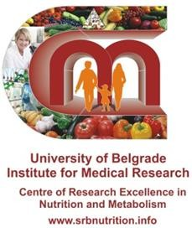

# Informed CONSENT FORM

**for the participation in the PhD project conducted by Fathia Faid at Institute for Medical Research, Center of Research Excellence in Nutrition and Metabolism, Serbia**

Name: ………………………………………………………. Participants ID: ....................................

Date: …………………………………………................

I agree to provide Fathia Faid with information about my health status, lifestyle and dietary habits by filling the questionnaire within the research project. I know that all provided data are confidential and used only for the reserch-scientific purposes. I can decide after signing this informed consent document that I no longer want to take part in this study for any reason at any time and in that case I will inform the organisator of the research about my decision.

I have read the foregoing information and I have had the opportunity to ask questions about it and any quetions that I have asked have been answered to my satisfaction by the research organisators. I consent voluntarily to participate in this research and authorize the use of my health information as outlined above. Therefore, I am signing two copies of this document, one for me and another one for the researchers.

Signature: .................................................................

Contact person:

Fathia Faid

Email: [fathia_faid1000@yahoo.com](mailto:fathia_faid1000@yahoo.com)

Phone: :+381 61 137 45 34

+218 92 702 40 70

+218 91 404 35 72

Annex 5.



#### 24 Hour Diet recall

**Subject No.**

***All information is strictly confidential***

|  |  |  |  |  |  |  |  |  |  |  |
| --- | --- | --- | --- | --- | --- | --- | --- | --- | --- | --- |
| **Date of recall** |  | | | | | | | | | |
| **Which day of the week** | Mon | Tue | Wed | | Thu | Fri | | Sut | Sun | |
| **Is this a typical day?** | | | Yes | | | | No | | | |
| **How many meals you had?** |  | | | | | | | | | |
| **Circle meals** | Breakfast | Snack 1 | | Lunch | Snack 2 | Dinner | | Supper | | Other |

|  |  |  |  |  |  |
| --- | --- | --- | --- | --- | --- |
| **When (time)** | **Meals** | **Food, dish and drink item and method of preparation (fried,**  **cooked, baked...)** | **Amount Consumed** | | **Where (home/away)** |
| **Food** | **Drink** |
|  | **Breakfast** |  |  |  | **(home/away)** |
|  | **Snack 1** |  |  |  | **(home/away)** |

|  |  |  |  |  |  |
| --- | --- | --- | --- | --- | --- |
|  | **Lunch** |  |  |  | **(home/away)** |
|  | **Snack 2** |  |  |  | **(home/away)** |
|  | **Dinner** |  |  |  | **(home/away)** |
|  | **Supper** |  |  |  | **(home/away)** |
|  | **Other** |  |  |  | **(home/away)** |
|  | **Supplements** |  |  |  |  |

**Thank you for answering this questionnaire! If you have any questions about questionnaire please feel free to contact the researcher: Fathia Faid**

**Email:** [**fathia_faid1000@yahoo.com**](mailto:fathia_faid1000@yahoo.com)

**Phone**: +381 61 137 45 34

+218 92 702 40 70

+218 91 404 35 72

**Postal address:**

Centre of Research Excellence in Nutrition and Metabolism Institute for Medical Research, University of Belgrade, Serbia Tadeusa Koscuska 1 PO BOX 102 11000 Belgrade Serbia [www.srbnutrition.info;](http://www.srbnutrition.info/)

Phone office +381 11 3031997 Fax office +381 11 2030169

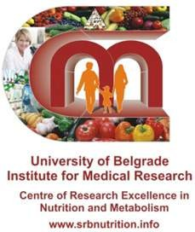

1. Date :
2. Name and Last Name :

GENERAL QUESTIONNAIRE

1. Date of Birth:
2. Weight (kg):

Place of Birth: Height (cm):

Waist measurement(cm):

1. Highest Level of Education:

Annex 6.

illiterate primary school

preparatory school secondary school high diploma

Undergraduate University Degree Masters/PhD Degree

Other:

1. Number of Household members: 0 1 2 3 4 5
2. Marital Status:

Married Divorced Widow Engaged single

1. How much money, per week, your family spend on food? Euros What percentage of your family monthly budget is spent on food? %
2. Do you have any allergies?(Circle) NO YES€If YES, explain:
3. Are you following a specific diet?Yes( ) No ( )

If yes, please specify:

1. Do you suffer from any chronic illnesses? (Circle) NO YES€If YES, explain:
2. Are you currently taking any medication? (Circle) NO YES€If YES, explain:
3. In addition to your regular food consumption, do you regularly (daily) take any supplements such as vitamins and minerals (pills, tablets, syrups)? (Circle)

NO YES€If YES, write the name of the supplement and the provider:

How long have you been taking these supplements? When do you take the supplements:

on an empty stomach with a meal

months.

Anytime

1. On average, how many cups of coffee do you drink per day? 0-1 2-3 4-5 more than 5

15. which type of coffee do you most often drink? --------------------------------------------------------------------

1. Do you drink tea?

NO YES€If YES, which type of tea do you most often drink: black or green other:

1. On average, how many cups of tea do you drink per day?

0-1 2-3 4-5 more than 5

1. Do you add milk in the coffe or tea? NO YES €If YES How much? ------------------------------
2. On average, how many carbonated beverages (soft drinks) do you consume per week?

one pop beverage = 1 can ofCoca-cola or 1 can of Fanta or 1 can of any other carbonated drink

0 1-7 8-14 more than 14 Other

20 .Have you sunbased (sitting or spending time on the sun) at the yard in the last 3 months?

NO YES € IF YES, how often (per week) andhow long min

(per week) and how long min

21.When you spend time on sun,do you wearing veil full? NO YES or short clothes and

without sleeves? NO

YES IF YES do you use the sunblock during that?

YES NO

|  |  |  |  |  |  |  |  |  |  |  |
| --- | --- | --- | --- | --- | --- | --- | --- | --- | --- | --- |
| 22.Which supplements have you taken in the last 3 months | | | | | | | | | | |
| Specific vitamins | NEVER | ONCE PER MONTH | 2-3 TIMES PER MONTH | ONCE PER WEEK | TWICE PER WEEK | 3-4 TIMES PER WEEK | 5-6 TIMES PER WEEK | EVERY DAY | Write down the dosage, if possible | How long (months) have you been taking this supplement |
| Vitamin A |  |  |  |  |  |  |  |  |  |  |
| Beta carotene |  |  |  |  |  |  |  |  |  |  |
| Vitamin C |  |  |  |  |  |  |  |  |  |  |
| Vitamin E |  |  |  |  |  |  |  |  |  |  |
| Folic acid |  |  |  |  |  |  |  |  |  |  |
| Calcium |  |  |  |  |  |  |  |  |  |  |
| Vitamin D |  |  |  |  |  |  |  |  |  |  |
| Zinc |  |  |  |  |  |  |  |  |  |  |
| Iron |  |  |  |  |  |  |  |  |  |  |
| Sellenium |  |  |  |  |  |  |  |  |  |  |
| Omega 3, fish oils |  |  |  |  |  |  |  |  |  |  |
| Multivitamins |  |  |  |  |  |  |  |  |  |  |
| Other (write down the name of the supplement) |  |  |  |  |  |  |  |  |  |  |

23. Do you have physical activity (ie. walking, running, fitness, sports, etc.)? NO YES€ IF YES, what activity?

How many HOURS per week? les than ½ h ½ - 3½ h more than 3½ h

3. (triangles cheese)

never once a month

2-3/month

once a week 2-3/week 4-6/week once a day

4. sliced cheese

never once a month

2-3/month

once a week 2-3/week 4-6/week once a day

5. cream cheese, philadelphia cheese never once a month 2-3/month once a week 2-3/week 4-6/week

once a day

FOOD QUESTIONNAIRE

Annex 7.

How many times a WEEK do you have :

Breakfast is the first meal of the day (1-2 hours after geting up); Brunch is beetwen breakfast and lunch ; Snack is beetwen lunch and dinner.

breakfast 0 1 2 3 4 5 6 7

brunch 0 1 2 3 4 5 6 7

lunch 0 1 2 3 4 5 6 7

snack 0 1 2 3 4 5 6 7

dinner 0 1 2 3 4 5 6 7

### During the last3MONTH, how often did you consume:

Dairy Products:

1. milk

never

once a month

2-3/month

once a week 2-3/week 4-6/week once a day

2. cheese (edam, cheddar, mozzarella cheese )

never once a month 2-3/month

once a week 2-3/week 4-6/week once a day

6. ricotta, salt cheese

never once a month

2-3/month

once a week 2-3/week 4-6/week once a day

11. pigeon meat, quail meat

never once a month 2-3/month once a week 2-3/week 4-6/week

once a day

12. offal

never once a month

2-3/month

once a week 2-3/week 4-6/week once a day

13. barbecue

never

once a month

2-3/month

once a week 2-3/week 4-6/week once a day

7. kiri cheese, pouk cheese, kraft cheese

never once a month 2-3/month

once a week 2-3/week 4-6/week once a day

During the last3 MONTH, how often did you consume: Meat:

8. eggs

never

once a month

2-3/month

once a week 2-3/week 4-6/week once a day

9.meat (Lamb, Goat meat, Beef and Camel meat)

never once a month 2-3/month

once a week 2-3/week 4-6/week once a day

10. chicken and turkey

never once a month

2-3/month

once a week 2-3/week 4-6/week once a day

14. dried meat (lamb,goat)

never once a month 2-3/month once a week 2-3/week 4-6/week

once a day

17. arzam fish

never once a month

2-3/month

once a week 2-3/week 4-6/week once a day

18. orada fish

never once a month

2-3/month

once a week 2-3/week 4-6/week once a day

19. tuna fish

never once a month

2-3/month

once a week 2-3/week 4-6/week once a day

20. caned tuna fish

never once a month

2-3/month

once a week 2-3/week 4-6/week once a day

21. kawali fish, trelia fish, pori fish never once a month 2-3/month once a week 2-3/week 4-6/week

once a day

22. salmon

never once a month

2-3/month

once a week 2-3/week 4-6/week once a day

### During the last 3MONTH, how often did you consume:

Seafood:

15. sardin fish

never once a month

2-3/month

once a week 2-3/week 4-6/week once a day

16. canned sardines

never once a month

2-3/month

once a week 2-3/week 4-6/week once a day

During the last3MONTH, how often did you consume:

25. butter

never once a month

2-3/month

once a week 2-3/week 4-6/week once a day

26. margarine

never once a month

2-3/month

once a week 2-3/week 4-6/week once a day

Oils:

24. other oils (Corn oil, Sunflower oil, etc) never once a month 2-3/month once a week 2-3/week 4-6/week

once a day

Which oil do you most often use?

23. olive oil for cooking

for salad

never once a month 2-3/month

once a week 2-3/week 4-6/week once a day

During the last 3 MONTH, how often did you consume: Vegetables:

27. sheep fat(for frying and cooking) never once a month 2-3/month once a week 2-3/week 4-6/week

once a day

28. camel fat(for frying and cooking) never once a month 2-3/month once a week 2-3/week 4-6/week

once a day

29.beans

never once a month

2-3/month

once a week

2-3/week

4-6/week

once a day

30.onion, spring onion

never once a month

2-3/month

once a week

2-3/week

4-6/week

once a day

31. green peas

never once a month

2-3/month

once a week 2-3/week 4-6/week once a day

32.broccoli, cauliflower, cabbage

never once a month 2-3/month once a week 2-3/week 4-6/week

once a day

33. beets

never once a month

2-3/month

once a week 2-3/week 4-6/week once a day

35. carrot

never once a month

2-3/month

once a week 2-3/week 4-6/week once a day

36. green beans

never once a month

2-3/month

once a week 2-3/week 4-6/week once a day

37. fresh peppers

never once a month

2-3/month

once a week 2-3/week 4-6/week once a day

38. tomatoes

never

once a month

2-3/month

once a week 2-3/week 4-6/week once a day

39. potatoes

never

once a month

2-3/month

once a week 2-3/week 4-6/week once a day

34. salad: lettuce

arugula

other green salad

never once a month 2-3/month

once a week 2-3/week 4-6/week once a day

40. spinach

never once a month

2-3/month

once a week 2-3/week 4-6/week once a day

41. cucumber

never once a month

2-3/month

once a week 2-3/week 4-6/week once a day

42. parsley, coriander

never once a month

2-3/month

once a week 2-3/week 4-6/week once a day

43. zucchini

never

once a month

2-3/month

once a week 2-3/week 4-6/week once a day

44. eggplant

never

once a month

2-3/month

once a week 2-3/week 4-6/week once a day

45. pumpkin

never once a month

2-3/month

once a week 2-3/week 4-6/week once a day

During the last 3MONTH, how often did you consume: Fruit:

46. radish

never once a month

2-3/month

once a week 2-3/week 4-6/week once a day

47. okra/bamia

never once a month

2-3/month

once a week 2-3/week 4-6/week once a day

48. citrus fruit (orange,mandarin, lemon) never once a month 2-3/month once a week 2-3/week 4-6/week

once a day

49. bananas

never once a month

2-3/month

once a week 2-3/week 4-6/week once a day

50. apples, pears

never once a month

2-3/month

once a week 2-3/week 4-6/week once a day

51. strawberries , grapes, blueberries never once a month 2-3/month once a week 2-3/week 4-6/week

once a day

53. nuts (almonds, walnuts, hazelnuts) never once a month 2-3/month once a week 2-3/week 4-6/week

once a day

54. nuts (Cashew ,Pistachios)

never once a month 2-3/month once a week 2-3/week 4-6/week

once a day

55. watermelon,cantaloupe

never once a month 2-3/month once a week 2-3/week 4-6/week

once a day

56.figs,apricot

never once a month

2-3/month

once a week 2-3/week 4-6/week once a day

57.dates

never once a month

2-3/month

once a week 2-3/week 4-6/week once a day

58.kiwi

never

once a month

2-3/month

once a week 2-3/week 4-6/week once a day

52.dried fruit ( dry apricot, dry figs,Raisins..)

never once a month 2-3/month

once a week 2-3/week 4-6/week once a day

62. kedney beans, lentils, chickpeas never once a month 2-3/month once a week 2-3/week 4-6/week

once a day

63. reeds

never once a month

2-3/month

once a week 2-3/week 4-6/week once a day

64. rice

never

once a month

2-3/month

once a week 2-3/week 4-6/week once a day

During the last 3MONTH, how often did you consume: Grains:

65. bread: white

whole wheat

grain bread

barley

never once a month 2-3/month

once a week 2-3/week 4-6/week once a day

66. cereals (corn or oat flakes , multy grain ) never once a month 2-3/month

once a week 2-3/week 4-6/week once a day

Which cereal do you most FREQUENTLY consume?

_

(for example : plain corn flakes, oat flakes or other type of cereals) Please write down the name of the product and producer (copy from the box)!

59.avocado,manga, guava

never once a month

2-3/month

once a week 2-3/week 4-6/week once a day

60. pasta

never once a month

2-3/month

once a week 2-3/week 4-6/week once a day

61. kuskus

never once a month

2-3/month

once a week 2-3/week 4-6/week once a day

67. corn meal, corn bread

never once a month 2-3/month once a week 2-3/week 4-6/week

once a day

72. cocoa: powder

Nesquik

never once a month 2-3/month

once a week 2-3/week 4-6/week once a day

73. peanuts

never

once a month

2-3/month

once a week 2-3/week 4-6/week once a day

74. potato chips, pretzels, etc.

never once a month 2-3/month once a week 2-3/week 4-6/week

once a day

During the last 3MONTH, how often did you consume: OTHER:

68. croissant, flakey pastery, biscuits never once a month 2-3/month once a week 2-3/week 4-6/week

once a day

69. cakes and deserts

never once a month

2-3/month

once a week 2-3/week 4-6/week once a day

70. milk chocolate

never once a month

2-3/month

once a week 2-3/week 4-6/week once a day

71. dark chocolate

never once a month

2-3/month

once a week 2-3/week 4-6/week once a day

###### PLEASE CHOOSE THE APPROPRIATE SERVING SIZE FOR 1 MEAL

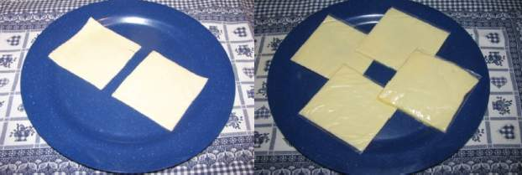

78. sliced cheese

A) 25 g

B) 50 g

or C) g

75, milk

100mL

200 mL

1 cup (250 mL)

½ L

1L

mL



76. cheese edam. cheddar

A) 62 g B)125 gC)187 gd) 250 g

77. (triangles cheese)

one piece two piece

three piece

-------------------piece



79.Cream cheese, Philadelphia cheese A)20 g B)32 gC)45 g

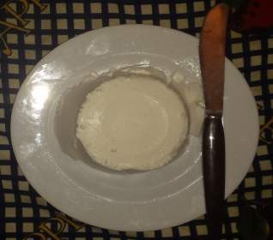

1. ricotta cheese
   1. 62 g

B)125 gC)250 g



81.salt cheese (feta)

A)30 g B)60 gC)90 gd)120

82. kiri cheese

one piece two piece

three piece

-------------------piece

83. eggs 1 egg eggs

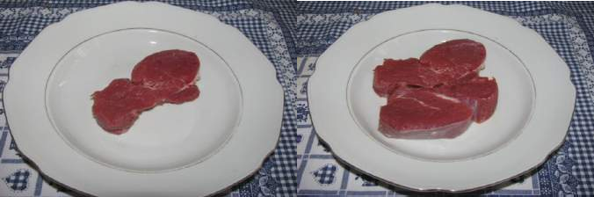

84. Meat (Lamb, Goat meat, Beef and Camel meat)

A) 100 g B) 200 g

or C) g

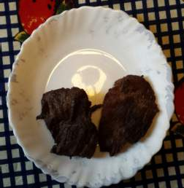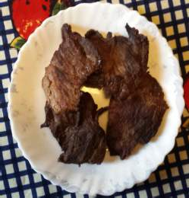

85. chicken A)190 g

B)230 g

C) 424

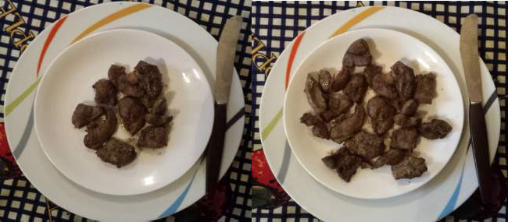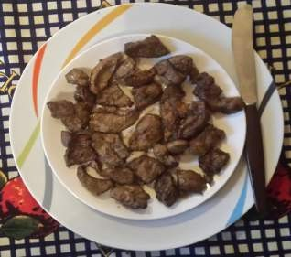

1. offal
   1. 72 g

B)135 g

C)175g

g

87,Barbecue lamb

A)46 g B)93 g

C)133g

d)163g



88. Barbecue chicken

A)56 g B)117g

C) 200 g

89.pigeon, quail

1\2 pigen, quail

1 pigen, quail

2 pigen, quail

---------------pigen, quail -

90. sardin fish

2-3 sarden fish

3-6 sarden fish

7-10 sarden fish

sarden fish ,

|  |  |  |  |  |  |  |  |
| --- | --- | --- | --- | --- | --- | --- | --- |
| 91. | canned | sarden | ½ can | 1 can | 2 cans |  | cans |

92. arzam fish

½ fish 1 fish

2 fish

fish

93. orada fish

½ fish 1 fish

2 fish

fish

94. tuna fish

½ fish 1 fish

2 fish

fish

|  |  |  |  |  |  |  |  |
| --- | --- | --- | --- | --- | --- | --- | --- |
| 95. | canned | tuna | ½ can | 1 can | 2 cans |  | cans |

96.kawali,trelia fish

2-3 fish

3-6 fish

7-10 fish

sarden fish

97. salmon fish

½ fish 1 fish

2 fish

fish



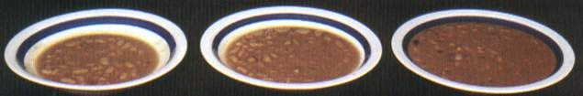

1. beans, lentils
   1. 100 g

B) 180 g

C) 320 g

or D) g

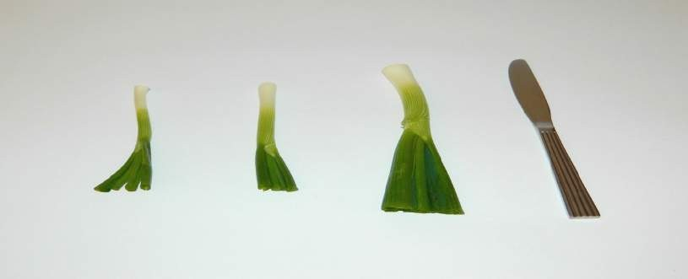

1. spring onion
   1. 7 g

B)12 g C)35 g

1. onion
   1. 240 g

B)58 g

C)154 g

D)228g



102. green peas A) 25 g

B) 125 g

C) 200 g

or D) g

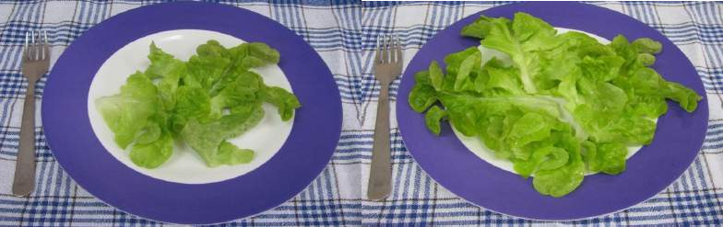

103. lettuce, green salad

1. 15 g

B) 35 g

or C) g

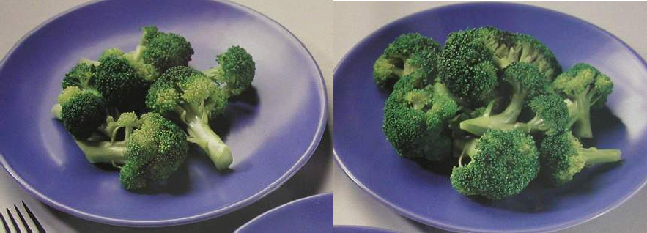

101. broccoli, cauliflower, savoy cabbage

1. 46 g B) 84 g

C) 146 g

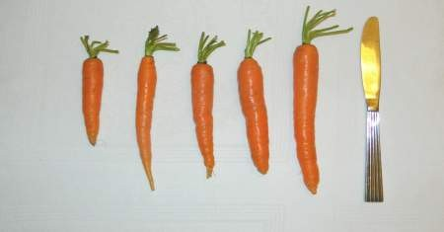

104. carrot A (25 g), B (27 g), C) (53 g), D) (53 g) E)(64)

or F) grams



105. beets A) 100 g

B) 180 g

C) 230 g

d) 86g

e)171g

f) 250

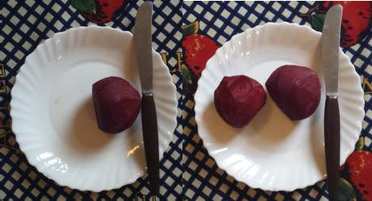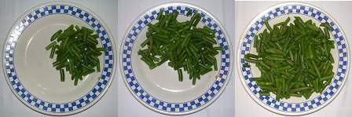

106. green beans

A (60 g)

B (150 g)

C ( 235 g)

Or d grams



107. peppers

A (55 g)

B (100 g)

or C grams

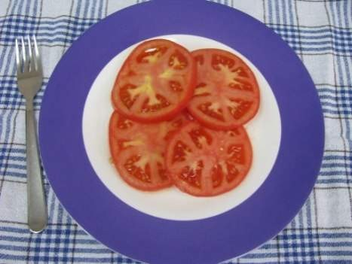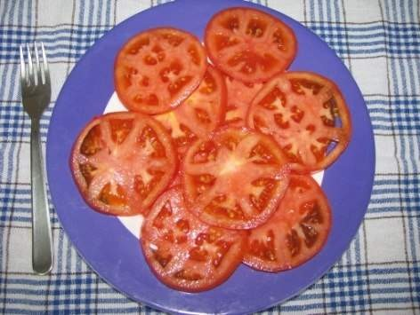

108. tomatoes

A (80 g)

B (180 g)

or C grams

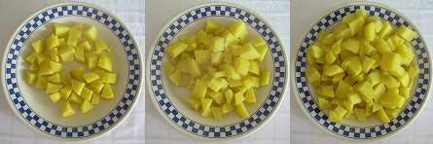

109. potatoes

1. 150 g

B) 300 g

C) 500 g

or D) g



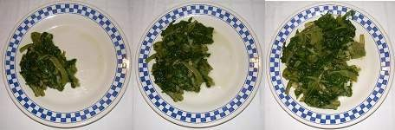

110. spinach, collard greens

1. 110 g

B) 190 g

C) 225 g

or D) g



111. cucumber A)73 g

B)118 g

C)40g

D) 109g

E)167g



112. radish A)40 g

B)50 g

C)60g



113. citrus fruits (orange, mandarine, grapefruit, lemon)

one whole fruit

A)268g

two whole fruits

B)210g

# whole fruits

C)187g

A)140g

B)90g

C)40g

114. bananas

1 peace

2 peaces

1. 164g

# bananas

b)198g c)241g

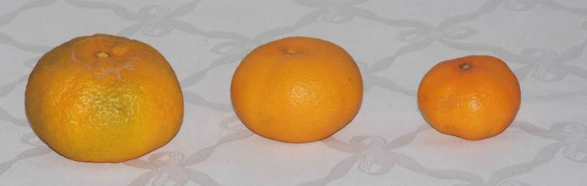

115. apples, pears

1 peace 2 peaces A)130g

# of fruits

b)170g c)320g



116. pears

1 peace

2 peaces

# of fruits

117. blueberries (1 cup = 250 mL)

½ cup 1 cup 1½ cup

2 cups

cups



118. strawberries

1. 40g B)69g

C)101g

D)123g



119. grabe

1. 200g

B)400g

C)600g

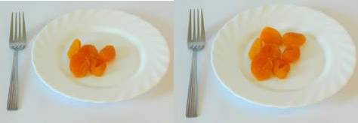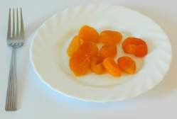

120. dry apricot

A)16g B)28 g

C)38g

D) 53



121. dry figs A)39g

B)75 g

C)111g

D)

180 g

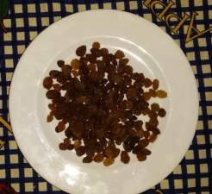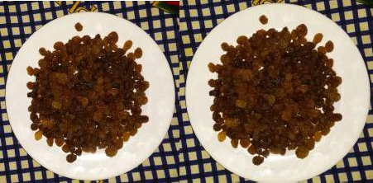

122. raisins A)35g

B)66 g

C)110g

D) 160 g



123. dry dates

1. 65g

B)130 g

C) 200 g

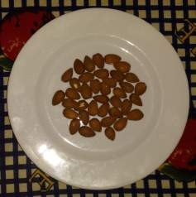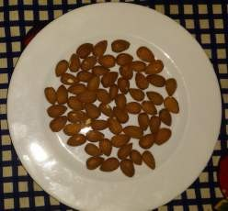

124. almond

1. 35g

B)43 g

C) 100 g

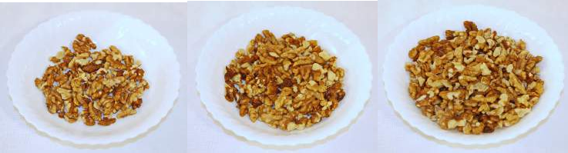

125. walnuts

A)40g

B)75 g

C) 150 g

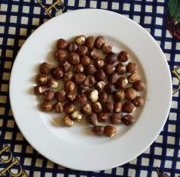

126. hazelnuts

A)35g

B)55 g

C) 90 g

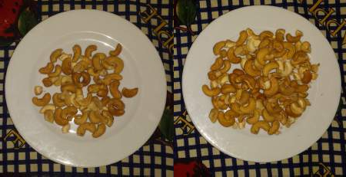

127. Cashew

A)35g

B)55 g

C) 90 g



130. Dates A)40

B)65 g

C)85 g

D) 110 g

E) 217 g

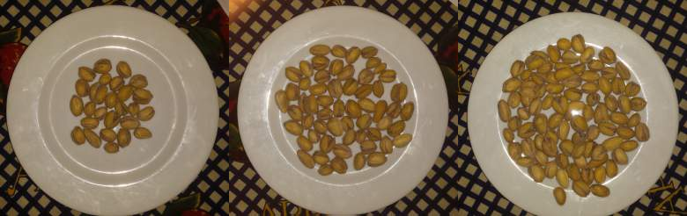

C)85g

B) 55 g

A) 35g

128. Pistachio

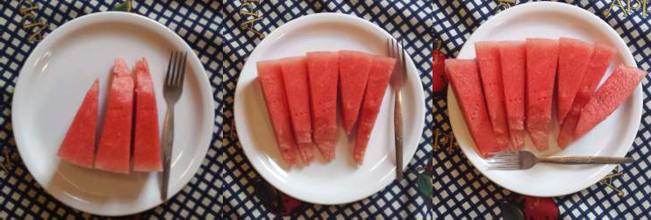

129. watermelon

A)362g

B)535 g

C) 735 g

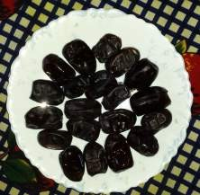

131. Kiwi

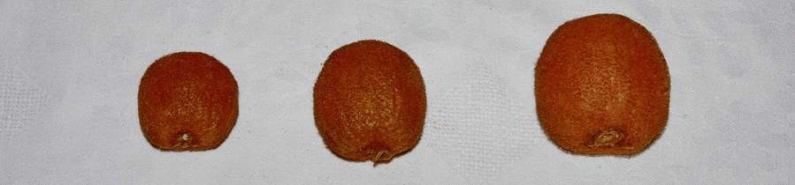

1 2

# of fruits

A)36g B)56 g C)96 g

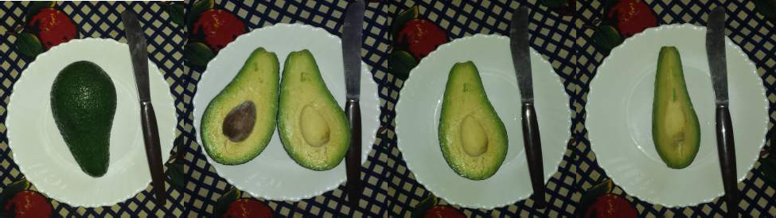

132. avocado

A)250g

B)125 g

C)62 g



133. mango

A)380g

B)217 g

C)160 g

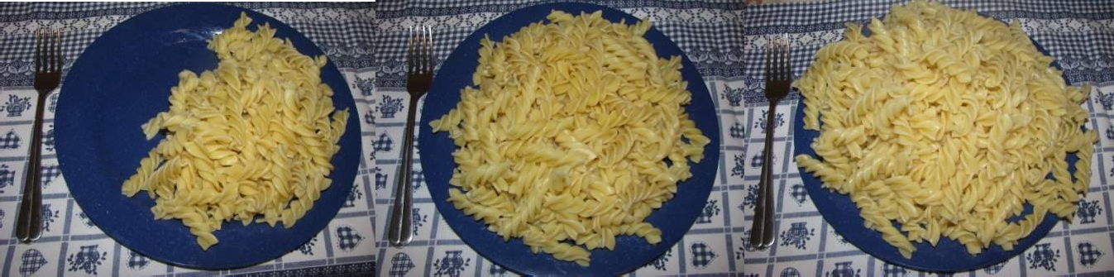

134. pasta

A) 100 g

B) 200 g

C) 350 g

or D) g

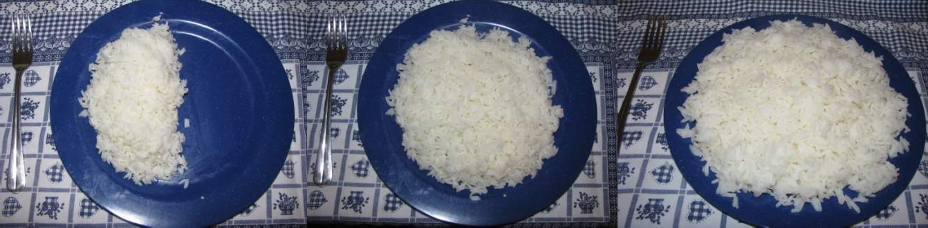

135.riceA) 150 g

B) 200 g

C) 350 g

or D) g



136.kuoskuos

1. 500 g

B) 803 g

C) 1140 g





137. bread

A) 40 g

B) 80 g

C) 120 g

D)135g

E)245g

or F) g



138.croissant

a) 60 g

B) 120

C) 96g

|  |  |  |  |
| --- | --- | --- | --- |
| 139. cakes | and | deserts | |
| A)120 g | B)230 g | | C)350 g  or D) g |

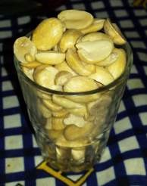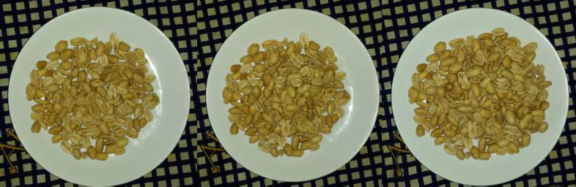

140.peanuts

1. 38 g

B) 76g

C) 114g

d)152

141. milk chocolate

whole chocolate (100 g)

½ chocolate (50 g)

g

142. cocoa

1 tea spoon

2 tea spoons

tea spoons

143. How much water do you drink DAILY ? (tap and bottle) 100 mL 200 mL ½ L 1L mL

144. On avrage, how much oil do you use when cooking?

1 dL 2 dL 1 cup (2,5 dL) ½ L 1L

dL

145. How much oil do you put in your salad?

1 tablespoon 2 tablespoons tablespoons

146. How much fat do you use when cooking?

1 tablespoon 2 tablespoons tablespoons

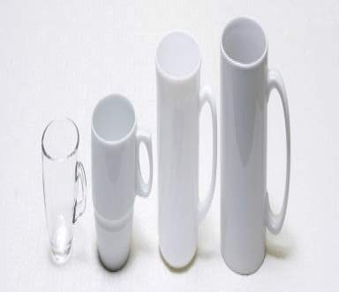

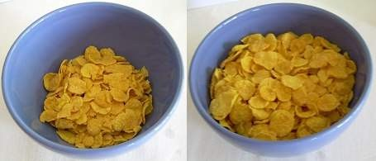

148. cereals: corn and similar.

A) 35 g

B) 85 g

or C) g

147.coffee,tea a)70ml

b)150ml

c)250ml

d)320ml

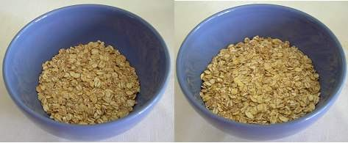

149. grain cereals, oat flakes, muslie sl.

A) 70 g B) 145 g

or C) g

150. Do you consume food enriched with vitamin D? (circle NO or YES) (such food is usually labeled “enriched with vitamin D“ (ex. MILK AD-Imlek )) NO YES€ if YES, name the product:

once a week 2-3/week 4-6/week once a day

What is your usual serving ?

(to describe the serving size please use the pictures from the previous pag

2-3/month

once a month

never

How often did you consume this product during the last month?



University of Belgrade Institute for Medical Research

Centre of Research Excellence in and Metabolism [www.srbnutrition.info](http://www.srbnutrition.info/)

**استمارة الموافقة المسبقة**

للمشاركة في مشروع الدكتوراه الذي أجرته فتحية فيض معهد البحوث الطبية ، مركز التميز البحثي في التغذية واأليض ، صربيا

......................................................................المشاركه تعريف االسم

.....................................................................:التاريخ

اوافق على تزويد فتحية فيض بمعلومات عن حالتي الصحية وأسلوب حياتي وعاداتي الغذائية عن طريق ملء االستبيان ضمن مشروع البحث. أعلم أن جميع البيانات المقدمة سرية وتستخدم فقط لألغراض العلمية البحثية. يمكنني أن أقرر بعد التوقيع على وثيقة الموافقة

المستنيرة أنني لم أعد أرغب في المشاركة في هذه الدراسة ألي سبب في أي وقت وفي هذه الحالة سوف أبلغ المنظم بالبحث عن قراري.

لقد قرأت المعلومات السابقة وقد أتيحت لي الفرصة لطرح أسئلة حولها وأي إجابات قمت بطلبها تم الرد عليها بشكل مرض من قبل

منظمي البحث. أوافق طوعا على المشاركة في هذا البحث وأصرح باستخدام معلوماتي الصحية كما هو موضح أعاله. لذلك ، أنا أوقع

نسختين من هذه الوثيقة ، واحدة بالنسبة لي واألخرى للباحثين.

.......................... :.التوقيع

الشخص الذي يمكن االتصال به...................................:

فتحية فيض

البريد [اإللكترونيfaid1000@yahoo.com](mailto:faid1000@yahoo.comينورتكللإا) fathia :

هاتف 34 45 61137 381+

+218 92 702 40 70

+218 91404 35 72

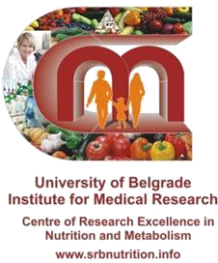

**استدعاء النظام الغذا يئ عىل مدار 24 ساعة**

**رقم**

|  |  |  |  |  |  |  |  |
| --- | --- | --- | --- | --- | --- | --- | --- |
|  | | | | | | | **تاريخ االستدعاء** |
| **االحد** | **السبت** | **الجمعة** | **الخميس** | **االربعاء** | **الثالثاء** | **االثنين** | **في أي يوم من األسبوع** |
| **ال** | | | | **نعم** | | | **هل هذا يوم عادي؟ نعم / ال** |
| **كم عدد الوجبات التي تناولتها؟** | | | | | | | |
| **اخرى** | **اضافات** | **العشاء** | **وجبة خفيفة 2** | **وجبه غداء** | **وجبة خفيفة 1** | **االفطار** | **ضع دائرة** |

|  |  |  |  |  |  |
| --- | --- | --- | --- | --- | --- |
| **منزلى / خارج** | حجم االستهالك | | **الوجبات , شراب الطعام**  **وطريقة تحضير (مقلي ، (مطبوخة ، مخبوزة** | ***الوجبه*** | الوقت |
| الطعام | الشراب |
| **منزلى / خارج** |  |  |  | ***االفطار*** |  |
| **منزلى / خارج** |  |  |  | ***وجبة خفيفة 1*** |  |
| **منزلى / خارج** |  |  |  | ***وجبة غداء*** |  |

|  |  |  |  |  |  |
| --- | --- | --- | --- | --- | --- |
|  |  |  |  |  |  |
| **منزلى / خارج** |  |  |  | ***وجبة خفيفة 2*** |  |
| **منزلى / خارج** |  |  |  | ***وجبة عشاء*** |  |
| **منزلى / خارج** |  |  |  | ***وجبة خفيفة*** |  |
| **منزلى / خارج** |  |  |  | ***اخري*** |  |
| **منزلى / خارج** |  |  |  | ***مكمالت*** |  |

**شكرا لك على اإلجابة على هذا االستبيان!**

**إذا كان لديك أي أسئلة حول االستبيان ، فال تتردد في االتصال بالباحث:**

**فتحية فيض**

**البريد اإللكتروني:** [**fathia_faid1000@yahoo.com**](mailto:fathia_faid1000@yahoo.com)

**34 45 61137 381+ :هاتف**

**70 40 702 92 218+**

**72 35 91404 218+**

**العنوان البريدي: مركز التميز البحثي في معهد التغذية والتمثيل الغذائي للبحوث الطبية ، جامعة بلغراد ، صربيا 11000 102 BOX PO 1 Koscuska Tadeusa بلغراد صربيا**

**؛** [**www.srbnutrition.info**](http://www.srbnutrition.info/)

**2030169 11 381+ فاكس 3031997 11 381+ الهاتف مكتب**

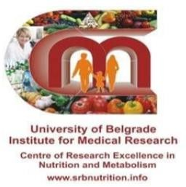

استبيان تردد الغذاء االستبيان العام

.1 التاريخ

.2 االسم واللقب:

محيط الخصر(سم)

مكان الوالدة

الطول (سم)

.3 تاريخ الوالدة:

.4 الوزن (كخ)

.5 أعلى مستوى تعليمي:

⇨ امي ⇨ ابتدائي ⇨ اعدادي ⇨ ثانوي ⇨ دبلوم عالي ⇨ جامعي

## ⇨ ماجستير او دكتوراه

5 4 3 2

.6 عدد أفراد األسرة: 1

اعزب

خاطب

ارمل

مطلق

.7 الوضع االجتماعي: متزوج

.8 كم من المال في األسبوع تنفق عائلتك على الطعام؟ ............... يورو

ما هي نسبة الميزانية الشهرية لعائلتك التي يتم إنفاقها على الطعام ؟ %

.9 هل لديك أي حساسية: نعم ال

اذا نعم اشرح ماهي:

.10 هل تتبع حمية ذائية خاصة؟ نعم ال

اذا نعم حدد نوع الحمية:

.11

اذا نعم وضح

ال

هل تعاني من اي مرض مزمن؟ نعم

اذا نعم ماهو:

ال

هل تتناول اي ادوية حاليا؟ نعم

ماهو

.12

.13 باإلضافة إلى استهالكك الغذائي العادي ، هل تتناول بانتظام (يوميًا) أي

مكمالت غذائية مثل الفيتامينات والمعادن (حبوب, شراب, كبسول) ؟ نعم

ال اذا نعم اكتب اسم المكمل الغذائي:

اشهر

منذ متى وانت تستهلك هذا المكمل الغذائي؟

في اي وقت تتناول هذا المكمل:

اي وقت

مع الوجبة

على معدة فارغة

في المتوسط ˛ كم فنجان من القهوة تشرب يوميا؟

أي نوع من القهوة تشربه غالبًا

.14

## .15

نعم

احمر

ال

غالباً ما تشربه:

هل تشرب الشاي؟

.16

## ذا كان نعم, أي نوع من أنواع الشاي الذي

أخضر, انواع اخرى.

.17 في المتوسط ˛ كم كوب من الشاي تشرب يوميا؟

اكثر من 5

5-4

3-2

## 1- 0

هل تضيفي الحليب في

نعم

القهوة أو الشاي؟ ال

إذا كانت اإلجابة "نعم" كم؟ مل

.18

## .19 كم متوسط عدد المشروبات الغازية التي تستهلكها في األسبوع؟ علبة

واحدة, يمكن من كوكا كوال أو علبة فانتا أو يمكن من أي مشروب غازية أخرى

اخرى

اكثر من 14

14-8

7-1 0

.20 هل تجلس في الشمس داخل الفناء خالل الـ 3 أشهر الماضية؟

إذا كان نعم كم مرة في اليوم........ وكم دقيقة.........

كم مرة في االسبوع........ وكم دقيقة.........

نعم ال

نعم اذا نعم هل

عندما تجلسي في الشمس هل ترتدي حجاب كامل؟ ال

او ارتداء مالبس قصيرة وبدون قفازات؟ ال نعم

.21

## تستخدمي واقي للشمس اثناء جلوسك في الشمس؟ نعم ال

|  |  |  |  |  |  |  |  |  |  |  |
| --- | --- | --- | --- | --- | --- | --- | --- | --- | --- | --- |
| .22 اي من المكمالت االتية اخدتها خالل الثالث اشهر الماضية: | | | | | | | | | | |
| وانت شهر منذ كم  المكمل هذا تستخدم الغذائي | امكن اذا الجرعة | يوم كل | االسبوع في مرات 6-5 | االسبوع في مرات 4-3 | االسبوع في مرتين | االسبوع في مرة | الشهر في مرتين | الشهر في مرة | ابدا | الفيتامين |
|  |  |  |  |  |  |  |  |  |  | فيتامين A |
|  |  |  |  |  |  |  |  |  |  | بيتا كاروتين |
|  |  |  |  |  |  |  |  |  |  | فيتامين c |
|  |  |  |  |  |  |  |  |  |  | فيتامين E |
|  |  |  |  |  |  |  |  |  |  | حمص الفوليك |
|  |  |  |  |  |  |  |  |  |  | كالسيوم |
|  |  |  |  |  |  |  |  |  |  | فيتامين د |
|  |  |  |  |  |  |  |  |  |  | زنك |
|  |  |  |  |  |  |  |  |  |  | حديد |
|  |  |  |  |  |  |  |  |  |  | سلينيوم |
|  |  |  |  |  |  |  |  |  |  | اوميجا,3 زيت الحوت |
|  |  |  |  |  |  |  |  |  |  | فيتامينات متعددة |
|  |  |  |  |  |  |  |  |  |  | اخرى, تدكر |

.23 هل تمارس اي نشاط جسدي, مثل (المشي, الجري, اللياقة البدنية,رياضات

اخرى)...؟ ال نعم

اذا نعم ماهو هذا النشاط؟

كم من الوقت تمارس هذا النشاط في االسبوع؟

نصف الى ثالثة ساعات ونصف الساعة

اقل من نصف ساعة اكثر من ثالثة ساعات ونصف

استبيان تردد الغذاء

كم مرة في االسبوع تتناول االتي:

7 6 5 4 3 2 1 0 :االفطار وجبة ➢

7 6 5 4 3 2 1 0 :خفيفة وجبة •

7 6 5 4 3 2 1 0 :الغذاء وجبة ➢

7 6 5 4 3 2 1 0 :خفيفة وجبة •

7 6 5 4 3 2 1 0 :العشا وجبة ➢

االتي:

خالل األشهر الثالثة الماضية كم مرة استهلكت

منتجات االلبان:

3-2 مرات في الشهر

6-4 في االسبوع

مرة واحدة في الشهر

.1 الحليب مطلقا

كل يوم

3-2 في االسبوع

مرة واحدة في االسبوع

.2 جبنة ادم, شيدر, موزيريال

كل يوم

3-2 مرات في الشهر

6-4 في االسبوع

مرة واحدة في الشهر

مطلقا

3-2 في االسبوع

مرة واحدة في االسبوع

3-2 مرات في الشهر

6-4 في االسبوع

مرة واحدة في الشهر

.3 جبنة المثلثات مطلقا

كل يوم

3-2 في االسبوع

مرة واحدة في االسبوع

3-2 مرات في الشهر

6-4 في االسبوع

مرة واحدة في الشهر

.4 جبنة الشرائح مطلقا

كل يوم

3-2 في االسبوع

مرة واحدة في االسبوع

.5 جبنة فيالدلفيا, اي جبنة كريم

كل يوم

3-2 مرات في الشهر

6-4 في االسبوع

مرة واحدة في الشهر

مطلقا

3-2 في االسبوع

مرة واحدة في االسبوع

3-2 مرات في الشهر

6-4 في االسبوع

مرة واحدة في الشهر

.6 الريكوتا, جبنة مالحة

مطلقا

كل يوم

3-2 في االسبوع

مرة واحدة في االسبوع

3-2 مرات في الشهر

6-4 في االسبوع

.7 جبنة كيري, بوك, كرافت

مطلقا مرة واحدة في الشهر

كل يوم

3-2 في االسبوع

مرة واحدة في االسبوع

3-2 مرات في الشهر

6-4 في االسبوع

مرة واحدة في الشهر

.8 البيض مطلقا

كل يوم

3-2 في االسبوع

مرة واحدة في االسبوع

اللحوم:

.9 لحم الضان, الماعز, البقر, الجمل

كل يوم

3-2 مرات في الشهر

6-4 في االسبوع

مرة واحدة في الشهر

مطلقا

3-2 في االسبوع

مرة واحدة في االسبوع

لحم الدجاج والديك الرومي

.10

3-2 مرات في الشهر

6-4 في االسبوع

مرة واحدة في الشهر

مطلقا

كل يوم

3-2 في االسبوع

مرة واحدة في االسبوع

لحم الحمام, والسمان

.11

3-2 مرات في الشهر

6-4 في االسبوع

مرة واحدة في الشهر

مطلقا

كل يوم

3-2 في االسبوع

مرة واحدة في االسبوع

المعالق (الكبد, القلب, الرئة)

.12

3-2 مرات في الشهر

6-4 في االسبوع

مرة واحدة في الشهر

مطلقا

كل يوم

3-2 في االسبوع

مرة واحدة في االسبوع

كل يوم

3-2 مرات في الشهر

6-4 في االسبوع

مرة واحدة في الشهر

.13 الشواء مطلقا

3-2 في االسبوع

مرة واحدة في االسبوع

لحم مجفف (ضان, ماعز)

.14

3-2 مرات في الشهر

6-4 في االسبوع

مرة واحدة في الشهر

مطلقا

كل يوم

3-2 في االسبوع

مرة واحدة في االسبوع

االسماك:

كل يوم

3-2 مرات في الشهر

6-4 في االسبوع

مرة واحدة في الشهر

.15 سمك السردين مطلقا

3-2 في االسبوع

مرة واحدة في االسبوع

كل يوم

3-2 مرات في الشهر

6-4 في االسبوع

مرة واحدة في الشهر

.16 سردين معلب مطلقا

3-2 في االسبوع

مرة واحدة في االسبوع

كل يوم

3-2 مرات في الشهر

6-4 في االسبوع

مرة واحدة في الشهر

.17 سمك الرزام مطلقا

3-2 في االسبوع

مرة واحدة في االسبوع

كل يوم

3-2 مرات في الشهر

6-4 في االسبوع

مرة واحدة في الشهر

.18 سمك الوراثة مطلقا

3-2 في االسبوع

مرة واحدة في االسبوع

كل يوم

3-2 مرات في الشهر

6-4 في االسبوع

مرة واحدة في الشهر

.19 سمك التونة مطلقا

3-2 في االسبوع

مرة واحدة في االسبوع

كل يوم

3-2 مرات في الشهر

6-4 في االسبوع

مرة واحدة في الشهر

.20 تونة معلبة مطلقا

3-2 في االسبوع

مرة واحدة في االسبوع

سمك الكاوالي, تريليا, البوري

.21

3-2 مرات في الشهر

6-4 في االسبوع

مرة واحدة في الشهر

مطلقا

كل يوم

3-2 في االسبوع

مرة واحدة في االسبوع

كل يوم

3-2 مرات في الشهر

6-4 في االسبوع

مرة واحدة في الشهر

.22 السلمون مطلقا

3-2 في االسبوع

مرة واحدة في االسبوع

الزيوت والدهون:

لسلطات

للطبخ,

.23 زيت الزيتون مطلقا

3-2 مرات في الشهر

6-4 في االسبوع كل يوم

مرة واحدة في الشهر 3-2 في االسبوع

مرة واحدة في االسبوع

اي زيوت اخرى (زيت الذرة, زيت عباد الشمس),,,,,.

.24

3-2 مرات في الشهر

6-4 في االسبوع

مرة واحدة في الشهر

مطلقا

كل يوم

3-2 في االسبوع

مرة واحدة في االسبوع

كل يوم

3-2 مرات في الشهر

6-4 في االسبوع

مرة واحدة في الشهر

.25 الزبدة مطلقا

3-2 في االسبوع

مرة واحدة في االسبوع

كل يوم

3-2 مرات في الشهر

6-4 في االسبوع

مرة واحدة في الشهر

.26 السمن مطلقا

3-2 في االسبوع

مرة واحدة في االسبوع

دهن الضان (للقلي, للطبخ)

.27

3-2 مرات في الشهر

6-4 في االسبوع

مرة واحدة في الشهر

مطلقا

كل يوم

3-2 في االسبوع

مرة واحدة في االسبوع

دهن الجمل (للقلي, للطبخ)

.28

3-2 مرات في الشهر

6-4 في االسبوع

مرة واحدة في الشهر

مطلقا

كل يوم

3-2 في االسبوع

مرة واحدة في االسبوع

الخضراوات:

كل يوم

3-2 مرات في الشهر

6-4 في االسبوع

مرة واحدة في الشهر

.29 فول مطلقا

3-2 في االسبوع

مرة واحدة في االسبوع

البصل, بصل اخضر

.30

3-2 مرات في الشهر

6-4 في االسبوع

مرة واحدة في الشهر

مطلقا

كل يوم

3-2 في االسبوع

مرة واحدة في االسبوع

كل يوم

3-2 مرات في الشهر

6-4 في االسبوع

مرة واحدة في الشهر

بازيالء خضراء

مطلقا

.31

مرة واحدة في االسبوع 3-2 في االسبوع

بروكلي, قرنبيط, كرنب

.32

3-2 مرات في الشهر

6-4 في االسبوع

مرة واحدة في الشهر

مطلقا

كل يوم

3-2 في االسبوع

مرة واحدة في االسبوع

كل يوم

3-2 مرات في الشهر

6-4 في االسبوع

مرة واحدة في الشهر

.33 بنجر مطلقا

3-2 في االسبوع

مرة واحدة في االسبوع

سالطات اخرى 3-2 مرات في الشهر

6-4 في االسبوع

جرجير

خس

.34 سالطة مطلقا

مرة واحدة في الشهر

كل يوم

3-2 في االسبوع

مرة واحدة في االسبوع

كل يوم

3-2 مرات في الشهر

6-4 في االسبوع

مرة واحدة في الشهر

.35 جزر مطلقا

3-2 في االسبوع

مرة واحدة في االسبوع

كل يوم

3-2 مرات في الشهر

6-4 في االسبوع

مرة واحدة في الشهر

فاصوليا خضراء

مطلقا

.36

مرة واحدة في االسبوع 3-2 في االسبوع

كل يوم

3-2 مرات في الشهر

6-4 في االسبوع

مرة واحدة في الشهر

.37 فلفل اخضر مطلقا

3-2 في االسبوع

مرة واحدة في االسبوع

كل يوم

3-2 مرات في الشهر

6-4 في االسبوع

مرة واحدة في الشهر

.38 طماطم مطلقا

3-2 في االسبوع

مرة واحدة في االسبوع

كل يوم

3-2 مرات في الشهر

6-4 في االسبوع

مرة واحدة في الشهر

.39 بطاطا مطلقا

3-2 في االسبوع

مرة واحدة في االسبوع

كل يوم

3-2 مرات في الشهر

6-4 في االسبوع

مرة واحدة في الشهر

.40 السبانخ مطلقا

3-2 في االسبوع

مرة واحدة في االسبوع

كل يوم

3-2 مرات في الشهر

6-4 في االسبوع

مرة واحدة في الشهر

.41 خيار مطلقا

3-2 في االسبوع

مرة واحدة في االسبوع

كل يوم

3-2 مرات في الشهر

6-4 في االسبوع

مرة واحدة في الشهر

معدنوس, كسبر

مطلقا

.42

مرة واحدة في االسبوع 3-2 في االسبوع

كل يوم

3-2 مرات في الشهر

6-4 في االسبوع

مرة واحدة في الشهر

.43 كوسة مطلقا

3-2 في االسبوع

مرة واحدة في االسبوع

كل يوم

3-2 مرات في الشهر

6-4 في االسبوع

مرة واحدة في الشهر

.44 بيذنجان مطلقا

3-2 في االسبوع

مرة واحدة في االسبوع

كل يوم

3-2 مرات في الشهر

6-4 في االسبوع

مرة واحدة في الشهر

.45 يقطين مطلقا

3-2 في االسبوع

مرة واحدة في االسبوع

كل يوم

3-2 مرات في الشهر

6-4 في االسبوع

مرة واحدة في الشهر

.46 فجل مطلقا

3-2 في االسبوع

مرة واحدة في االسبوع

كل يوم

3-2 مرات في الشهر

6-4 في االسبوع

مرة واحدة في الشهر

.47 بامية مطلقا

3-2 في االسبوع

مرة واحدة في االسبوع

الفواكة:

الحمضيات (برتقال, ماندرين, ليمون)

.48

3-2 مرات في الشهر

6-4 في االسبوع

مرة واحدة في الشهر

مطلقا

كل يوم

3-2 في االسبوع

مرة واحدة في االسبوع

كل يوم

3-2 مرات في الشهر

6-4 في االسبوع

مرة واحدة في الشهر

.49 موز مطلقا

3-2 في االسبوع

مرة واحدة في االسبوع

كل يوم

3-2 مرات في الشهر

6-4 في االسبوع

مرة واحدة في الشهر

.50 تفاح, كمثري مطلقا

3-2 في االسبوع

مرة واحدة في االسبوع

توت, عنب, فراولة

.51

3-2 مرات في الشهر

6-4 في االسبوع

مرة واحدة في الشهر

مطلقا

كل يوم

3-2 في االسبوع

مرة واحدة في االسبوع

فواكة مجففة (مشمش, تين, زبيب)...,

.52

3-2 مرات في الشهر

6-4 في االسبوع

مرة واحدة في الشهر

مطلقا

كل يوم

3-2 في االسبوع

مرة واحدة في االسبوع

مكسرات (لوز, جوز, بندق)

.53

3-2 مرات في الشهر

6-4 في االسبوع

مرة واحدة في الشهر

مطلقا

كل يوم

3-2 في االسبوع

مرة واحدة في االسبوع

مكسرات (بندق, كاجو)

.54

3-2 مرات في الشهر

6-4 في االسبوع

مرة واحدة في الشهر

مطلقا

كل يوم

3-2 في االسبوع

مرة واحدة في االسبوع

كل يوم

3-2 مرات في الشهر

6-4 في االسبوع

مرة واحدة في الشهر

.55 بطيخ, شمام مطلقا

3-2 في االسبوع

مرة واحدة في االسبوع

كل يوم

3-2 مرات في الشهر

6-4 في االسبوع

مرة واحدة في الشهر

.56 تين,مشمش مطلقا

3-2 في االسبوع

مرة واحدة في االسبوع

كل يوم

3-2 مرات في الشهر

6-4 في االسبوع

مرة واحدة في الشهر

.57 التمر مطلقا

3-2 في االسبوع

مرة واحدة في االسبوع

كل يوم

3-2 مرات في الشهر

6-4 في االسبوع

مرة واحدة في الشهر

.58 كيوي مطلقا

3-2 في االسبوع

مرة واحدة في االسبوع

افوكادو, مانجو, جوافة

.59

3-2 مرات في الشهر

6-4 في االسبوع

مرة واحدة في الشهر

مطلقا

كل يوم

3-2 في االسبوع

مرة واحدة في االسبوع

الحبوب:

كل يوم

3-2 مرات في الشهر

6-4 في االسبوع

مرة واحدة في الشهر

.60 معكرونة مطلقا

3-2 في االسبوع

مرة واحدة في االسبوع

كل يوم

3-2 مرات في الشهر

6-4 في االسبوع

مرة واحدة في الشهر

.61 كسكسي مطلقا

3-2 في االسبوع

مرة واحدة في االسبوع

عدس, حمص, فاصوليا

.62

3-2 مرات في الشهر

6-4 في االسبوع

مرة واحدة في الشهر

مطلقا

كل يوم

3-2 في االسبوع

مرة واحدة في االسبوع

كل يوم

3-2 مرات في الشهر

6-4 في االسبوع

مرة واحدة في الشهر

.63 قصب مطلقا

3-2 في االسبوع

مرة واحدة في االسبوع

كل يوم

3-2 مرات في الشهر

6-4 في االسبوع

مرة واحدة في الشهر

.64 ارز مطلقا

3-2 في االسبوع

مرة واحدة في االسبوع

شعير

خبز الحبوب

القمح الكامل

االبيض

كل يوم

3-2 مرات في الشهر

6-4 في االسبوع

مرة واحدة في الشهر

:الخبز .65

مطلقا

3-2 في االسبوع

مرة واحدة في االسبوع

حبوب االفطار: كورن فلكس, شوفان, حبوب متعددة

.66

3-2 مرات في الشهر

6-4 في االسبوع

مرة واحدة في الشهر

مطلقا

كل يوم

3-2 في االسبوع

مرة واحدة في االسبوع

اكتب نوع الحبوب التي غالبا ما تتناولها

خبز ذرة او وجبة ذرة

.67

3-2 مرات في الشهر

6-4 في االسبوع

مرة واحدة في الشهر

مطلقا

كل يوم

3-2 في االسبوع

مرة واحدة في االسبوع

بسكويت, معجنات, كروسان

.68

3-2 مرات في الشهر

6-4 في االسبوع

مرة واحدة في الشهر

مطلقا

كل يوم

3-2 في االسبوع

مرة واحدة في االسبوع

كل يوم

3-2 مرات في الشهر

6-4 في االسبوع

مرة واحدة في الشهر

كيك, وحلويات

مطلقا

.69

مرة واحدة في االسبوع 3-2 في االسبوع

اخرى:

كل يوم

3-2 مرات في الشهر

6-4 في االسبوع

مرة واحدة في الشهر

حليب بالشيكوالتة

مطلقا

.70

مرة واحدة في االسبوع 3-2 في االسبوع

كل يوم

3-2 مرات في الشهر

6-4 في االسبوع

مرة واحدة في الشهر

شيكوالتة سوداء

مطلقا

.71

مرة واحدة في االسبوع 3-2 في االسبوع

|  |  |  |
| --- | --- | --- |
| ـــــــــــــــــــــــ |  | نسكوك بوردة :كاكاو .72 |
| مطلقا مرة واحدة في الشهر 3-2 مرات في الشهر مرة واحدة في االسبوع 3-2 في االسبوع 6-4 في االسبوع كل يوم | | |

كل يوم

3-2 مرات في الشهر

6-4 في االسبوع

مرة واحدة في الشهر

.73 كاكاوية مطلقا

3-2 في االسبوع

مرة واحدة في االسبوع

كل يوم

3-2 مرات في الشهر

6-4 في االسبوع

مرة واحدة في الشهر

.74 رقائق البطاطا مطلقا

3-2 في االسبوع

مرة واحدة في االسبوع

ارجو اختيار الحجم المناسب لك من الطعام في الوجبة الواحدة:

مل

لتر

نصف لتر

250مل (كوب)

مل200

.75 حليب 100مل



جبنة ادم, شيدر

.76

جم62 .د

جم125 .ج

جم187 .ب

جم250 .أ

اخرى

ثالث قطع

قطعتين

جبنة مثلثاث: قطعة واحدة

.77



جبنة شرائح

.78

جم. ج

ب25.جم

جم50 .أ



جبنة فيالدلفيا واي جبنة كريم

.79

جم20 .ج

جم32 .ب

جم45 .أ

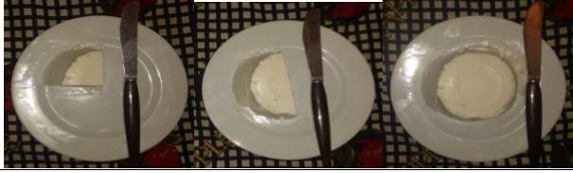

الريكوتا

.80

ج62.جم

جم125 .ب

جم250 .أ



جبنة مالحة (فيتا)

.81

جم30 .د

ج60.جم

جم90 .ب

جم120 .أ

اخرى

ثالث قطع

قطعتين

كيري: قطعة واحدة

.82

اخرى

البيض: قطعة واحدة

.83



جم100 .ب

اللحم (الضان, الماعز, البقر, الجمل)

جم 200 .أ

.84

.85 لحم دجاج



جم190 .ج جم230 .ب جم424 .أ



.86 المعالق (الكبد, القلب, والرئة)

جم175 .ج

جم135 .ب

جم175 .أ



جم46 .د

جم93 .ج

جم133 .ب

.87 شواء ضان أ163.جم



جم56 .ج

جم117 .ب

.88 شواء الدجاج أ. 200جم

2 حمامة, سمانة

.89لحم الحمام والسمان: 0.5 واحدة حمامة, سمانة واحدة حمامة, سمانة

اخرى

6-

6-

6-

اخرى

سمكتين

سمكة

.92سمك الرزام: نصف سمكة

اخرى

سمكتين

سمكة

.93سمك الوراثة: نصف سمكة

اخرى

سمكتين

سمكة

.94سمك التونة: نصف سمكة

اخرى

10-7 سمكات

6-3 سمكات

.90سمك السردين: 3-2 سمكات

علب

2 علب

.91 السردين المعلب: 0.5علبة علبة

ت

6-

اخرى

سمكتين

.97سمك السالمون:

نصف سمكة سمكة

علب

2 علب

علبة

.95التونة المعلب: 0.5 علبة

.96سمك الكاوالي, التريليا:,

اخرى

10-7 سمكات

6-3 سمكات

3-2 سمكا

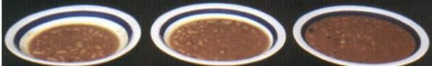

جم100 .ج

جم180 .ب

.98الفاصوليا, العدس:

جم320 .أ



ج. 7جم

جم12 .ب

.99 البصل االخضر:

جم 35 .أ



جم240 .د

جم58 .ج

.100بصل: أ. 228جم ب. 154جم

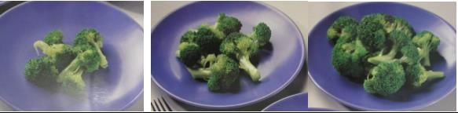

.100البروكلي, قرنبيط, كرنب:

جم46 .ج

جم84 .ب

جم146 .أ



جم25 .ج

جم125 .ب

.101البازيالء: أ. 200جم



.102خس او اي سالطات خضراء:

جم15 .ب جم35 .أ

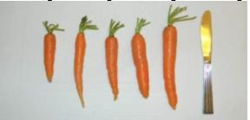

.103الجزر: أ. 64جم ب. 53جم ج. 35جم د. 27جم ه. 25جم

|  |  |  |  |
| --- | --- | --- | --- |
| جم100 | .ج | جم180 .ب | .104بنجر: أ. 230جم |
| جم86 .و | | جم171 .ه | جم250 .د |



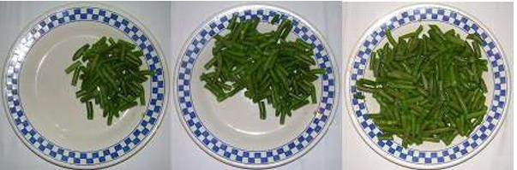

.105الفاصوليا الخضراء:

جم60 .د

جم150 .ب

جم235 .أ



جم55 .ب

.106فلفل اخضر: أ. 100جم

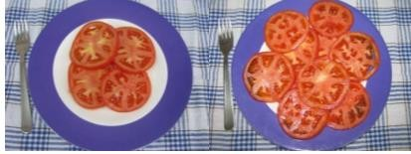

جم80 .ب

.107طماطم: أ. 180جم

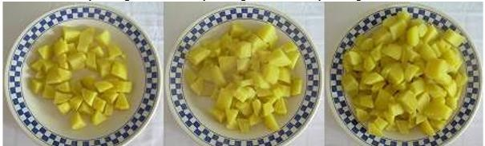

جم150 .ج

جم300 .ب

.108بطاطا: أ. 500جم

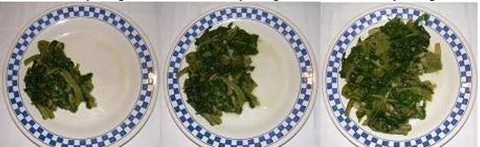

.109سبانح:

جم110 .ج

جم190.ب

جم225 .أ



جم167.د

جم109 .ه

.110خيار: أ. 40جم

جم118 .ب

جم73 .ج



.111الفجل:

جم40 .ج

جم50 .ب

جم60 .أ

|  |  |  |  |
| --- | --- | --- | --- |
| .......... برتقاالت  جم268 .ج | الحمضيات: البرتقال, ماندرين, ليمون: برتقالة كاملة برتقالتين 187جم ب. 210جم | | .112  .أ |
| جم140 .و | جم90 .ه | جم40 .د | |





اخرى

موزتان

.113موز: موزة واحدة

جم164.ج جم198 .ب

جم 241 .أ

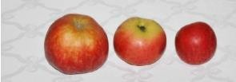

اخرى ج. 130جم

.114تفاح:

تفاحة واحدة تفاحتان أ. 320جم ب. 170جم

اخرى

حبتين

.115كمثري: حبة واحدة

.116توت: الكوب = 250مل

اخرى

كوبين

كوب ونصف

كوب

نصف كوب



د40.جم

جم69 .ج

جم101.ب

.117فراولة: أ. 123جم



جم600 .ج

جم400 .ب

:عنب.118 جم600 .أ



.119مشمش مجفف:

جم16 .د

جم28 .ج

جم38 .ب

جم53 .أ



.120تين مجفف:

جم39 .د

جم75 .ج

جم111 .ب

جم180 .أ

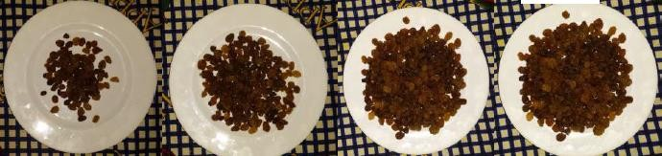

جم35 .د

جم66 .ج

جم110 .ب

.121زبيب: أ. 160جم



جم65 .ج

جم130 .ب

:تمر.122 جم200 .أ

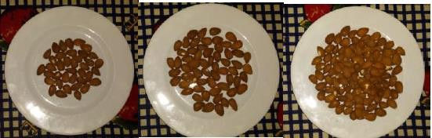

ج35.جم

جم43 .ب

.123 اللوز: أ100.جم

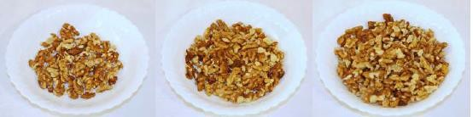

جم40 .ج

جم75 .ب

.124الجوز: أ. 150جم

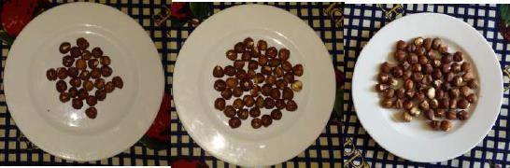

جم35 .ج

جم55 .ب

.125البندق: أ. 90جم



جم35 .ج

جم55 .ب

.126كاجو: أ. 90جم

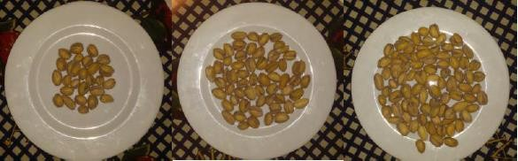

جم35 .ج

جم55 .ب

.127 فستق: أ. 85جم



جم362 .ج

جم535 .ب

.128البطيخ: أ. 735جم



هـ. 217جم

.129التمر: أ. 110جم ب. 85جم

ج65.جم

د40.جم

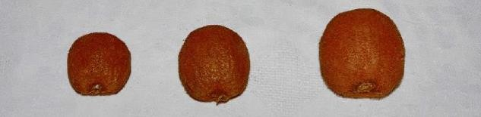

أخرى ب. 56جم

2

جم36 .ج

.130 الكيوي:

1

جم96 .أ



جم250 .ج

جم125 .ب

.131افوكادو: أ62.جم

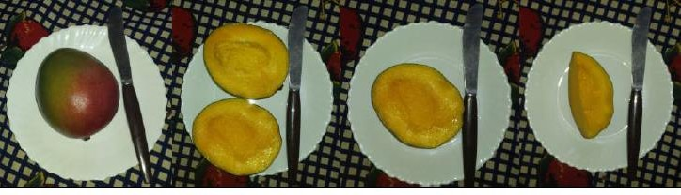

جم280 .ج

جم217 .ب

.132مانجو: أ. 160جم



جم100 .ج

جم200 .ب

.133المعكرونة: أ. 350جم

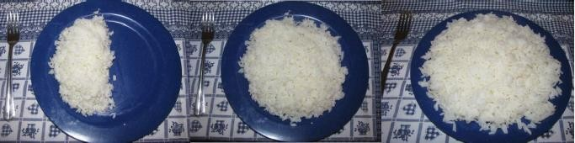

جم150 .ج

جم200 .ب

:ارز.134 جم350 .أ



جم500 .ج

جم803 .ب

.135كسكسي: أ. 1140جم



جم40 .ج

ب80.جم

.136الخبز:

جم12 .أ

هـ. 135جم

جم245.د



جم60 .ج

جم120 .ب

.137كرواسان: أ. 96جم



جم120 .ج

جم230 .ب

.138كيك وحلويات: أ. 350جم

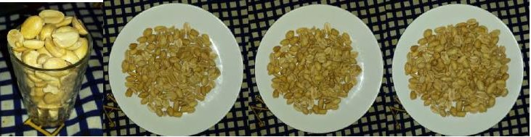

جم38 .د

جم76 .ج

جم114 .ب

.139كاكاوية: أ. 152جم

جم........

نصف 50جم

.140 حليب بالشكوالتة: شكوالتة كاملة 100جم

........مالعق شاي

ملعقتين شاي

.141كاكاو: ملعقة شاي

.143 كمية الماء التي تشربها يوميا:

مل....

لتر

نصف لتر

مل200

مل100

.144 متوسط كمية الزيت التي تستخدمها في الطبخ:

لتر

نصف لتر

2.5 ديسيلتر

2 ديسيلتر

ديسيلتر

..... ديسيلتر

|  |  |  |  |  |
| --- | --- | --- | --- | --- |
| .145 كمية الزيت التي تضعها في السلطة: | | | | |
| ..... مالعق شاي |  | ملعقتين شاي |  | ملعقة شاي |

|  |  |  |  |  |
| --- | --- | --- | --- | --- |
| .146 كمية الدهون التي تستخدمها في الطبخ: | | | | |
| ..... مالعق شاي |  | ملعقتين شاي |  | ملعقة شاي |



مل70 .د

مل150 .ج

مل250 .ب

.147 شاي وقهوه: أ. 320مل

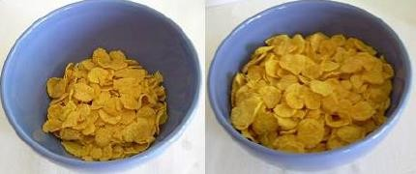

جم35 .ب

.148 حبوب االفطار: أ. 85جم

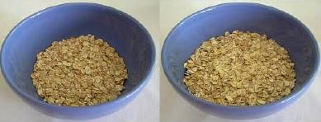

جم70 .د جم145 .ج

ال

.150 هل تتناول اي طعام مدعم بفيتامين د؟ نعم

اذا نعم ماهو اسم هذا المنتج:

كم مرة استخدمت هذا المنتج خالل الشهر الماضي:

3-2 مرات في الشهر

6-4 في االسبوع

مرة واحدة في الشهر

مطلقا

كل يوم

3-2 في االسبوع

مرة واحدة في االسبوع

ماهوحجم الكمية التي غالبا ماتستخدمها؟